Quadratics Supplement

Factoring

Graphing

Quadratic Formula

Factoring ax2 + bx + c

ALWAYS factor out the GCF 1st!

**Example: 20x2 + 22x – 12 has a GCF of 2**

**– factor it out!**

**2(10x2 + 11x – 6)**

**Box Method**

1. Create a 2 x 2 box.
2. In the top left corner place the 1st tern (ax2)
3. In the bottom right corner place the last term (c)
4. Multiply a and c
5. Find two factors of this product which will add to equal b
6. Place the terms in the two remaining boxes with xs next to them
7. Factor out the GCF of each row and column
8. The binomials will give you your factors

To solve: set both factors (the two sets of parentheses) equal to zero and solve both equations, this will give you your solutions. ☺

**Example: 10x2 + 11x – 6**

Step 1: Step 2: Step 3: Step 4:

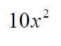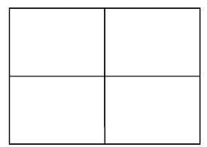 10 × -6 = -60

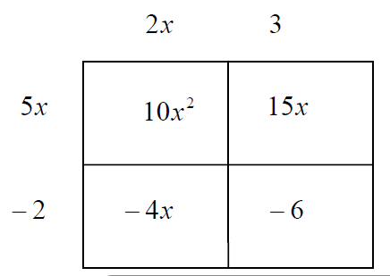

Step 5: Step 6: Step 7: Step 8:

15×-4 = -60 (2x + 3)(5x – 2 )

15+-4 = 11

Factors

15 and -4

To solve:

$$\left(2x + 3\right)=0 and \left(5x – 2 \right) =0$$

$2x=-3$ $5x=2$

$x=\frac{-3}{2}$ and $x=\frac{2}{5}$

**"Aussie" Method”**

*Seems strange at first. But if you get the pattern it will always work for you!!!*

ALWAYS factor out the GCF 1st!

**Example: 20x2 + 22x – 12 has a GCF of 2**

**– factor it out!**

**2(10x2 + 11x – 6)**

1. Draw 2 sets of parenthesis.
2. Place the two x's in them.
3. Multiply the coefficients (#s) from the first and last terms. (a and c)
4. Determine which of these pair of numbers will get you the MIDDLE term (the x term) and place them in the parenthesis.
5. Divide the numbers that you just placed in the parenthesis by the original lead coefficient (a) then simplify any fractions
6. If it does not divide evenly, and take the value of the denominator and move it in front of the x within that factor.
7. To solve: set both factors (the two sets of parentheses) equal to zero and solve both equations, this will give you your solutions. ☺

**Example: 10x2 + 11x – 6**

Step1: ( ) ( )

Step 2: ( x ) ( x )

Step 3: 10 x -6 = -60

Step 4: -4 x 15 = -60 and -4 + 15 = 11

$( x-4 ) ( x+15 )$

Step 5: $( x-\frac{4 }{10}) ( x+\frac{15}{10} )$ now simplify $( x-\frac{2 }{5}) ( x+\frac{3}{2} )$

Step 6:

Since there are fractions left, you must move 5 and 2 in front of the x’s

$$( 5x-2) ( 2x+3 )$$

To solve:

$$\left(2x + 3\right)=0 and \left(5x – 2 \right) =0$$

$2x=-3$ $5x=2$

$x=\frac{-3}{2}$ and $x=\frac{2}{5}$

Factoring Quadratics Practice

Practice using the **box method**:



Practice using the **Aussie method**:

$$7x^{2} – 30x + 8$$

What method do you prefer? Why?

Quadratic Practice Solving through Factoring

**Directions:** using the method of your choice, solve through factoring.

1. 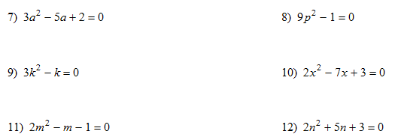
2. = 0
3. 

Quadratics: Prefect Square Binomials

Factor Together

1. 

Solve Together

1. 

**Independent**

**Factor completely**

1.  2. 

3.  4. 

5.  6. 

**Solve**

7.  8. 

9.  10.  (factor out the GCF 1st!)

11.  = 0 12. = 0

**Graphing Quadratics – Together**

Directions: For the given equation, fill in the table, plot the points (but wait to connect the points) on the grid, find the x-intercepts, y-intercepts, vertex, state if the vertex is the max or min, and state and draw in your axis of symmetry.

1. $y=-2x^{2}-8x±5$

|  |  |
| --- | --- |
|  |  |
|  |  |
|  |  |
|  |  |
|  |  |
|  |  |
|  |  |
|  |  |

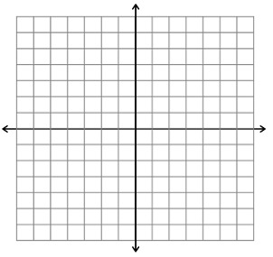

y-int: _______________________

Find Vertex:

Maximum or Minimum?

Axis of Symmetry: _______________

2. $y=-x^{2}+4x-1$

|  |  |
| --- | --- |
|  |  |
|  |  |
|  |  |
|  |  |
|  |  |
|  |  |
|  |  |
|  |  |

 y-int: _______________________

Find Vertex:

Maximum or Minimum?

Axis of Symmetry: _______________

**Graphing Quadratics- Each Other**

Directions: For the given equation, fill in the table, plot the points (but wait to connect the points) on the grid, find the x-intercepts, y-intercepts, vertex, state if the vertex is the max or min, and state and draw in your axis of symmetry.

1. $y=x^{2}+x-6$

|  |  |
| --- | --- |
|  |  |
|  |  |
|  |  |
|  |  |
|  |  |
|  |  |
|  |  |
|  |  |

 x-int: _____________________

y-int: _______________________

Find Vertex:

Maximum or Minimum?

Axis of Symmetry: _______________

2. $y=x^{2}-6x+0$

|  |  |
| --- | --- |
|  |  |
|  |  |
|  |  |
|  |  |
|  |  |
|  |  |
|  |  |
|  |  |



y-int: _______________________

Find Vertex:

Maximum or Minimum?

Axis of Symmetry: _______________

**Graphing Quadratics – Before you leave**

Directions: For the given equation, fill in the table, plot the points (but wait to connect the points) on the grid, find the x-intercepts, y-intercepts, vertex, state if the vertex is the max or min, and state and draw in your axis of symmetry.

1. $y=-x^{2}-6x-3$

|  |  |
| --- | --- |
|  |  |
|  |  |
|  |  |
|  |  |
|  |  |
|  |  |
|  |  |
|  |  |



y-int: _______________________

Find Vertex:

Maximum or Minimum?

Axis of Symmetry: _______________

2. $y=x^{2}-3x-4$

|  |  |
| --- | --- |
|  |  |
|  |  |
|  |  |
|  |  |
|  |  |
|  |  |
|  |  |
|  |  |



y-int: _______________________

Find Vertex:

Maximum or Minimum?

Axis of Symmetry: _______________

**Independent**

**Quadratics – Graphing**

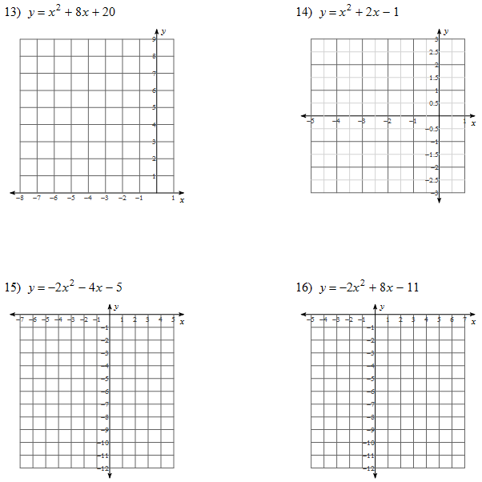

**Quadratics – Quadratic Formula**

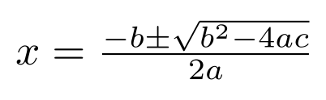

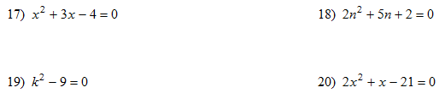



**What’s that you say? Story Problems!!!!**

Sample Problems- Together

1. The sum of two numbers is 31, their difference is 41. Find these numbers.
2. The product of two numbers is 640. Their difference is 12. Find these numbers.
3. One side of a rectangle is 3 ft shorter than twice the other side. Find the sides if the perimeter is 24 ft.
4. One side of a rectangle is 3 ft shorter than twice the other side. Find the sides if the area is 209 ft2.
5. One side of a rectangle is 4 in shorter than three times the other side. Find the sides if the perimeter of the rectangle is 48 in.
6. One side of a rectangle is 4 in shorter than three times the other side. Find the sides if the area of the rectangle is 319 in2.
7. We throw an object upward from the top of a 1200 ft tall building. The height of the object, (measured in feet) t seconds after we threw it is:

h (t) = 16t2 + 160t + 1200

1. Where is the object 3 seconds after we threw it?
2. How long does it take for the object to hit the ground?

Practice Problems

1. The product of two numbers is 65. Their difference is 8. Find these numbers.
2. If we square a number, we get six times the number. Find all numbers with this property.
3. The product of two consecutive even integers is 840. Find these numbers.
4. The area of a rectangle is 1260m2. Find the dimensions of the rectangle if we know that one side is 48m longer than three times the other side.
5. We are standing on the top of a 1680 ft tall building and throw a small object upwards. At every second, we measure the distance of the object from the ground. Exactly t seconds after we threw the object, its height, (measured in feet) is

h (t) = 16t2 + 256t + 1680

1. Find h (3). (h (3) represents the object’s position 3 seconds after we threw it.)
2. How much does the object travel during the two seconds between 5 seconds and 7 seconds?
3. How long does it take for the object to reach a height of 2640 ft?
4. How long does it take for the object to hit the ground?

**Homework - If you want extra practice**

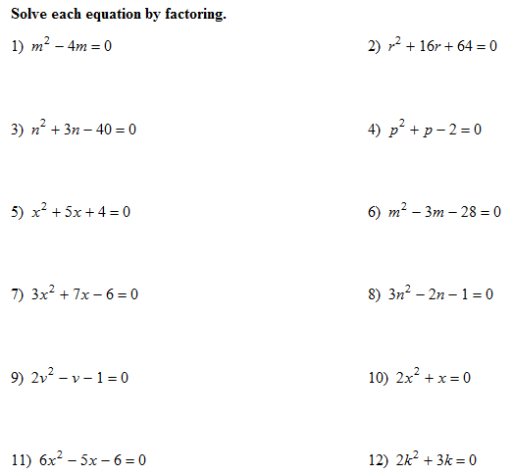

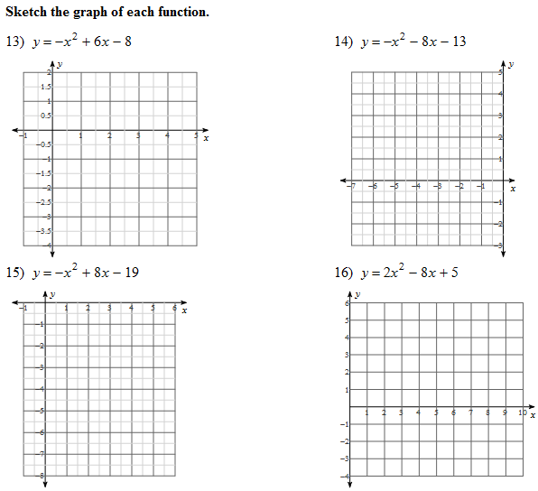

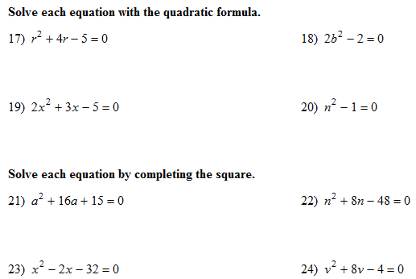

**Solutions**

