**Name: ________________________________________________________________________**

Chapter 6 Quadrilateral Proofs

**Write a two-column proof for the following.**

**#1-5 Parallelogram properties**

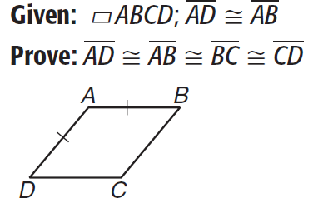**1.**

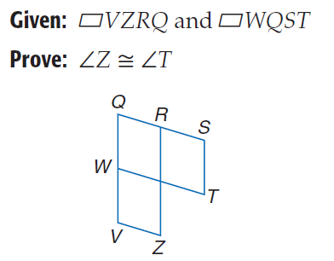

**2.**

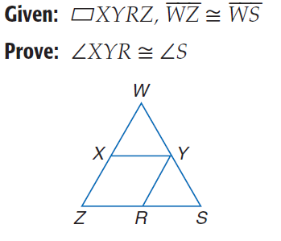

**3.**

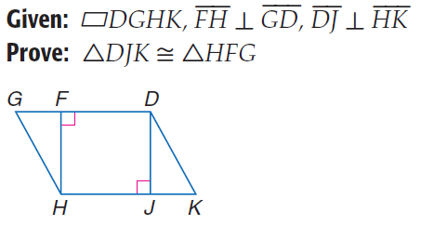

**4.**

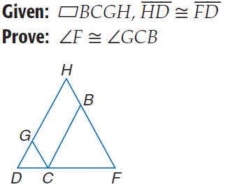**5.**

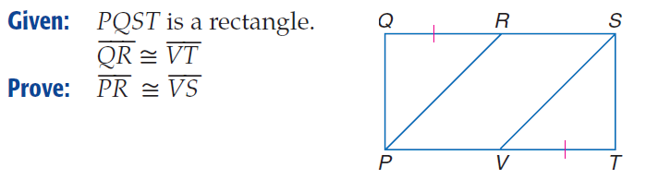

**6.**

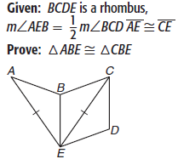

**7.**

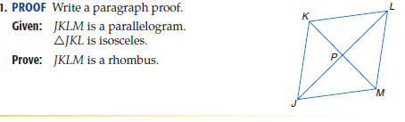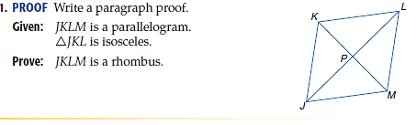**8.**

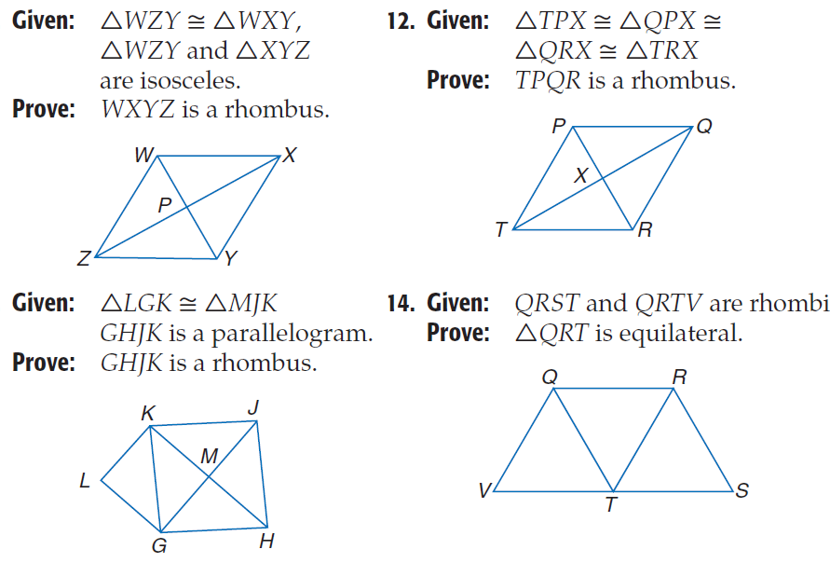**9.**



**10.**



**11.**



**12.**