Name: ___________________________________________ Hour: _____
1st Quarter Graded Assignment
Proofs:
1. Given: <1 $≅$<4
Prove: <2 $≅$<5

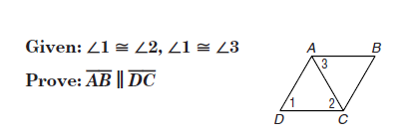
2.

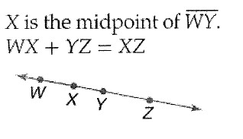
3.

1. $X$is the midpoint of $\overline{WY}$ 1. _________________________
2. _______________________ 2. Definition of Midpoint
3. XY + YZ = XZ 3. _________________________
4. ________________________ 4. Substitution
4. Prove the Triangle Sum Theorem
Given: p//$l and m is a transversal of p and l$
Prove: $m<5+m<2+m<6=180$

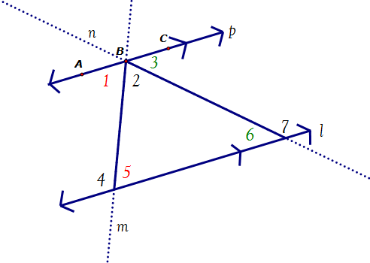

5. Given: <1$≅$<2 and BC//AD
Prove: <B$≅$<C
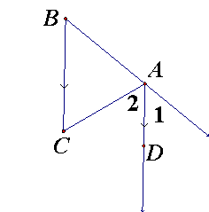

Logic and Reasoning
6. Draw a figure and make a conjecture given that ΔABC is a right triangle with <B as a right angle.

7. Is the conjecture true or false, if it is false, find a counter example.
Given: XY YZ
Conjecture: Y is a midpoint of XZ.

8. Make a conjecture about the next term in this sequence: (find the next number in the sequence) circle your final answer.

5, 10, 20, 40,

9. Complete the truth table.
q | r | ~q | ~q ^ r
T | T
T | F
F | T
F | F

Directions: Show geometry and justify EVERY step. Circle your final answer!
10. Find the length of DE.
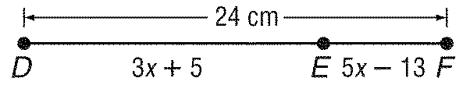

11. M is the midpoint of EK. Find the value of X and the length of EK.
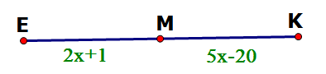

12.

13.

Directions: Show all work! Circle your final answer!
14.g.

15.g.
16.g.

Directions: Show all work! Circle your final answer!
17. Find the distance between D(-5,6) and E(8,-4).

18. Find the coordinates of the midpoint of $\overline{GH}$ for G(8,-6) and H(-14, 12)

19. Find the coordinates of G if P(-5,10) is the midpoint of $\overline{EG}$ and E has coordinates (-8,6).

Directions: Use the figure to answer the following 4 questions.
20. Name a line that contains points B and F.

a. $\overset{⃡}{EB}$ | b. line n
c. $\overset{⃡}{CB}$ | d. $\overset{⃡}{CD}$

21. Name the point of intersection of line l and line n.

a. E | b. B
c. C | d. D

22. Name the 3 points which are collinear.

a. A, B, F | b. D,C, A
c. E, D, F | d. E, D, C

23. What is another CORRECT name for Plane T.
a. Plane m, n, t | b. Plane t
c. Plane EDF | d. Plane ECD

Please list any students you were working with on this assignment.

