Name: ______________________________ Date: __________ Hour: ________

**Similar Polygons Quiz Review**

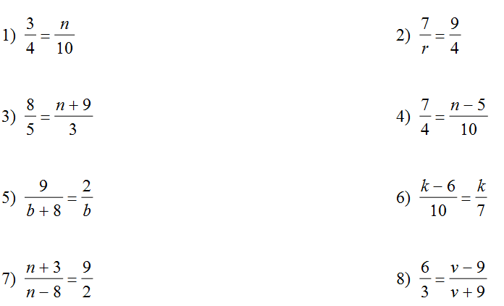Solve each proportion. Show all work and place your answer on the line provided.















State if the polygons are similar and explain why or why not. Hint: look at SLRs and angles.

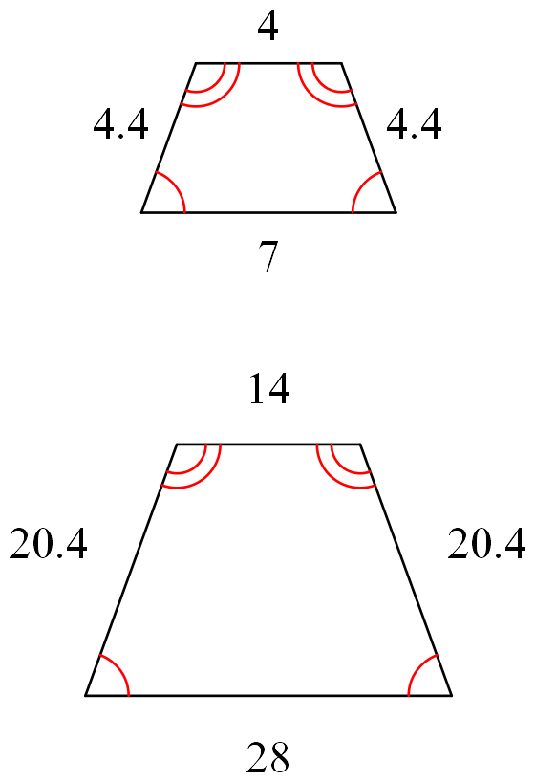

____9. ____10.

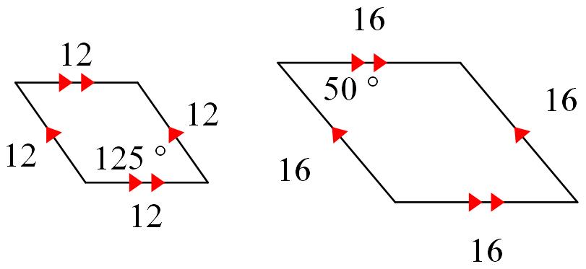

A.) Yes, corresponding angles are and SLR are =

B.) No, corresponding angles are but SLR are NOT =

C.) No, SLR are = but corresponding angles are NOT

D.) No, SLR are NOT = AND corresponding angles are NOT

A.) Yes, corresponding angles are and SLR are =

B.) No, corresponding angles are but SLR are NOT =

C.) No, SLR are = but corresponding angles are NOT

D.) No, SLR are NOT = AND corresponding angles are NOT

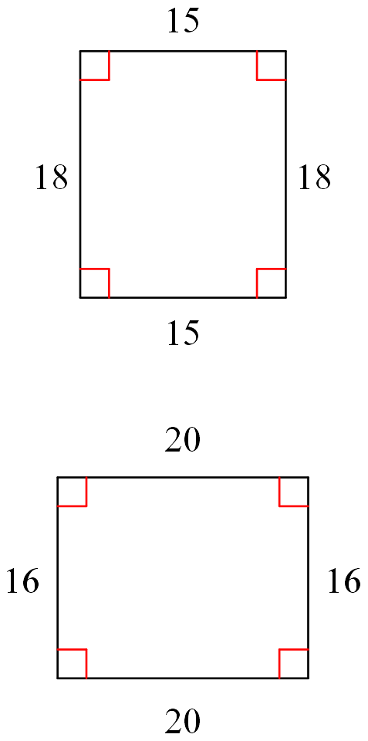

____11. ____12.

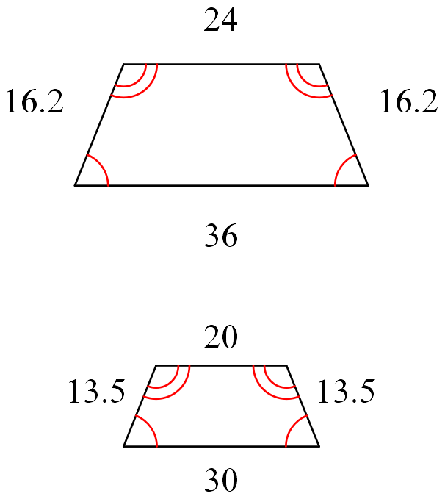

A.) Yes, corresponding angles are and SLR are =

B.) No, corresponding angles are but SLR are NOT =

C.) No, SLR are = but corresponding angles are NOT

D.) No, SLR are NOT = AND corresponding angles are NOT

A.) Yes, corresponding angles are and SLR are =

B.) No, corresponding angles are but SLR are NOT =

C.) No, SLR are = but corresponding angles are NOT

D.) No, SLR are NOT = AND corresponding angles are NOT

The polygons below are similar. Find the scale factor of the two similar figures.

13. 14.

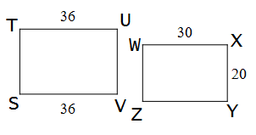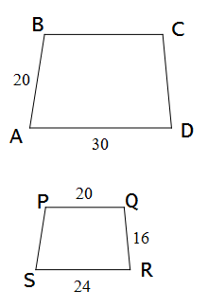

15. 16.

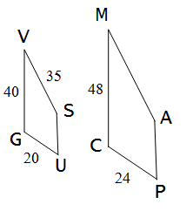

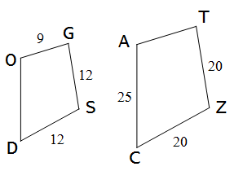

The polygons below are similar. Find the value of the variable.

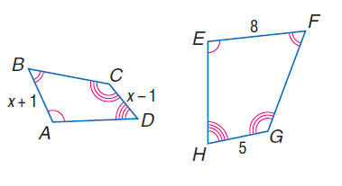17.

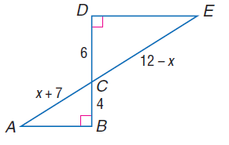18.

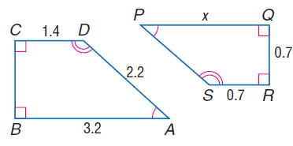

19.

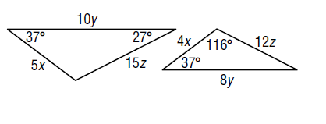

20.