Name: __________________________
Real World Applications Day 1 In-Class
Directions: Round to the nearest tenth.
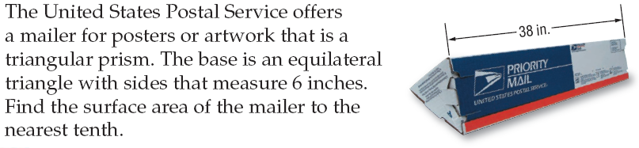
1.

2.

For #3 & 4 use the following information:

HINT: We are only painting the walls of the room.
3.

4.

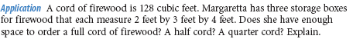
5.

7.

Name: __________________________ Date: ________ HOUR: ________
Real World Applications Day 1 HW
Directions: Round to the nearest tenth.
1. Find the surface area of the following figure.
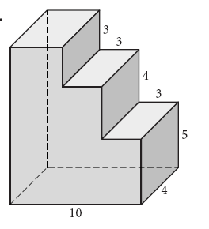

2.

a.

b.

c.

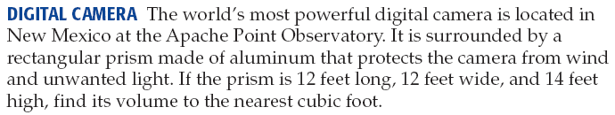
3.

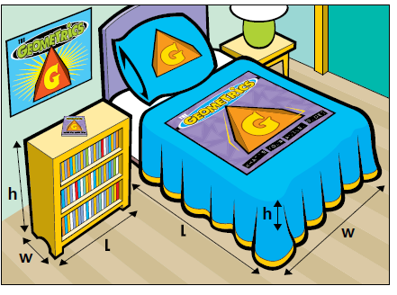
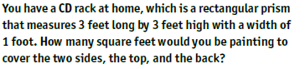
4.

Picture for #5
5.

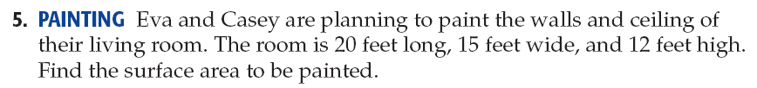
6.

Name: __________________________ Date: ________ HOUR: ________
Real World Applications Day 2 In Class
Directions: Round to the nearest tenth.
1.

2. Tunnels: Construction workers are digging a tunnel through a mountain. The space inside the tunnel is going to be shaped like a rectangular prism. The mouth of the tunnel will be a rectangle 20 feet high and 50 feet wide.

(a) The length of the tunnel will be 900 feet. What will the volume of the tunnel be?

(b) If instead of the rectangular shape, the tunnel had a semicircular shape with a 50 foot diameter, what would its volume be?

(c) What has the larger volume?

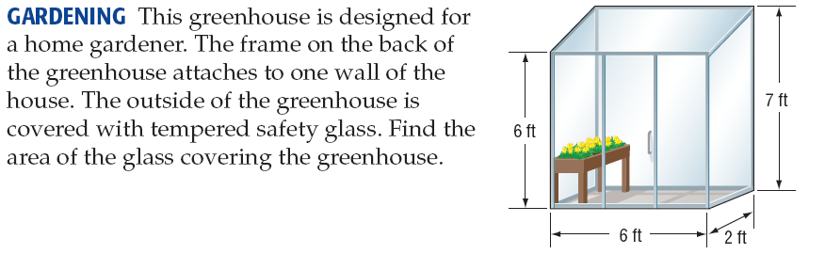
3.

Refer to the similar prisms for the following questions.

4. Find the scale factor of the two prisms from larger to smaller.

5. Find the ratio of the surface areas.

6. Find the ratio of the volumes.

7. Suppose the volume of the larger prisms is 810 cubic centimeters. Find the volume of the smaller.

Name: __________________________ Date: ________ HOUR: ________
Real World Applications Day 2 HW
Refer to the similar prisms for the following questions.

1. Find the scale factor of the two prisms from larger to smaller.

2. Find the ratio of the surface areas.

3. Find the ratio of the volumes.

4. Suppose the volume of the smaller prisms is 60 cubic inches. Find the volume of the larger.

Directions: Round to the nearest tenth.

5. The Great Pyramid of Khufu is a square pyramid. The lengths of the sides of the base are 755 feet. The original height was 481 feet. The current height is 449 feet. What volume of material has been lost?

6. Mount Rainier, which is an active volcano in Washington, is 4392 meters tall and about 18,000 meters across its base. Assume that it can be modeled by a cone. Find the volume of rock it would take to fill Mt. Rainier.

7.

8.

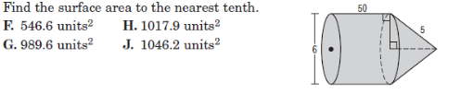
9.

Find the surface area and volume for the following composites.

10.

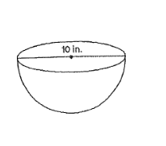

11.

Name: __________________________ Date: ________ HOUR: ________
Real World Applications Day 3

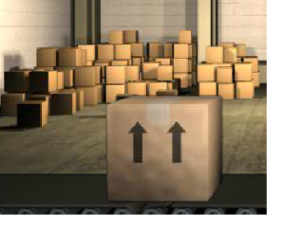
1. How many more inches of cardboard does a cube-shaped box with a side length of 8 inches have than a cube shaped box with a side length of 4 inches?

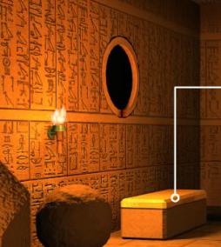
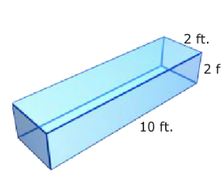
2. The outside of the pharaoh’s casket will be painted. The dimensions of the casket are shown in the diagram. Calculate the surface area of the 6 sides so that the proper amount of paint can be mixed.

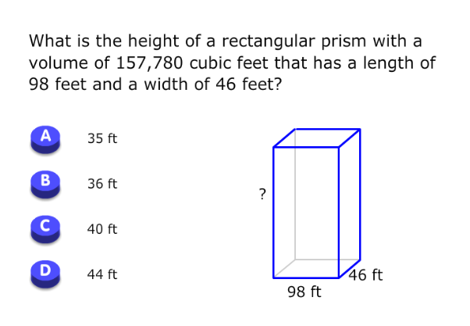
3. Find the surface area and volume of the composite. 4.

5. A can is 4 inches wide and 8 inches tall. To the nearest whole number, what is the area of a label that wraps around the can if the label is 3 inches shorter than the height of the can?

6. The diagram shows a pattern to make a camping tent in the shape of a square pyramid. If the triangular panels are 8 feet wide and 6 feet tall, how much material will it take to make the tent, including the base?

7. A traffic safety cone looks like a cone with a portion of its top removed. Sometimes they are filled with sand so they don’t blow away. If the volume of the top portion that is removed in 25 inches³, how much sand is needed to fill the remaining part of the cone?

