Name: _________________________________________________ Date: ________________ Hr: _______
RTI Triangle Review 2015
Directions: Find x.
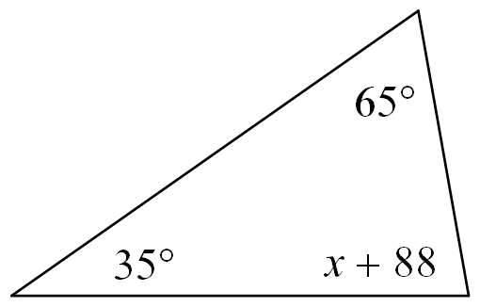
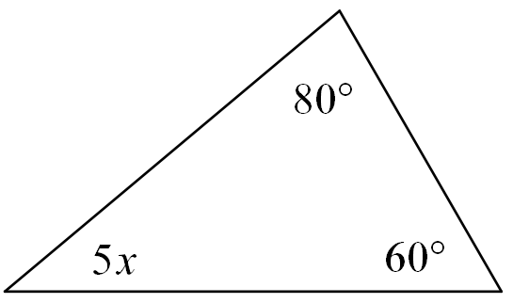
1. 2.

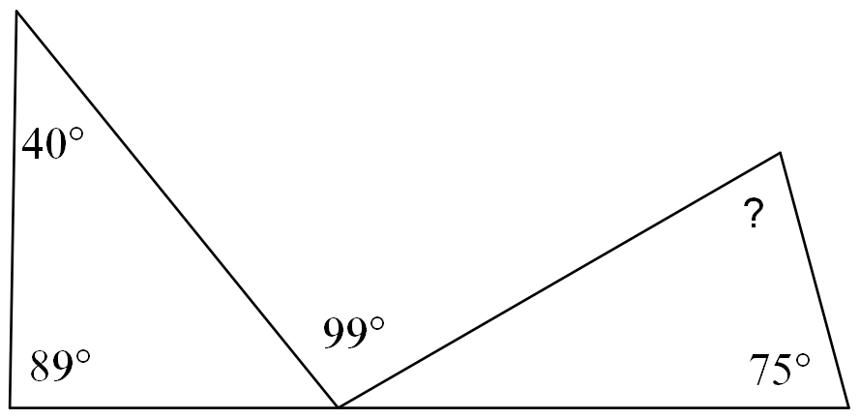
3. Find the measure of the missing angle.
4. Find the measure of the missing angle.
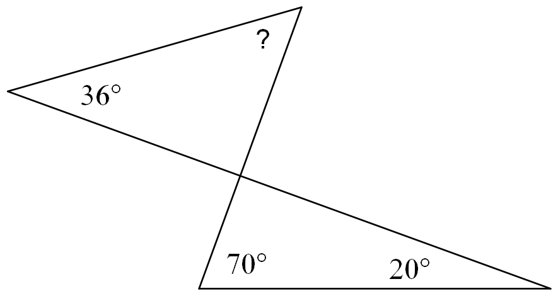

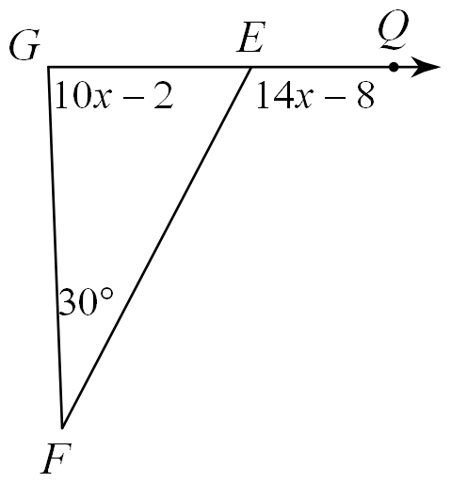
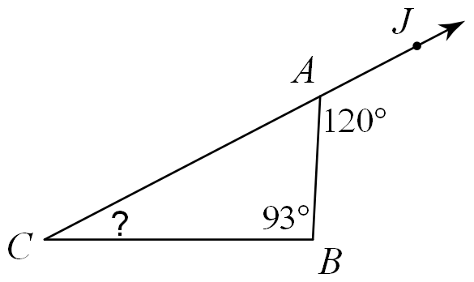
5. Find the measure of the missing angle. 6. Solve for x.

Directions: Draw, mark and label the figure, solve for the missing variable, and find the lengths of each side.
7.

8.

9. Find the missing coordinates of each triangle.

Find the measures of the numbered angles.
10. 11. 12.

13. 14.

Find all missing angle measures.
15. 16.

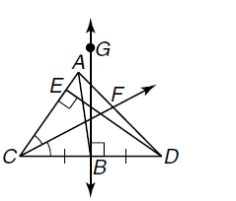
17. Highlight and name the median of the triangle.

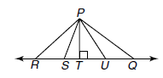
18. Name the shortest distance from P to RQ.

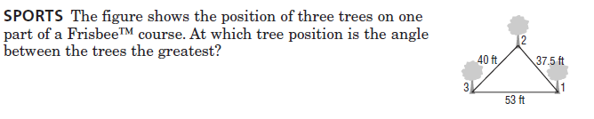
19.

20. List the angles from least to greatest.

21. List the side lengths from greatest to least.

22. Do the following lengths form a triangle 4, 6, 16. Why or why not?

23. Find the range for the measure of the third side given two sides of the triangle are
12 and 19.

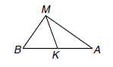
24. Given the following triangle with median MK state if the following statements are true or false.
a. $m<MKA = 90ᵒ$
b. $BK ≅ AK$
c. $m<BMK = m<AMK$
d. ∆BMA is isosceles with vertex angle M.

25. Classify the triangle by its sides and angles given the two angle measure are 61$ᵒ$ and 29ᵒ.

26. Classify the triangle by its sides and angles given the two angle measure are 12$ᵒ$ and 84ᵒ.

27. If in an isosceles triangle, the vertex angle is 5 more than 3 times the measure of one of the base angles, find the measures of EVERY angle. Show all work and algebraic set up.

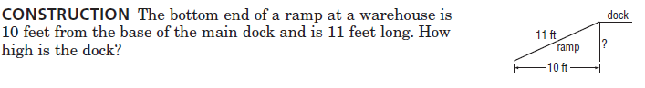
28.

29. Find the value of x. 30. Find the value of x. 31. Find the value of x and y.
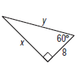

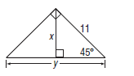
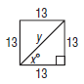
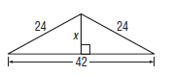
32. Find the value of x. 33. Find the value of x and y. 34. Find the value of x and y. and y.

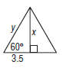
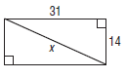
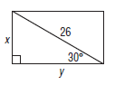
35. Find the value of x and y. 36. Find the value of x. 37. Find the value of x and y.

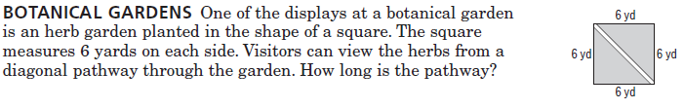
38.

39. MEDIAN IF LJ is the median of ∆IJK, find x.
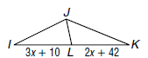

40. ROUTE Mrs. Burge’s House, her Parent’s House, and Dakota High school form a triangle on a map. What route would have the longest drive? (i.e. Which two buildings are farthest apart?)
Parent’s House
2x-4

Mrs. Burge’s House
3x-6
5x+20
Dakota High School

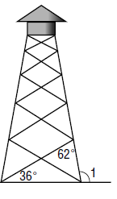
41. TOWERS A lookout tower sits on a network of struts and posts. Leslie measured 2 angles on the tower, find the measure of <1.

42. PATHS Rachel walks around a triangular path. At each corner, she records the measure of the angle she creates. She makes one complete circuit around the path. What is the sum of the three angle measure that she wrote down during one complete circuit?

43. CRAZY ANGLES! Find the measures of the numbered angles.
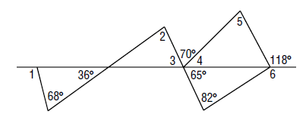

44. BOOKENDS Two bookends are shaped like right triangles. The bottom side of each triangle is exactly half as long as the slanted hypotenuse of the triangle. If all the book between the bookends are removed and they are pushed together, they will form a single triangle. Classify the triangle that will be formed as equilateral, isosceles or scalene.

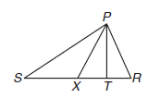
45. ∆XRP is isosceles with vertex < PXR. m<PSR = 31ᵒ,
m<XPT = 24ᵒ, m<RTP = 103ᵒ.

(a) Name the legs of the isosceles triangle.

(b) Name the base angles of the isosceles triangle.

(c) Find the measures of the following angles:

m<SXP = _____ m<SPX = ______ m<PTX = ______

m<PXT = ______ m<TPR = ______ m<SRP = ______

46. Find the measures of the side of ∆KPL and classify the triangle by its sides.
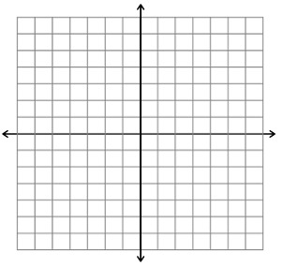
K(-4,3), P(1,2), L(-3,-2)

47. Find the measures of the side of ∆ABC and classify the triangle by its sides.
A( -9, -7), B(-6, -3), T(-5, -6)

48. Find the measures of the side of ∆RST and classify the triangle by its sides.
R(2,4), S(4,7), T(6,4)

