Angle Relationships TEST REVIEW Schmidt

1. Find the measure of each angle if the m<HFK=90° and m<HFG=135°.

Ray FJ is an angle bisector of <HFK.

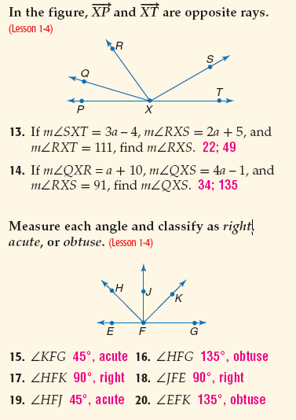

a. m<KFG= ____________ b. m<JFK= ___________

c. m<HFE= ____________ d. m<EFK= ___________

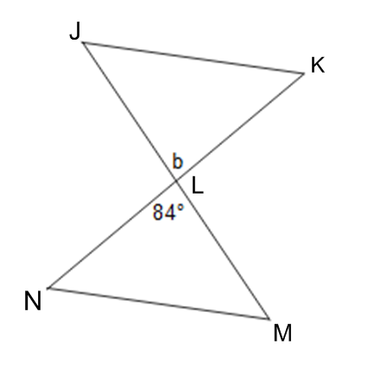

1e.

Find the m<KLM = ___________

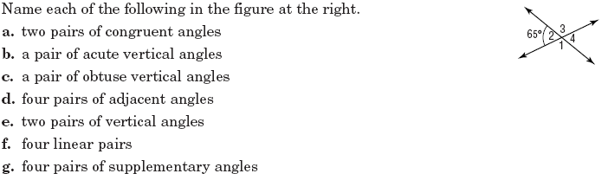2.

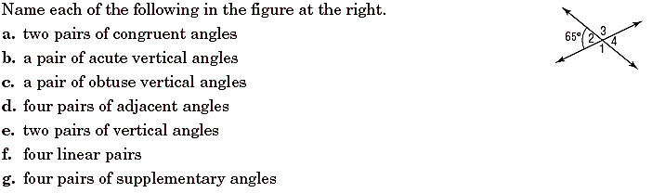

3. Classify all that apply, adjacent, vertical, linear pairs, ONE right angle, complementary, supplementary, and/or congruent.

a. <1 and <5 b. <GFH and <CFG

c. <2 and <5 d. <2 and <FCD

4. Two angles are complementary. The measure of one angle is 21 more than twice the measure of the other angle. Find the measures of the angles. (Show all work)

5. The measure of the supplement of an angle is 36 less than the measure of the angle. Find the measures of the angle. (Show all work).

**Directions:** For questions #6-10, show all geometry, justify the set up, and show all work to receive full credit!

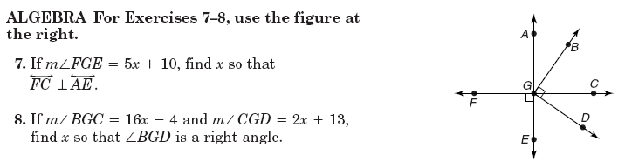6 a. 6b.







x = __________ x = __________

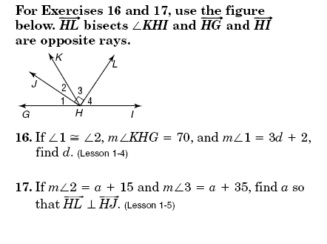7. $\vec{HL}$ bisects <KHI.

a. b.







d = __________ a = __________

c. If $\vec{HL}$ bisects <KHI, determine if the following statements are true or false.



<KHL $≅$ <LHI _____ L is in the interior of <KHI _____

m<KHL = 50 $°$ and m<KHI = 110 $°$______ m<LHI = $\frac{1}{2}$ (m<KHI) _______

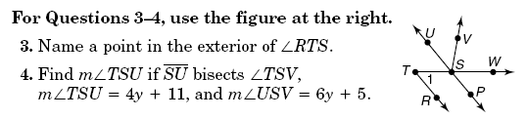8a. 8b. ***Using information from 8a***., find x, if

m<VSW= 8x – 2.





y=

$∠TSU=______________$ ______________

x = ______________

8c. Using the y and x from 8a and 8b above, find the value of 4x – 10y = ______________

9. In the figure to the right, $\vec{XP}$ and $\vec{XT}$ are opposite rays.

a. If *<SXT=3a – 4, <RXS=2a + 5, <RXT=111°.* Find *a* and the measure of <RXS.



a = ______________

<RXS = _____________

b. If *<QXR= a + 10, <QXS = 4a – 1*, and *<RXS=91°,* Find *a* and <QXS.



a = ______________

<QXS = _____________

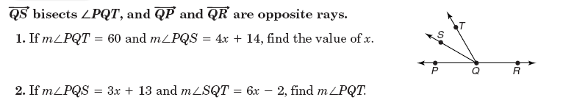10.

 a)





x = ____________

b.





x = _____________

<PQT = _____________

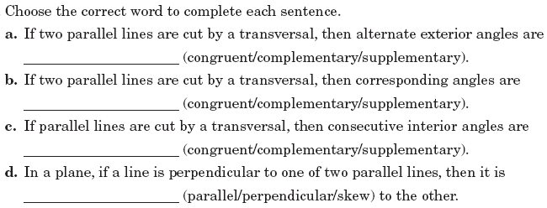

11.

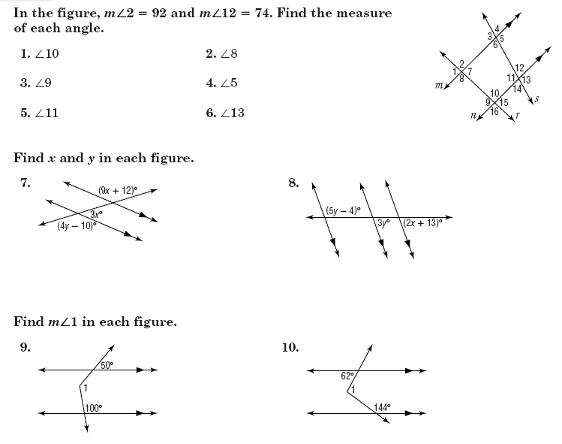

12.

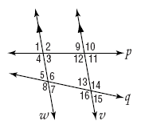13. If *w //v*, give the justification for each statement.

a. <2<12 b. <8<14 c. <5<13

d. <10<2 e. <7 + <16 =180° f. <16<6

14. If m<3=43°, find the measures of each angle. Fill them in on the picture and list them out in order.

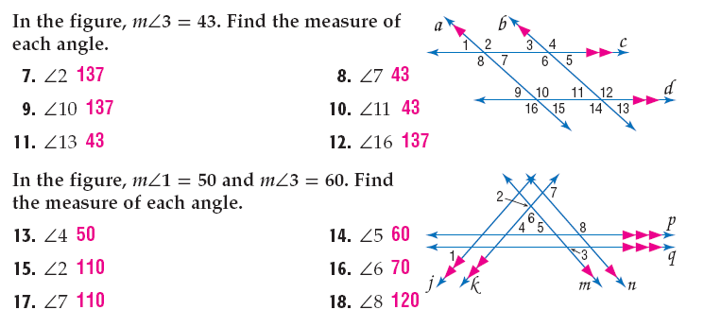

$$∠6=__________$$

$$∠7=__________$$

$$∠8=__________$$

$$∠9=__________$$

$$∠10=__________$$

$$∠11=__________$$

$$∠12=__________$$

$$∠13=__________$$

$$∠14=__________$$

$$∠15=__________$$

$$∠16=__________$$

$$∠1=__________$$

$$∠2=__________$$

$$∠3=__________$$

$$∠4=__________$$

$$∠5=__________$$

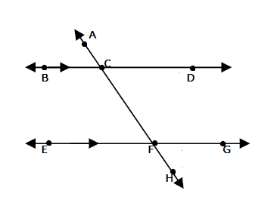Directions: Find the value of the variable, show your geometry and justification for each.

15.

12x-3

105ᵒ

x= ___________________

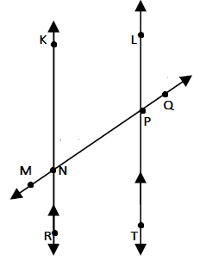

16.

-6+12x

11x

 x= ___________________

17.

7x+18

6x+19

x= ___________________



18.

53x-1

38x-1

x= ___________________

Directions: Find the value of the variable and the measure of the angle, show your geometry and justification for each.

****19.

22x+7

24x-1

x= _______________________

m<BCF = _______________



20.

15x+5 14x+12

x= ___________________

m< TPQ = _______________

21. If <3 is complementary to <2 and <1 is supplementary to <3. Find x and y if <1= 13x+4, <2=5y+4 and <3= 6x - 14

x = ________

y = ________

22. *Set up an equation that models the given situation, then find the measures of both angles in the situation.*

a. The measure of one angle is 7 times the measure of its compliment. Find the measure of each angle.

b. The measure of one angle is 15 times the measure of its supplement. Find the measure of each angle.

c. The measure of one angle is 47 less than the measure of its supplement. Find the measure of each angle.

d. Find the measure of two complementary angles if one angle is 12 more than the other.