Name: __________________________________________________

**Focus Special Parallelogram Practice**

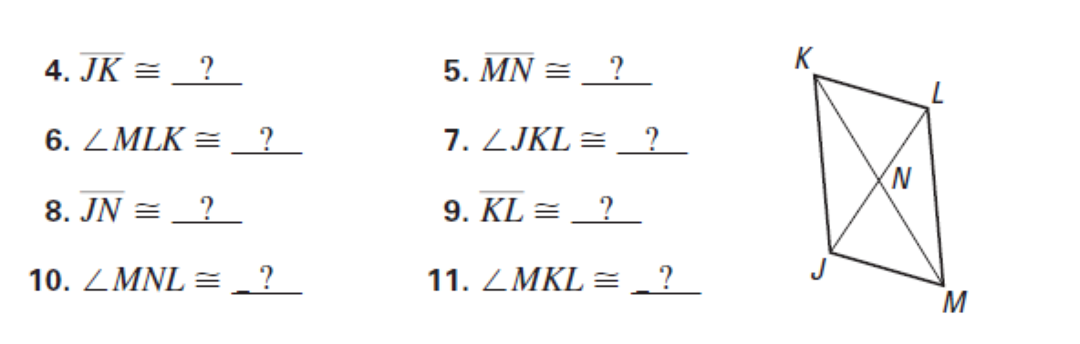Name the complete each statement about parallelogram JKLM. Show your justification for each.

1. <LMJ ≅ ____________ because _______________________________________

2. LK // _____ because _______________________________________________

3. KN ≅_______ because ______________________________________________

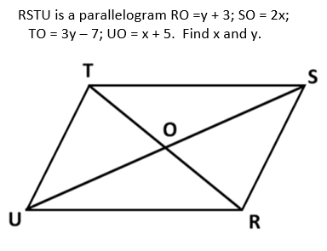4. RSTU is a parallelogram. RO = y + 3, SO = 2x; TO = 3y – 7; UO = x + 5. Find x and y.

You MUST show your geometry and justify.

Find x:

Geometry: Justify:

Find y:

Geometry: Justify:

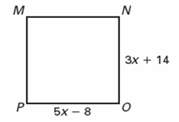5. MNOP is a square. Find x. You MUST show your geometry and justify.

Find x:

Geometry: Justify:

6. DEFG is a rhombus. Find x. You MUST show your geometry and justify.

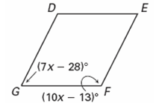Find x:

Geometry: Justify:

7. PQRS is a rhombus. Find x. You MUST show your geometry and justify.

Find x:

Geometry: Justify:

T

8. ABCD is a parallelogram. Solve for ***h and* g** and show your geometry and justifications for your set up.

Find g: 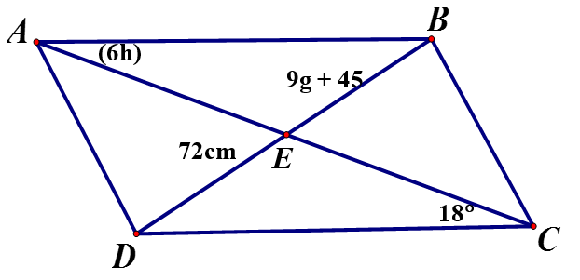



Find h:



9. If m∠1 = 12x + 4 and m∠2= 16x – 12 in rectangle ABCD, find x.

You MUST show your geometry and justify.

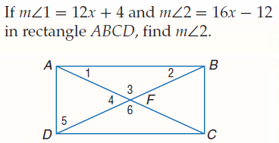 Find x:

Geometry: Justify:

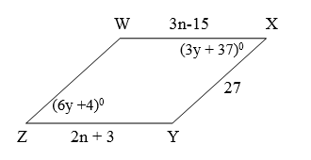10. WXYZ is a parallelogram. Find n, y, and m∠Z. You MUST show your geometry and justify.

Find n:

Geometry: Justify:

Find y: Find m∠Z. (No geo or just)

Geometry: Justify:

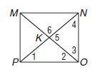11. MNOP is a square. Find all numbered angles and justify your reasoning.

m∠ 1 = __________ because ___________________________________________________

m∠ 2 = __________ because ___________________________________________________

m∠ 3 = __________ because ___________________________________________________

m∠ 4 = __________ because ___________________________________________________

m∠ 5 = __________ because ___________________________________________________

m∠ 6 = __________ because ___________________________________________________

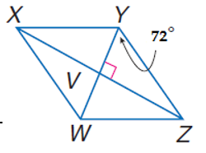

12. Use Rhombus WXYZ.

a. Find m<WYX.__________ because ________________________________

b. Find m<YZX. __________ because ________________________________

c. Find m<WZX. __________ because ________________________________

d. Find m<YZW. __________ because ________________________________

e. If WZ= 19m, find YZ. __________ because ________________________________

f. If WZ = 19m and VW = 4m, find VZ.

VZ = _______________________

13. If m∠SUT = 3x + 6 and m∠RUS = 5x – 4, find m∠SUT if URST is a rectangle.

You MUST show your geometry and justify.

Geometry: Justify:

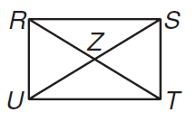

14. ABCD is a rhombus. Find x. You MUST show your geometry and justify.

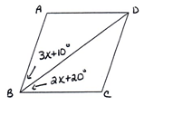Find x:

Geometry: Justify:

15. ABCD is a rectangle. If m∠AED = 12x and m∠BEC = 10x + 20, find m∠EDA.

You MUST show your geometry and justify.

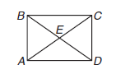Find x:

Geometry: Justify:

X = _________________________

m∠EDA = ___________________

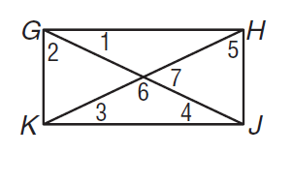16. GHJK is a rectangle. If m∠1 = 23°, find all remaining numbered angles. You do not need to show geometry or justify your work.

m∠2 = __________ m∠3 = _______________

m∠4 = __________ m∠5 = ________________

m∠6 = ___________ m∠7 = ________________