Name: _____________________________________________ Date: ____________ Hour: ___________
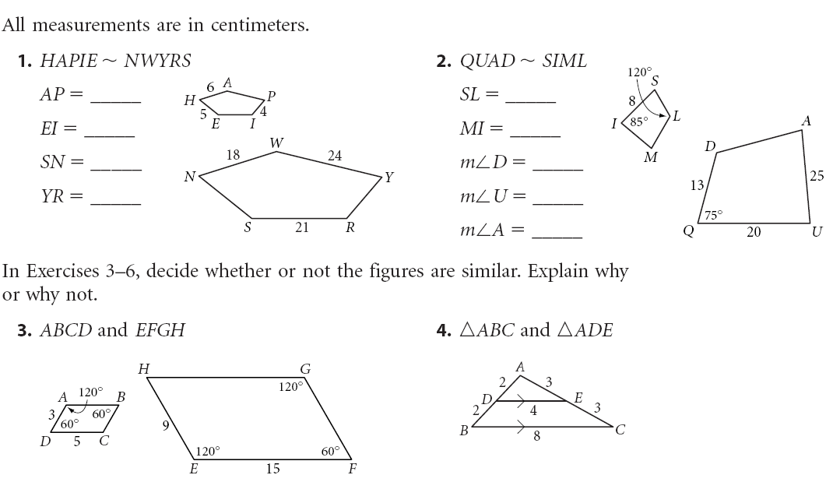
ACC Geometry Similarity Review- Quiz B

7. Explain if the following triangles are similar if so state
their similarity statement- order matters!!!

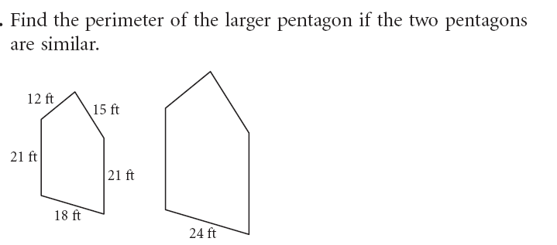
8.

9. State the similarity statement and EXPLAIN the similarity shortcut you used in DETAIL!
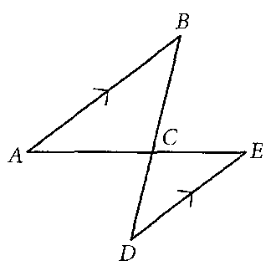

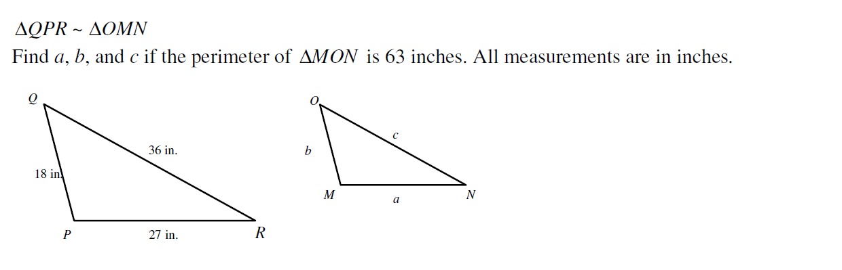
10.

11.

12.

13.

14. 15.

16.

Using Similar Right Triangles
17. State the similarity statement and find LM.
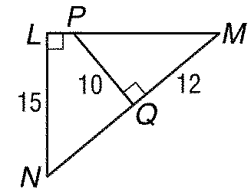

18. State the similarity statement and find x.
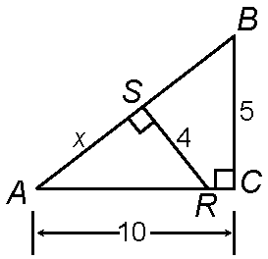

19. State the similarity statement and find x.

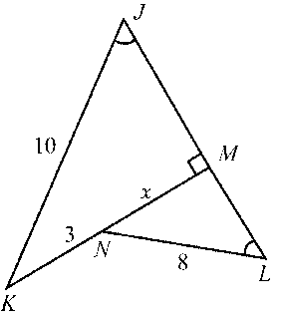

20. Find x.

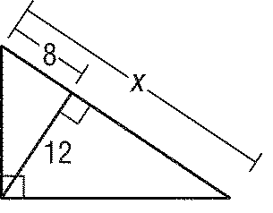

21. Find x.

