ACC Review for Surface Area and Volume (mostly Volume)

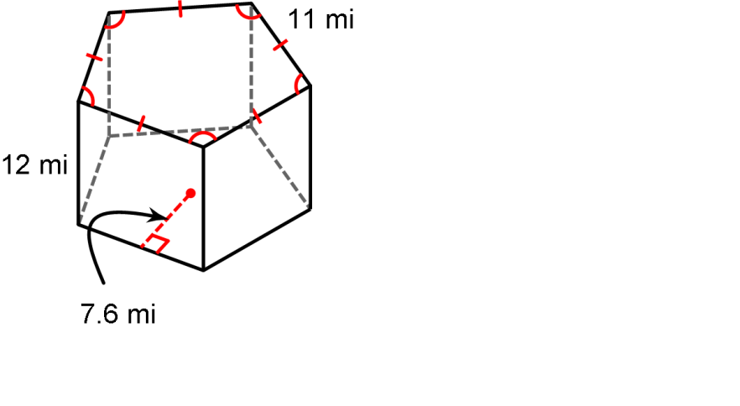Directions: Find the surface area and volume for the following prism.

1. SA= ___________________

V= ____________________

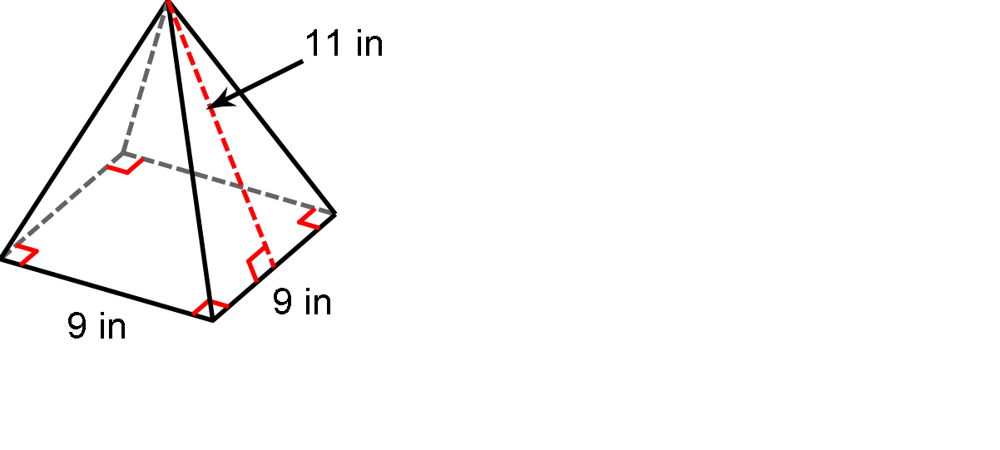Directions: Find the surface area and volume for the following pyramid.

2. SA= ___________________

V= ____________________

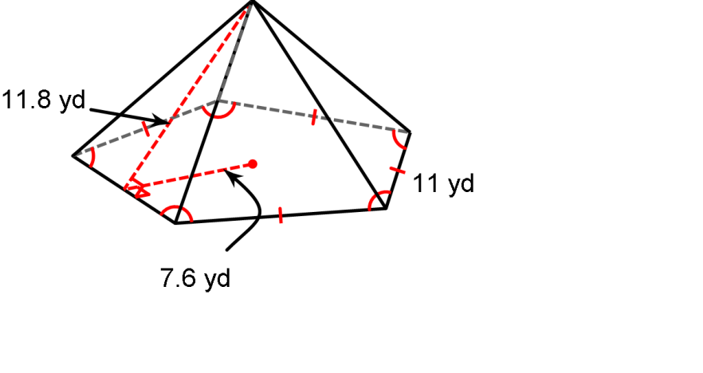Directions: Find the surface area for the following pyramid.

3. SA= ___________________

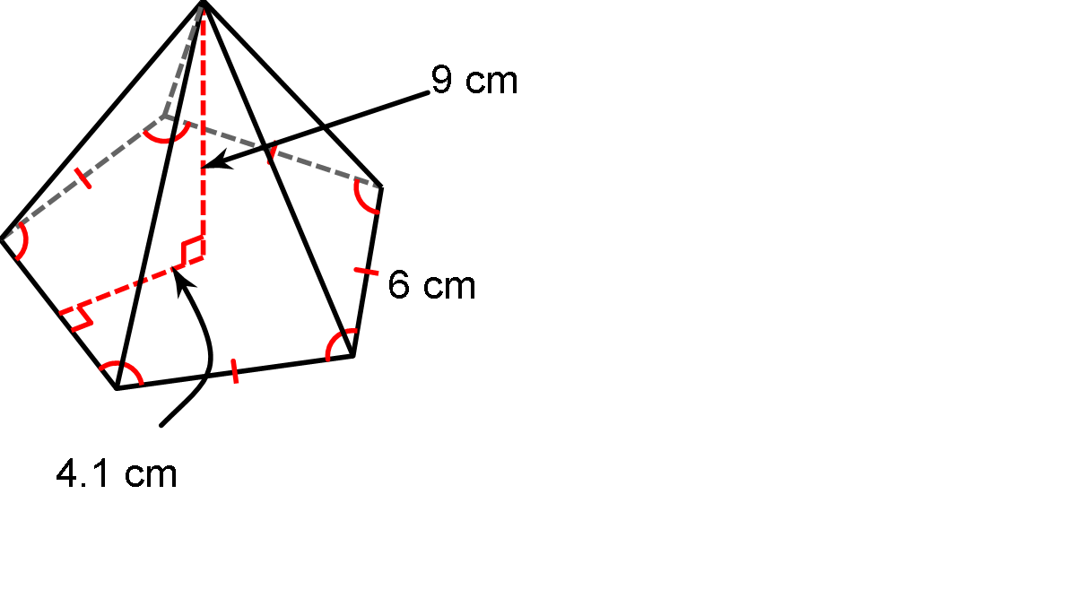Directions: Find the volume for the following pyramid.

4.

V= ____________________

5. Find surface area and volume.

20 cm

20 cm

Find the volume for the following figures.

**Directions:** Find the volume, and surface area of the solid, round to the nearest tenth if needed.

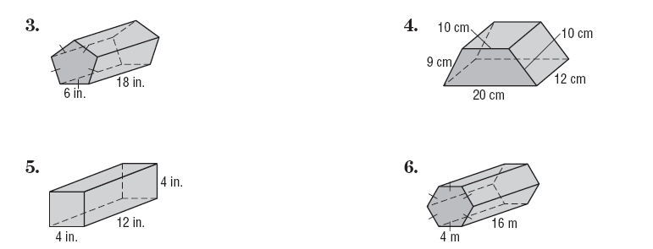

6. 7.

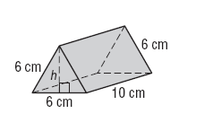



8. 9.

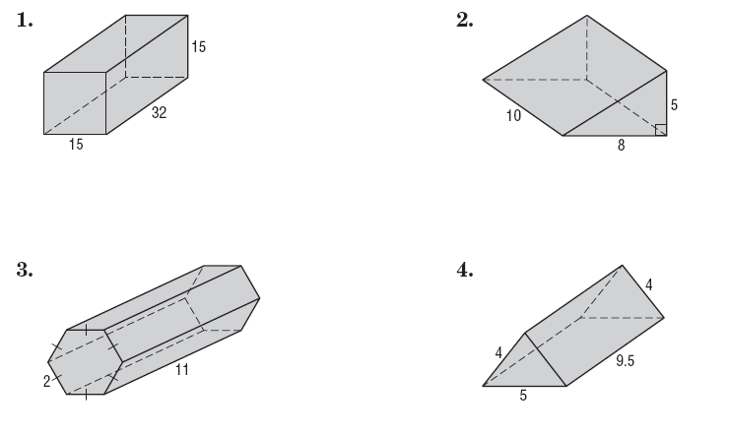



10. 11.

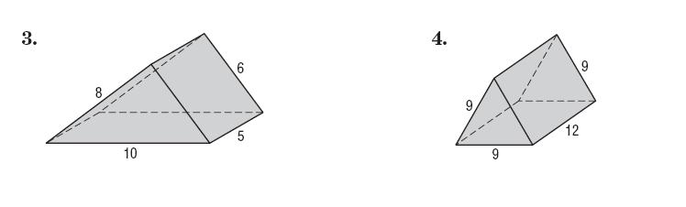

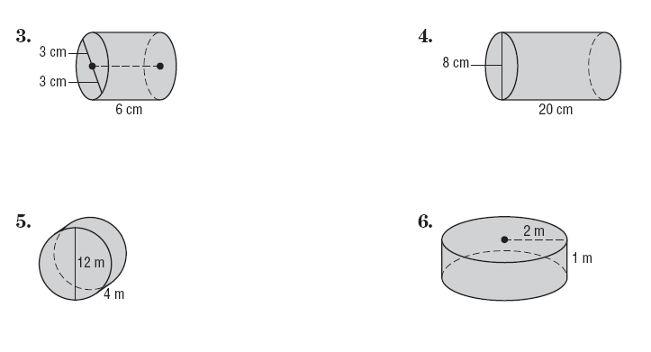

12. 13.

14. 15.



16.

17.



18. 19.



20. 21.



22. 23.

24. Find the expression for the volume of the prism.

7d4w

12d4w3m8

12d4w3m8



25.

26.

27. Susan has a fish tank in the shape of a cylinder that is 26 inches tall. The diameter of the tank is 12 inches. If there are 2 (even) inches of rocks in the bottom, how much water is needed to fill the tank?