Review for Special Rt. Triangle, Geometric Mean, Pythagorean Thm Test

**For each of the pictures below, state what method below you use to find the missing side:   
Geometric Mean, Pythagorean Theorem, 45-45-90 Shortcut, or 30-60-90 Shortcut**

1.______________________________ 2. _____________________________

3. _____________________________ 4. _______________________________

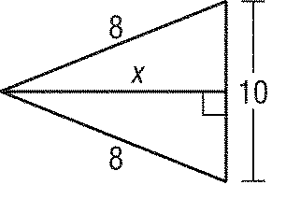

x

5. _______________________________ 6. ___________________________________

**All work must be shown in order to receive full credit. Make sure your calculator is in the correct mode. If it is not stated, round all final answers to the nearest tenth or nearest degree.**

**Multiple Choice**

*Identify the choice that best completes the statement or answers the question.*

____ 7. Find *x*.



|  |  |  |  |
| --- | --- | --- | --- |
| a. |  | c. |  |
| b. | 6 | d. | 5 |
|  |  |  |  |

____ 8. Which set of measures could represent the sides of a right triangle?

|  |  |  |  |
| --- | --- | --- | --- |
| a. | 5, 12, 13 | c. | 7, 17, 24 |
| b. |  | d. | 8, 15, 16 |

____ 9. Find *c*.

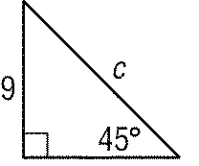

|  |  |  |  |
| --- | --- | --- | --- |
| a. | 18 | c. |  |
| b. |  | d. | 9 |

____ 10. Find the perimeter of a square if the length of its diagonal is 16 millimeters. Round to the nearest tenth.

|  |  |  |  |
| --- | --- | --- | --- |
| a. | 11.3 mm | c. | 90.5 mm |
| b. | 45.3 mm | d. | 128.0 mm |

11. Find the measure of , AB and BC.



12. Find *x, y,* and *z*.

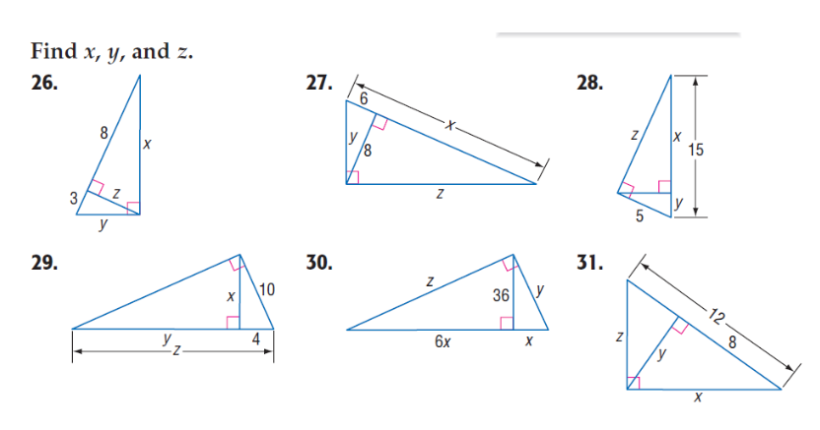

____ 13. Find *x* and *y*.



|  |  |  |  |
| --- | --- | --- | --- |
| a. |  | c. |  |
| b. |  | d. |  |

____ 14. Find *x* and *y*.



|  |  |  |  |
| --- | --- | --- | --- |
| a. |  | c. |  |
| b. |  | d. |  |

____ 15. Find *x* and *y*.



|  |  |  |  |
| --- | --- | --- | --- |
| a. |  | c. |  |
| b. |  | d. |  |

16. Find *x, y,* and *z.*

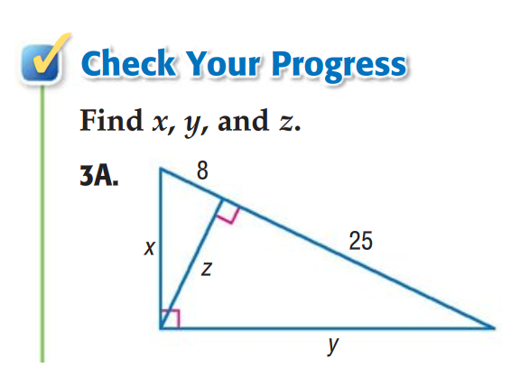

____ 17. Which set of measures could represent the sides of a right triangle?

|  |  |  |  |
| --- | --- | --- | --- |
| a. | 8, 10, 12 | c. | 9, 12, 15 |
| b. | 2, 3, 4 | d. | 7, 11, 14 |

____ 18. Find *x* and *y*.



|  |  |  |  |
| --- | --- | --- | --- |
| a. |  | c. |  |
| b. |  | d. |  |

____ 19. Find the length of the hypotenuse of a right triangle with legs that measure 5 and 7.

|  |  |  |  |
| --- | --- | --- | --- |
| a. |  | c. |  |
| b. |  | d. | 12 |

20. Find the missing side. Check to see what method to use first!!

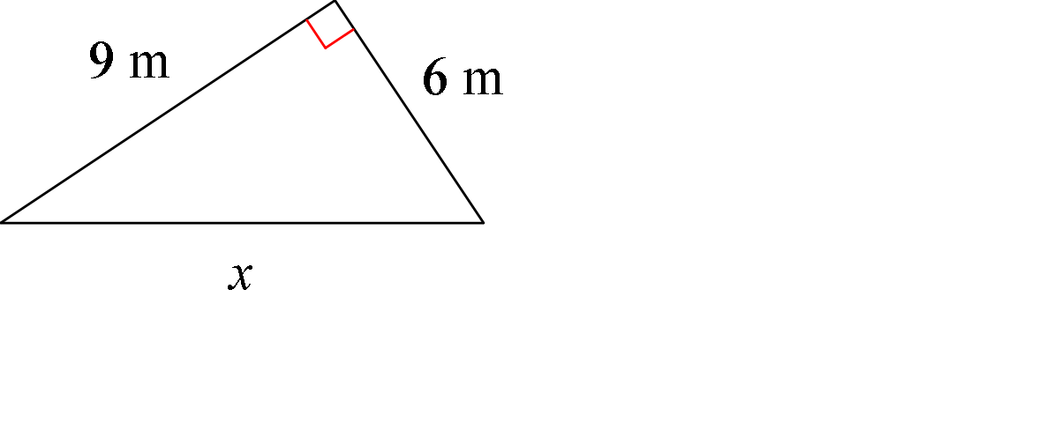

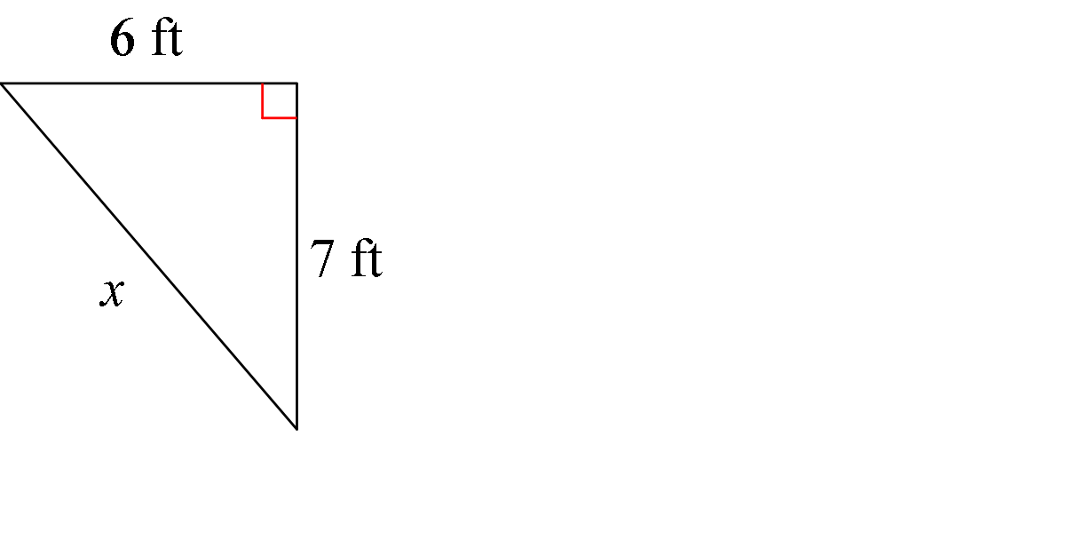

a. b.

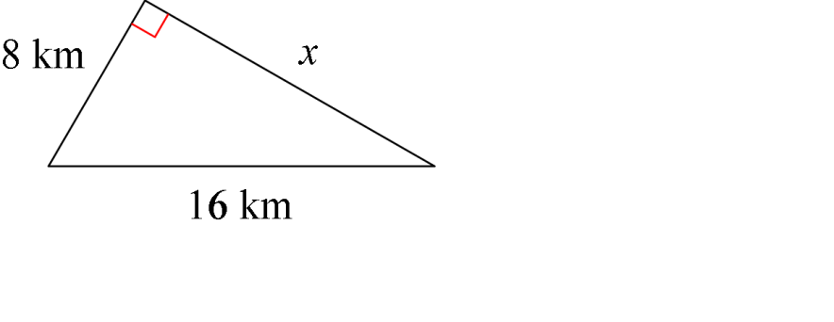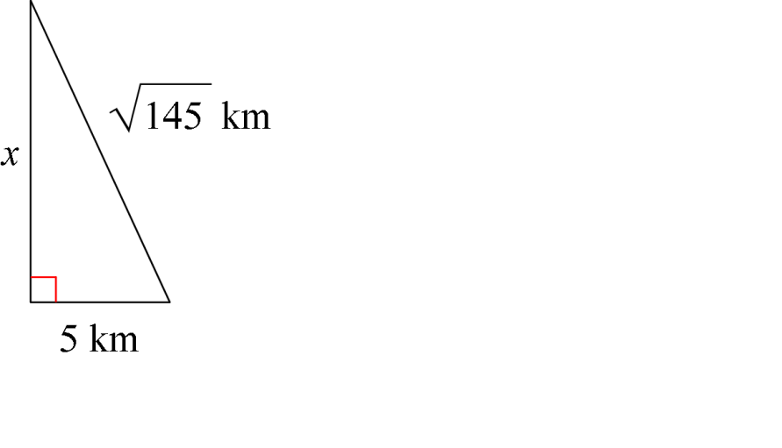

c.

d.

21. Determine whether *ABC* is a right triangle. Explain your answer.

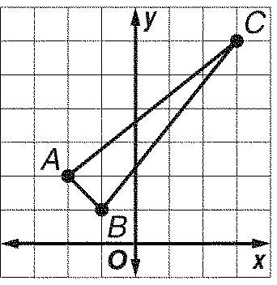

.

22. Find *x* and *y*.

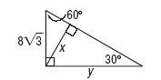

23. A photographer positioned the camera at *C* to take the picture of a beach front. *A* and *B* represents the position of two palm trees on the beach. The camera is positioned such that the two palm trees are just inside the edges of the photograph. Find the value of *x.*



24. In the figure below, find the value of *x, y ,*and *z*.



Name:____________________________

Pythagorean Theorem Date:_____________Hour:___________

Geometric Mean

Special Right Triangles

Plan of Attach Review

For each problem,

1) identify which KIND of problem it is from the list of 3 above in the title,

2) explain how you know which KIND,

3) solve for the unknown side(s) indicated.

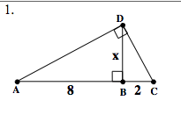

2. If AB = 14, find AC.



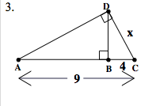

4.

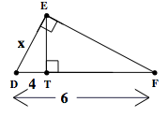

5.

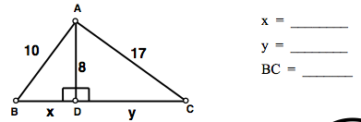

6. If CB = 10, find AB.



7.

