Rhombi Homework

**1. Fill in the blanks: Properties of Rhombi**

* Opposite sides of a parallelogram are ________________
* Opposite angles of a parallelogram are __________________
* Consecutive angles of a parallelogram are ______________________
* The sum of the angles of a parallelogram are = __________________
* The diagonals of a parallelogram _________________________
* Diagonals are ___________________ to each other
* Diagonals ______________ the angles

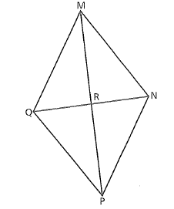

**2.** Use rhombus MNPQ to answer the following questions.

You must state the property you used.

a.) List congruent segments.

b.) List any right angles.

c.) List angle congruent angles.

In the rhombus, find the measure of each angle.

In the rhombus, find the measure of each angle .

3. 4.

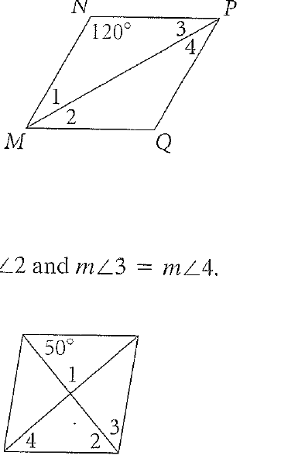



**You must state the property you used for EACH answer!**

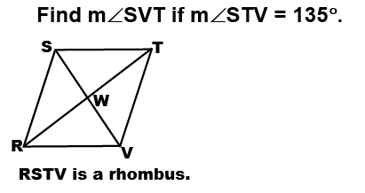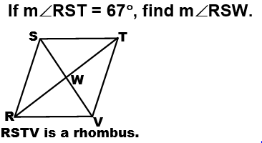5. 6.

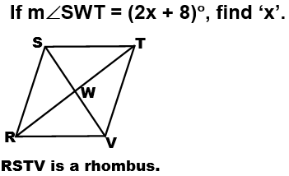

If you are given the following information of RSTV, can it be classified as a rhombus? Why or why not?

ST= 5 $\sqrt{2}$ units VT= 5 $\sqrt{2}$ units

SR= 5 $\sqrt{2}$ units RV= 5

7. 8.

**You must state the property you used for EACH answer!**

Use rhombus PQRS and the given information to find each value.

S

T

P

Q

R

1. If SQ = 24, RP = 10, find SR.
2. If mPRS = 17, find mQRS.
3. Find mSTR.
4. If SP = 4x – 3 and PQ = 18 + x, find the value of x.
5. Determine whether the figure with vertices E(-2,-1), F(-4,3), G(1,5) H(3,1) is a rhombus.