Rhombi Day 2 In Class Practice

Directions: Show all work and justify your work. Failure to do so will result in a zero.

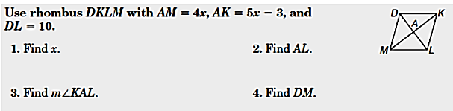***1.*** *Use rhombus DKLM with AM = 4x, AK = 5x – 3, and DL = 10cm.*

*Find x, AL, AM, and use Pythagorean Theorem to find DM.*

**Find x.**

**Geometry: Justification:**

**Find AL.**

**Geometry: Justification:**

**Find AM. Find <MAD.**

**Geometry: Justification: Geometry: Justification:**

**Find DM.**

**Geometry: Justification:**

***2.*** *Use rhombus RSTV with RS = 5y + 2, ST = 3y + 6, NV = 6, <STN = 30 and <RVT =120.*

*Find y, TV, m<NTV, <SVT, <RST, and <SRV.*

**Find y.**

**Geometry: Justification:**

**Find TV.**

**Geometry: Justification:**

**Find <NTV.**  **Find <SVT.**

**Geometry: Justification: Geometry: Justification:**

**Find <RST.**  **Find <SRV.**

**Geometry: Justification: Geometry: Justification:**

***3.*** *Use rhombus PRYZ with RK = 4y + 1, ZK = 7y – 14, PK = 3x – 1, and YK = 2x + 6.*

*Find x, y, PY, RZ, RY and <YKZ.*

**Find x.**

**Geometry: Justification:**

**Find y.**

**Geometry: Justification:**

**Find PY.**  **Find RZ.**

**Geometry: Justification: Geometry: Justification:**

**Find RY.**  **Find <YKZ.**

**Geometry: Justification: Geometry: Justification:**

**Show all work and follow all instructions. Failure to show work will result in a zero.**

4. Determine whether the figure with vertices E(-2,-1), F(-4,3), G(1,5) H(3,1) is a rhombus.



5. Determine whether the figure with vertices A(0,3), B(-3,0), C(0,-3), and D(3,0) is a rhombus.

