Name: __________________________________________________ HR: _____
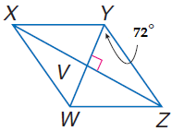
Rhombus Mini Practice Quiz
Use Rhombus WXYZ.

1. Find m<WYX.__________ Because ________________________________

2. Find m<YZX. __________ Because ________________________________

3. Find m<WZX. __________ Because ________________________________

4. Find m<YZW. __________ Because ________________________________

5. If WZ= 19m, find YZ. __________ Because ________________________________

6. What is the definition of a rhombus? __________________________________

___________________________________________________________________

Name: __________________________________________________ HR: _____
Rhombus Mini Practice Quiz
Use Rhombus WXYZ.

1. Find m<WYX.__________ Because ________________________________

2. Find m<YZX. __________ Because ________________________________

3. Find m<WZX. __________ Because ________________________________

4. Find m<YZW. __________ Because ________________________________

5. If WZ= 19m, find YZ. __________ Because ________________________________

6. What is the definition of a rhombus? __________________________________

___________________________________________________________________

