Name: __________________________________________________ Date: _________ Hr: ___________

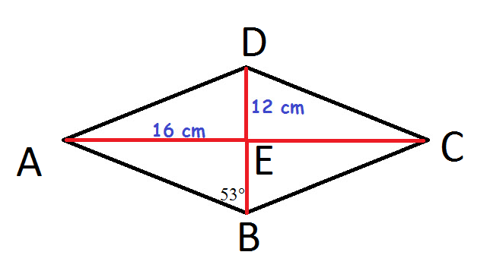
Rhombus Warm-Up
Directions: ABCD is a rhombus. Use your rhombus properties to complete the following. You must show your geometry and justify your work.
- Find m∠CBD.

- Find m∠ABC.

- Find m∠ADC.

- Find m∠AED.

- Find m∠DCB.

- Find m∠BAD.

- Find AD.

- Find the perimeter of ABCD.

7. Determine if ABCD is a rhombus? SHOW ALL WORK and given a mathematical reason why the or why not.
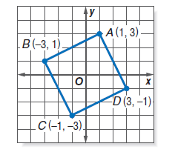

Parallelogram Warm-Up
DEFY is a parallelogram. Show your geometry and justify work.
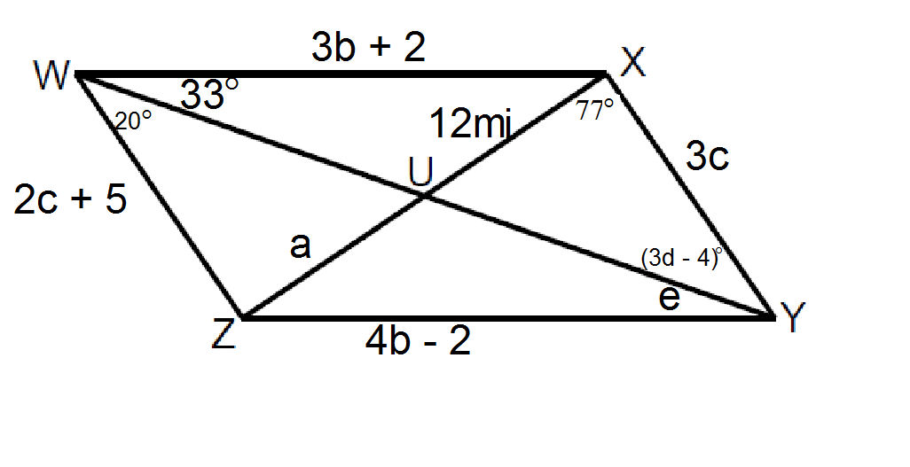

Find a: Find b: Find c:

Find d: Find e: Find XWZ:

Find m∠WZY: Find m∠UZY: Find m∠YUZ:

