Name: ___________________________________________________________

Geometry

**Right Triangle Practice Test**

1. Find x, y, and z. Show all of your work.

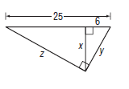

2. Verify whether or a not a triangle with the following sides is a right triangle:  
9, 16

3. Find c. 4. Find a and b. 5. Find a and b.

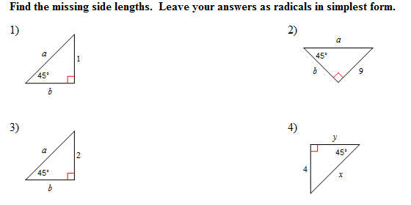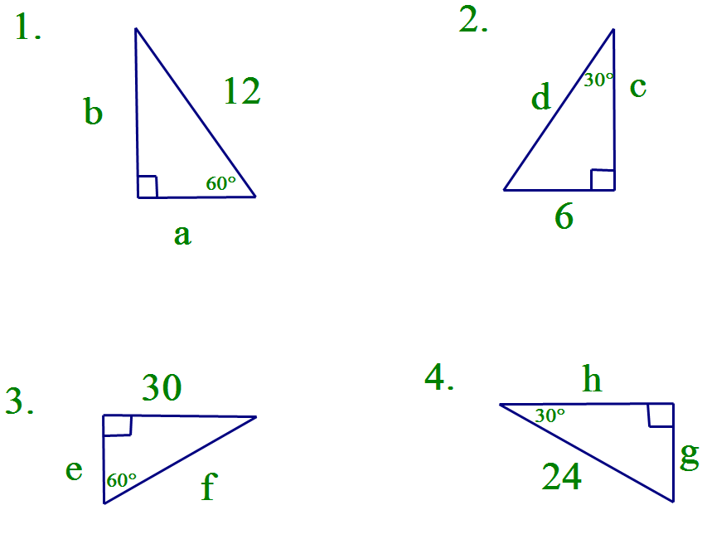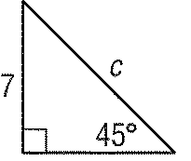

6. If find b, c, x and y.

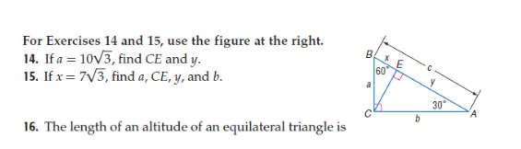

7. The diagonal of a square is 12 in long. What is the measure of each side length?

8. Find x. Simplify your answer.

12

10

x

10

9. Find x. Simplify your answer.

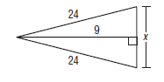

10. Find x, y, and z.