Name:____________________________

Pythagorean Theorem Date:_____________Hour:___________

Geometric Mean

Special Right Triangles

**Plan of Attack Review**

For each problem,

1) identify which KIND of problem it is from the list of 3 above in the title,

2) explain how you know which KIND,

3) solve for the unknown side(s) indicated.

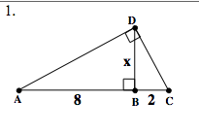

2. If AB = 15, find AC and BC.



Find x

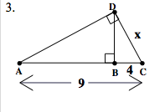

Find x

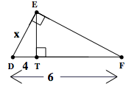

4.

5.

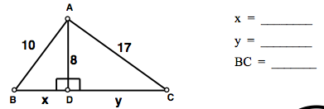

6. If CB = 10, find AB and AC.



7.

