Examples: Basic Surface Area & Volume of
Cylinders, Cones, and Spheres
Cylinders:
Surface Area:  SA = 2πr² + 2πrh | Lateral Area:  LA = 2πrh  NO BASES! | Volume:  V=BH  B = AREA of BASE B= πr²  H= Height connecting two bases.

Cylinder Example1:
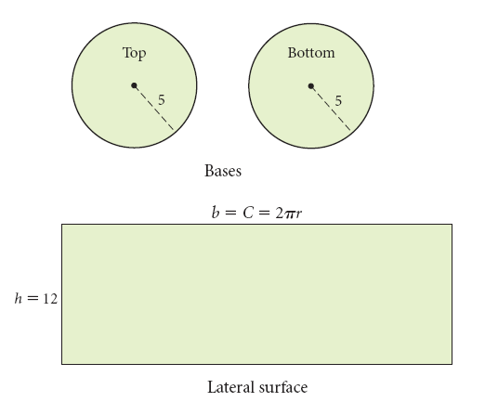
Find the surface area and volume of the cylinder. Keep in terms of pi and round to the nearest thousandth.
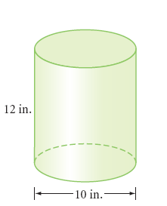

------------------------------------------------------------------------------------------
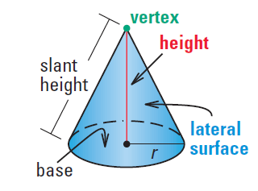
Cones:

Surface Area:  SA= ${πr}^{2}+πrl$ | Lateral Area:  LA= $πrl$ | Volume:  $$V=\frac{1}{3}BH$$  B = AREA of BASE B= πr²  H= Height perpendicular to the base.

Find the volume (round to the nearest thousandth) and surface area (keep in terms of pi) of the solid.
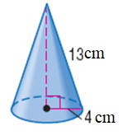
Cone Example 2:
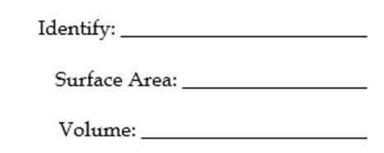

exact

rounded

Surface Area:  SA = 4πr² | Volume:  V = $\frac{4}{3}$πr³
Spheres
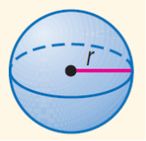

Find the volume and surface area of the sphere. Keep in terms of pi.
Sphere Example 3:
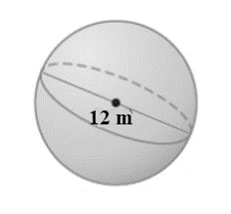

In Class Practice:
Directions: Identify each figure, find the surface area and volume of the following figures. You must write the formula you used first. Keep all answers in terms of pi, then show the rounded value to the nearest thousandth.
1.
Identify: ________________________

Surface Area: __________________

Volume: ______________________

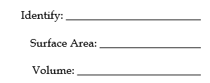
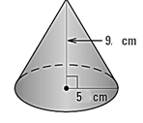
2.

rounded

exact
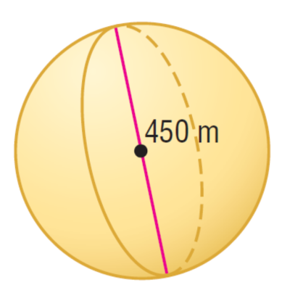

3.

