Name: _________________________________________________________
HW: Composites and Applications:
Surface Area & Volume of Cylinders, Cones, and Spheres

Directions: Identify any figures used, find the surface area and/or volume of the following figures. You must write the formulas you used first. Keep all answers in terms of pi, then show the rounded value to the nearest thousandth.

1. Mr. Ganty built a conical storage shed. The base of the shed is 4 meters in diameter, and the height of the shed is 3 meters. What is the volume of the shed?

2. This lampshade is a cylinder of height 18 inches and has a diameter of 6inches. If the lampshade is open at the top and bottom, what is the amount of material needed to cover the lampshade?

3. The largest beverage can was displayed in Taiwan in 2002. The “pop” can was 5meters tall and had a diameter of 3 meters. How much pop can be filled into the can?

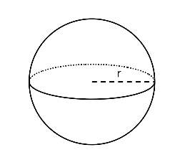
4. Suppose a paper cone is 5 inches tall and the radius of the base is 3 inches. A spherical scoop of snow cone ice is placed on top of the cone. If all the ice melts into the cone will the cone over flow?

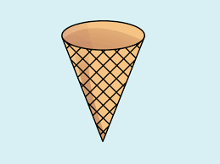

Directions: Identify any figures used, find the surface area and/or volume of the following figures. You must write the formulas you used first. Keep all answers in terms of pi, then show the rounded value to the nearest thousandth.

5. Find the surface area.
Top: ________________________
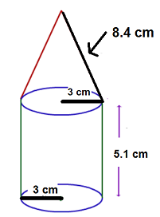
Bottom: ________________________

Surface Area: __________________

6. Find the surface area and volume.
Top: ________________________
Bottom: ________________________

Surface Area: __________________

Volume: __________________

7. Find the surface area and volume.
Top: ________________________

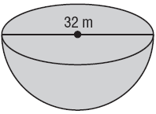
Bottom: ________________________

Surface Area: __________________

Volume: __________________

