Name: _____________________________________________Hour: _______
Basic Surface Area and Volume of CONES
Homework
Find the volume and surface area of the solid. Round to the nearest tenth.
1.

2.

3.

4.

5.

6. Find the surface area and volume of the composite solid.
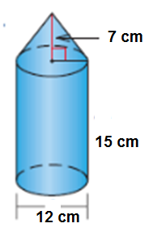

7. Find the surface area of the composite solid.
