Name: _______________________________________________________Hour: ___________________
Basic Surface Area and Volume of Cylinders Homework
Directions: Find the volume and surface area of the solid, round to the nearest tenth if needed.

1.

2.

3.

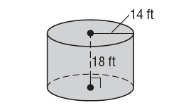
4. Find the radius of the cylinder below if the volume is 75.4 in³
6 in

5. Find the diameter of a cylinder whose volume is 75π cm³ and its height is 5 cm.

6. Find the height of a cylinder whose volume is 785.4 in³ and its radius is 5 inches.

