Name: _________________________________________________________ Hour: _______
Surface Area and Volume of Prisms - HW

Directions: Find the surface area and volume of the following figures.

1.

2.

3.

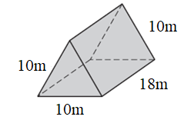
4.

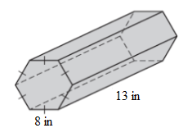
5.

