Basic Surface Area and Volume of Prisms - Notes

A right prism is a 3D solid made from two congruent bases with rectangular faces.
Surface Area:  Add up all of the faces and bases | Volume:  V=area of base x height  AREA of BASE  H= Height connecting two bases.

1. Name the figure, then find the volume and surface area of the prism.

2. Name the figure, then find the volume, lateral area and surface area of the prism. Hint: find the missing edge 1st.

3. Name the figure, then find the volume and surface area of the prism.
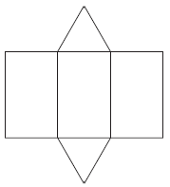

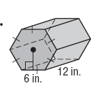
4. Name the figure, then find the volume and surface area of the prism. 6 in = side length.

Name: _________________________________________________________________________
Basic Surface Area and Volume of Prisms In Class Practice
1. Find the surface area of the prism.

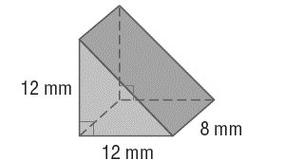
2. Find the surface area of the prism. Hint: find the missing edge 1st.

Turn the page!!!
3. Find the surface area of the prism.

4. Find the volume.

