Name: _____________________________________________Hour: _______
Basic Surface Area and Volume of Pyramids
Homework
Find the volume and surface area of the solid. Round to the nearest thousandth if it states to round.
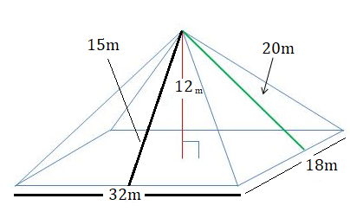
1.

2.
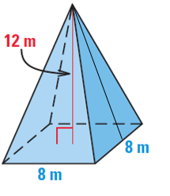

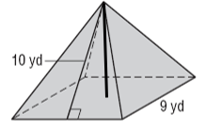
3.

4. Find the volume. Assume the base is a regular polygon.
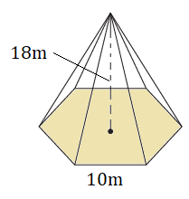

V = ____________________

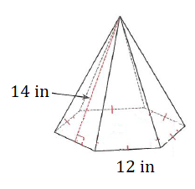
5. Find the surface area. Assume the base is a regular polygon.

SA = ___________________

7. Review: Find the surface area and volume of the prism.
