Name: _____________________________________________Hour: _______
Basic Surface Area and Volume of Pyramids
Homework 2017
Find the volume and/or surface area of the solid. Round to the nearest tenth.
1.

2.

3.

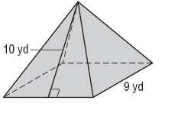
4.

Directions: Find the volume. Round to the nearest tenth if needed.
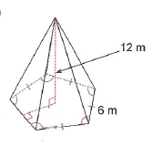
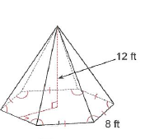
5. 6.

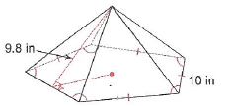
Directions: Find the surface area. Round to the nearest tenth if needed.
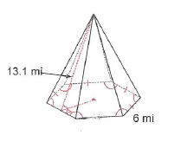
7. 8.

