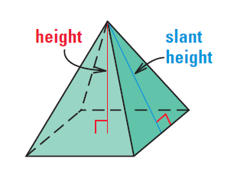
Basic Surface Area and Volume of Pyramids Notes
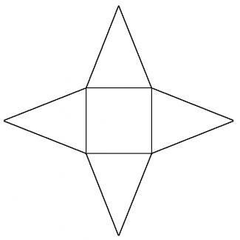
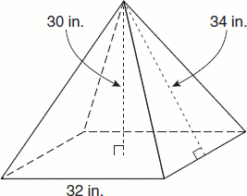

Surface Area:  Add up all of the triangular faces and the base! | Lateral Area:  Add up all of the triangular faces | Volume:  $$V=\frac{1}{3}\left(area of base\right) x H$$  H= Height perpendicular to the base.

Find the volume and surface area of the square pyramid. Round to the nearest thousandth.
1. Area of the BASE:

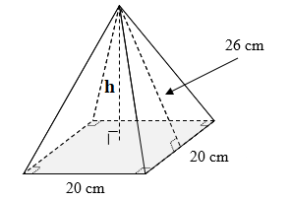
2.

3. Find the volume and surface area of the rectangular pyramid.
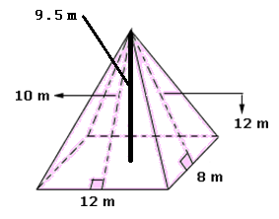

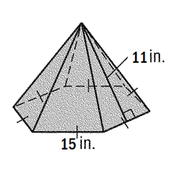
4. Find the surface area of the hexagonal pyramid. Assume the base is a regular polygon.

5. Find the volume of the hexagonal pyramid. Assume the base is a regular polygon.
