Surface Area of Cylinders and Cones
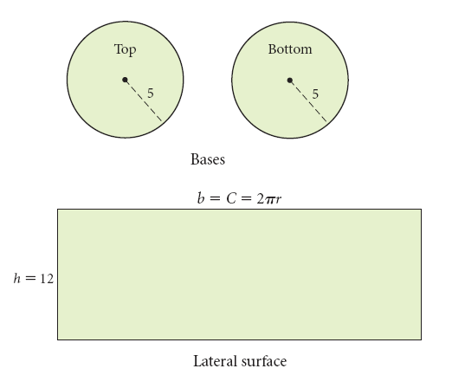
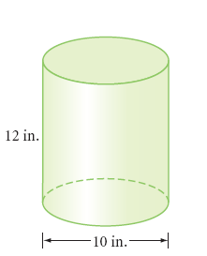

SA=

Cones:

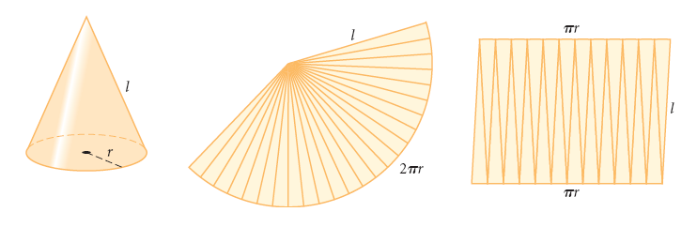

SA=

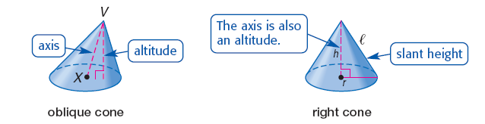

Find the lateral area and surface area of the following solids.

Example1: Example 2:
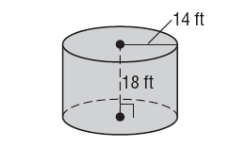
Find the radius of the base of a right cylinder if SA=528ft² and height is 10ft.

Example 3: Example 4:
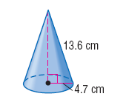
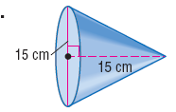

Surface Area of Cylinders and Cones (and others) Homework!
Find the surface area. Round to the nearest tenth if needed.
1. 2.

3. 4.

5.

3. 4.

5. 6.

8. 9. Find the surface area of the treasure chest.

10.

