Segment Relationships: Class Work
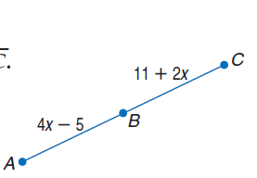
1. Find the measure of $\overline{BC}$ if B is the midpoint of $\overline{AC}$.

Find the value of the variable and ST if S is between R and T. Justify your steps.

2. $RS=7a, ST=12a, RT=76$

3. $RS=12, ST=2x, RT=34$

4. $RS=4y-1, ST=2y-1, RT=5y$

Find the value of the variable and BC if B is between A and C. Justify your steps.

5. AB = 6x, BC = 2x, AC = 96

6. AB = 21, BC = 3a, AC = 36

7. AB = 6y + 2, BC = 2y - 6, AC = 3y

