Name: __________________________________________________________________________ Hr. _________

Segment Relationships and Review Notes

Directions: You must show the geometry and justify each step.

1. Find the value of the variable and the length of GH if G is between P and H.
PG= 3x + 2, GH= 5x – 6, PH= 7x
Draw the picture:

Geometry: Justification:

2. M is the midpoint of EK. Find the value of X and the length of EK.
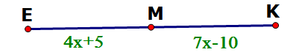

Geometry: Justification:

Directions: Use the Pythagorean Theorem or Distance Formula to find the distance of each segment, and then find the midpoint of each segment and slope. You must simplify radicals and fractions!!!! You must show all work for each problem.

3. A(-4,2), B(8,-6) Distance: __________
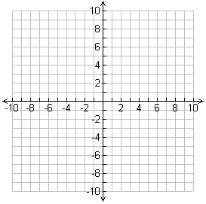
Midpoint:___________

Slope: _________

4. Find the coordinates of D if M(-6,4) is the midpoint of DF and F(-5,-3). You must show all work, from start to finish.

Directions: DRAW and LABEL a figure for each relationship.

5. $<RST$ with $\vec{SH} as an angle bisector$

6. $\overline{LK}⊥\overset{⃡}{MN}$

7. $\overline{RT}≅\overline{SP}$

8. $\overset{⃡}{UR} is a segment bisector to \overline{TP}$

9. <XYZ and <XYW are linear pairs.

Name: __________________________________________________________________________ Hr. _________

Segment Relationships and Review HW
1. Find the value of the variable and the length of GH if G is between P and H.
PG= 2x – 4, GH= 7x + 1 PH= 8x

Draw the figure:

Geometry: Justification:

2. M is the midpoint of EK. Find the value of X and the length of EK.
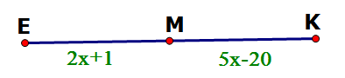

Geometry: Justification:

3. Directions: Use the Pythagorean Theorem or Distance Formula to find the distance of each segment, and then find the midpoint of each segment and slope. You must simplify radicals and fractions!!!! You must show all work for each problem.

A(6,-2), B(4,-10) Distance: __________
Midpoint:___________

Slope: _________

4. Find the coordinates of D if M(-1,6) is the midpoint of DF and F(2,9). You must show all work, from start to finish. You will be graded on your set up and how you solve algebraically.

Directions: DRAW and LABEL a figure for each relationship.

5. $<SRT$ with $\vec{RH} as an angle bisector$

6. $\overset{⃡}{MN} is a segment bisector of \overline{TP}$

7. $\overline{AB}≅\overline{FR}$

8. $\overset{⃡}{FR}⊥\overset{⃡}{EB}$

9. <JCK and <KCL are linear pairs.

