Geometry Name___________________
Segment Relationships: Basics Date:__________HR :____

1. Describe the figure as a point, line, segment, or ray.
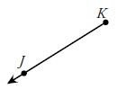
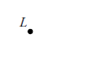
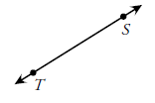
a. b. c. d.

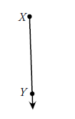
e. f. g. h.

2. RS TU, ST = 14, RU = 46
R
S
T

U
B
C
U
T
U
*the figure is not drawn to scale*

a) Find RS b) Find SU.

3. Find ST 4. Find ZY.
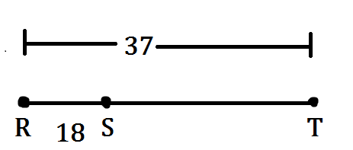
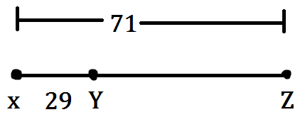

Refer to the figure and the given information to find each measure.

5. Given : AC = 38 m 6. Given the figure and DG = 27 ft .
C
.
A
B
5x-4
8x - 10
D
O
G
2x+3
3x - 1

x = _______ AB = ______BC = ______
x = _______ DO = ______OG = ______

7. B is the midpoint of AC.
A
B
C
25 m
x

x = _________ AB = _________ BC = _________ AC = _________

8. B is the midpoint of AC.
A
B
C
4x-12
-2x+21

x = _________ AB = _________ BC = _________ AC = _________

9. Find x and the measure of $\overline{JK}$if K is the midpoint of $\overline{JL}$. Show work.

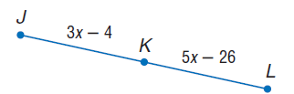
x = ____________

JL = ___________

10. Find x and the measure of $\overline{JK}$if K is the midpoint of $\overline{JL}$. Show work.

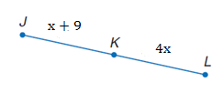
x = ____________

JL = ___________

