Name: _______________________________________________________ HOUR: _______

Segments Graded Assignment HW#1

Directions: Show your geometry and justification for #1-

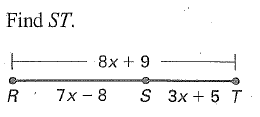

1.

x = ___________________

ST = __________________

2. KM = 58, Kl = 3x2 – 7x – 3, LM = x2 + 5x – 29, find LM.

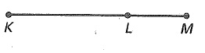



x = ___________________

LM = __________________

**Midpoints with Algebra: In each diagram, M is the midpoint of the segment. Find the indicated length.**

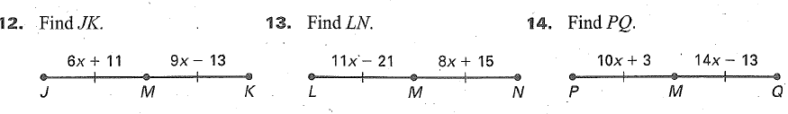

3.

x = ___________________

JK = __________________

4. Point M is the midpoint of segment AB. AM = ${3x}^{2}-6x-12$ and MB = $x^{2}-3x+8$. Find x and AB.

x = ___________________

AB = __________________

REVIEW:

Find the slope, distance, and midpoint for the following segments.

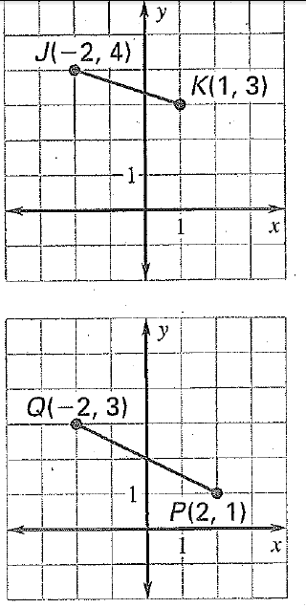

5.

Slope ___________________

Distance ________________

Midpoint __________________

**6. Directions:** Solve for x.

Show your work:

x = ____________

**Directions:** Identify each pair of angles as adjacent, vertical, complementary, supplementary, or a linear pair. Circle **ALL** terms that apply.

**7. 8.**

**Adjacent Adjacent**

**Vertical Vertical**

**Complementary Complementary**

**Supplementary Supplementary**

**Linear Pair Linear Pair**

**9. 10.**

****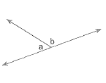 **Adjacent Adjacent**

**Vertical Vertical**

**Complementary Complementary**

**Supplementary Supplementary**

**Linear Pair Linear Pair**

**11. 12.**



**Adjacent Adjacent**

**Vertical Vertical**

**Complementary Complementary**

**Supplementary Supplementary**

**Linear Pair Linear Pair**

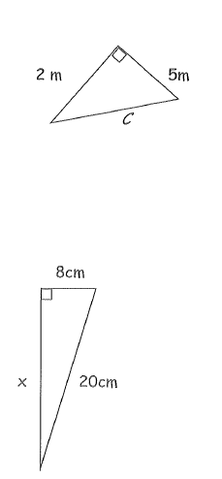Directions. Find the variable.

****13. 14.

c = _________________ x = _____________________

Drawing Figures:

15. <1 and <2 are linear pairs. 16. <3 and <4 are vertical angles.

17. is and angle bisector of < WXZ.