Segments Review Day 2- In Class
Directions: Use the number line for questions 1-3 to determine lengths of segments.
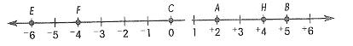

1. $\overline{AB}$ 2. $\overline{EC}$ 3. $\overline{FH}$

Find the value of x in each diagram.

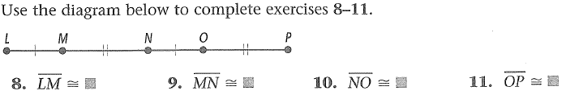

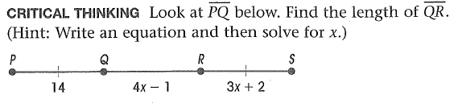
12.

Midpoint Examples:
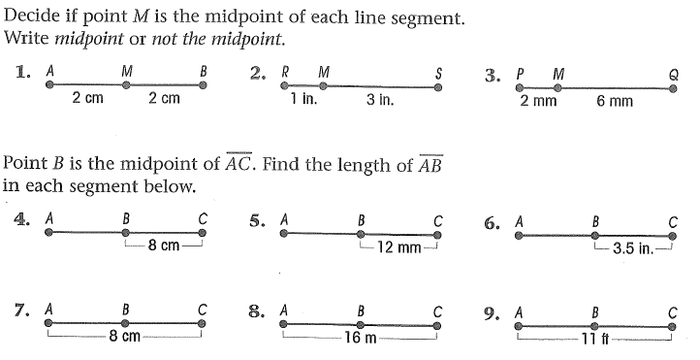

Midpoints with Algebra: In each diagram, M is the midpoint of the segment. Find the indicated length.
10. 11. 12.

Segment Addition with Algebra: Find x and the indicated lengths.
13. 14. 15.

Name: _______________________________________________________ HOUR: _______
Segments Review Day 2- HW
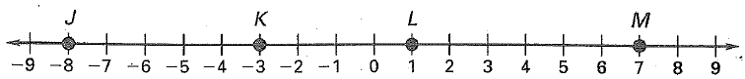
Directions: Use the number line for questions 1-3 to determine lengths of segments.

1. $\overline{KM}$ = 2. $\overline{JM}$ = 3. $\overline{LK}$=

4. Find x. 5. List the pairs of congruent segments.
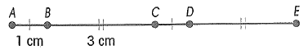

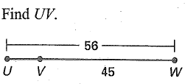
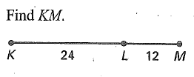
6. 7.

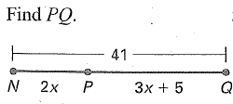
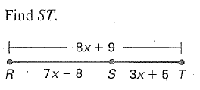
8. 9.

Midpoints with Algebra: In each diagram, M is the midpoint of the segment. Find the indicated length.
10. 11.

REVIEW:
Find the slope distance and midpoint for the following segments.
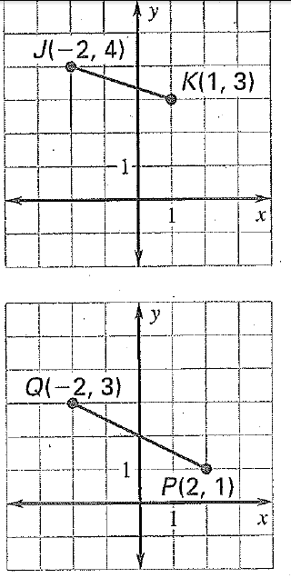
12. 13.

Drawing Figures:
14. <1 and <2 are linear pairs. 15. <3 and <4 are vertical angles.

16. $\vec{XY}$is and angle bisector of < WXZ. 17. l $∥m$ and l $and m are$ $⊥to n.$

