Name: _______________________________________________________ HOUR: _______
Segments Review Day 2- HW
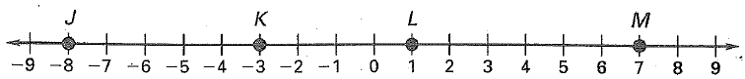
Directions: Use the number line for questions 1-3 to determine lengths of segments.

1. $\overline{KM}$ = 2. $\overline{JM}$ = 3. $\overline{LK}$=

4. Find x. 5. List the pairs of congruent segments.
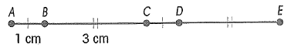

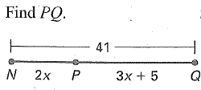
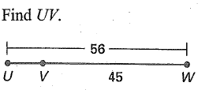
6. 7.

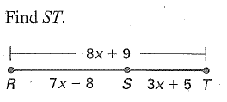
8.

9. KM = 58, Kl = 3x² – 7x – 3, LM = x² + 5x – 29, find LM.

Midpoints with Algebra: In each diagram, M is the midpoint of the segment. Find the indicated length.
10. 11.

12. Point M is the midpoint of segment AB. AM = -2x² – 9 - 1 and MB = 12x² + 5 – 5. Find x and AB.

REVIEW:
Find the slope distance and midpoint for the following segments.
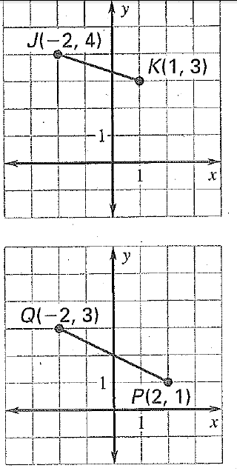
13. 14.

Drawing Figures:
15. <1 and <2 are linear pairs. 16. <3 and <4 are vertical angles.

17. $\vec{XY}$is and angle bisector of < WXZ. 18. l $∥m$ and l $and m are$ $⊥to n.$

