Similarity Notes
Directions: Watch this video: http://www.youtube.com/watch?v=1O-ieOZ5y6s&feature=related and fill out the notes below. It will go through the examples with you. (Note: the o’s are letters and not zeros in the above link!)

What are similar figures?

__________________________________________________________________________________________________

__________________________________________________________________________________________________

The notation for similar is like a congruence symbol but without the =. ΔABC ~ΔXYZ reads triangle ABC is similar to triangle XYZ
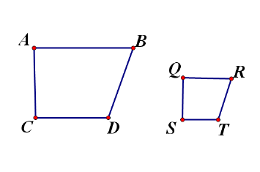
Side _____ corresponds to side _____

Side _____ corresponds to side _____

Side _____ corresponds to side _____

Side _____ corresponds to side _____

Set up the corresponding sides as a ratio:

Their ratios form proportions. We use the proportions to state two equal ratios. When we talk about the ratios above we call them side length ratios or scale factor.

COMMON ERROR!!!!!! (write the common error below)

In addition to the sides being proportional, the corresponding angles _________________________________.

That means m< _______ = m< __________

That means m< _______ = m< __________

That means m< _______ = m< __________

That means m< _______ = m< __________
Example #1A
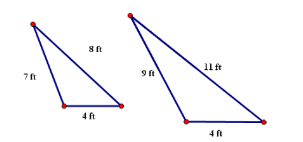
Set up side length ratios (scale factors) for each side length. Simplify each fraction.

Are they similar? Why or why not? _______________________________________

.
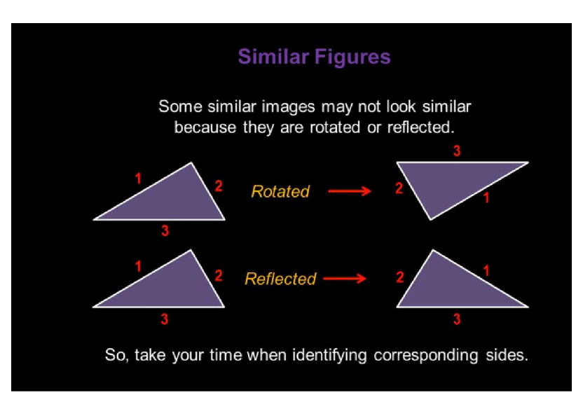

Example #1B
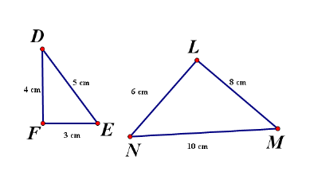
Which sides are corresponding? Set up the scale factors (ratios) Must show the geometry AND the number ratios:

Are the triangles similar? Why or why not?

________________________________________________________________________________
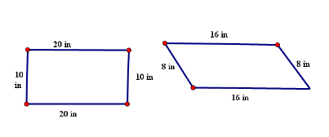

Show the sides are proportional, but these figures are not similar because

_________________________________ ___.

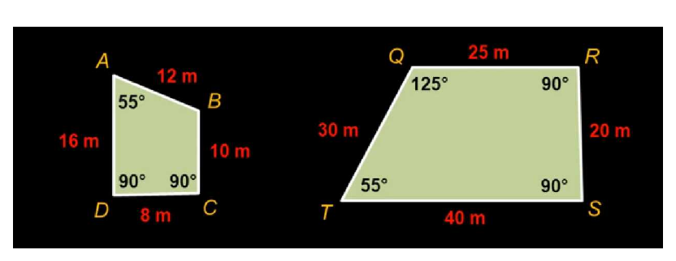
Example 2

< _____ corresponds to < _____ and both are ________

< _____ corresponds to < _____ and both are ________

< _____ corresponds to < _____ and both are ________

< _____ corresponds to < _____ and both are ________

Set up ratios for corresponding sides- Must show the geometry AND the number ratios!:

Are the two figures similar? Why or why not? ________________________________________________________________________________
________________________________________________________________________________________________________________________________________________________________.

