**Simplifying Radicals**

**Daily Questions:** Find the first 15 perfect squares.

12= 1 62= 36 112= 121

22= 4 72= 49 122= 144

32= 9 82= 64 132= 169

42= 16 92= 81 142= 196

52= 25 102= 100 152= 225

**1**. Simplify the following radicals. Use the progress boxes to check off each step as you complete it.

 Find a perfect square that divides into the given radical evenly. (bigger the better)

 Separate the radicand into the  product of the two numbers

 Give each of the numbers its own radical sign

 Simplify the perfect square 

 Can the new root be reduced? 

1. $\sqrt{20}$ b)

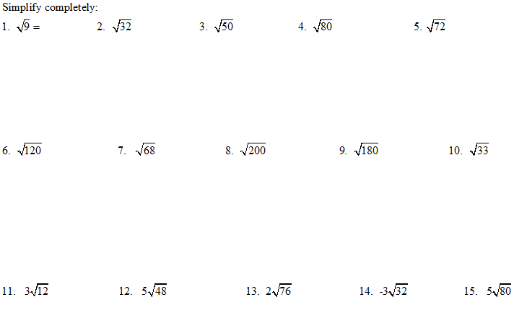

 Separate the fraction into two parts. 

 Multiply both parts by the radical in the 

denominator.

 Simplify the radical on top if possible. 

 Simplify the entire fraction. 

c) $\sqrt{\frac{5}{2}}$ d) $\frac{3}{\sqrt{8}}$

e) $2\sqrt{3}∙4\sqrt{6}$ f) $\sqrt{\frac{2}{3}}∙\sqrt{\frac{5}{6}}$

More Advanced Practice

1. 2. 3.

4. 5. 6.

7. 8. 9.

10. 11.

12. 13.

14. 15.

16. 17.

18. 19.

20.