Sketching Angles (in Degree) Notes

Angles of rotation are formed in the coordinate plane between an initial ray & terminal ray.
The positive x-axis represents ____º and each quadrant will represent increments of 90º.
To sketch a positive angle measure rotate ______________________ and for a
negative angle measure rotate ____________________.
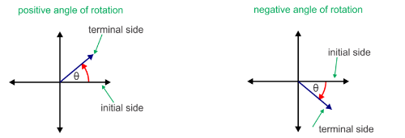

$-$270º
90º
QI
QII
QII
QI

$-$180º
0º /$-$360º
0º /360º
180º

QIV
QIII
$-$90º
270º
QIV
QIII

**You will need to be able to quickly identify which quadrant the angle lies in**

Examples: Sketch the angles & identify which quadrant the angle is located in.

1. 220° 2. 150° 3. -150°

4. 225° 5. -225° 6. 330°

Reference Angles

The reference angle is the acute angle formed by the terminal side of the angle and the ______________.The reference angle is always ____________.

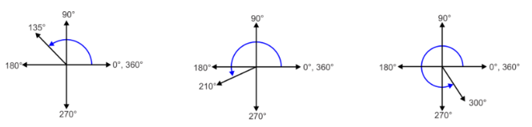
Examples: Find the reference angle of the angles sketched below.
9.
8.
7.

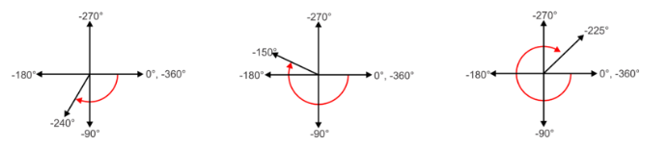
12.
11.
10.

Putting it together ** ultimate goal is to be able to do this without a sketch**
Directions: Determine what quadrant the angle is located, then find the reference angle.
13. 300° 14. 150° 15. -135° 16. -200°

Quad: Quad: Quad: Quad:
R.A. : R.A. : R.A. : R.A. :

