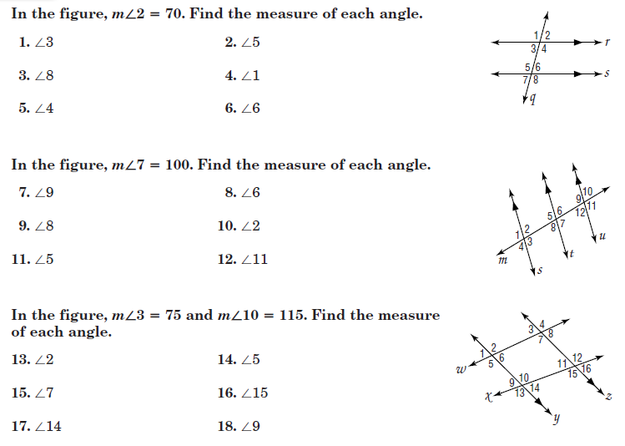
Special Angles and Parallel Lines HW

19.

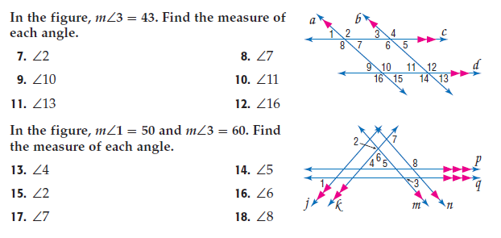
This is out of the book so you don’t have to bring it home… You’re welcome!

19.
2.

Slope MN: ____ Slope MN: ____

Slope RS: _____ Slope RS: _____
20.) Write the equation of a line in slope intercept form which pass through the points A(5.1) and B(8,-2)

21.) Write the equation of a line in slope intercept form which pass through the points A(-5,-2) and B(-8,-2)

22.) Write the equation of a line in slope intercept form which is parallel to
$y=-\frac{1}{2}x-6$ and passes through the point (-3,2).

23.) Write the equation of a line in slope intercept form which is parallel to
$y=-2x-7$ and passes through the point (-1,-2).

24.) Write the equation of a line in slope intercept form which is perpendicular to $2x+y=5$ and passes through the point (2,-2).

25.) Write the equation of a line in slope intercept form which is perpendicular to $-\frac{2}{3}x-y=15$ and passes through the point (0,-15).
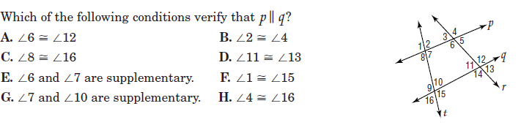
26.)

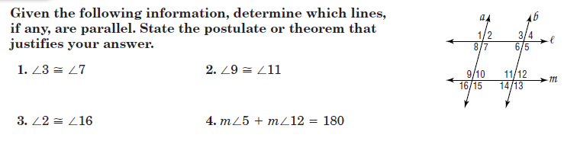
From Workbook: 3.5 Skills Practice

From Workbook: 6.5 Practice
