ACC Geometry
Sphere Practice:

1. A ball has a circumference of 24 in. Find the surface area, rounded to the nearest tenth.

2. Find the surface area of a hemisphere with a radius of 3.8 in and round to the nearest tenth

3. Suppose the surface area of a sphere is 64π square feet. Find the radius and volume of this sphere.

4. The volume of a sphere is 288π cubic centimeters. What are the radius and surface area?

Find the surface area and volume of the following. Use exact values and rounded to the nearest tenth.
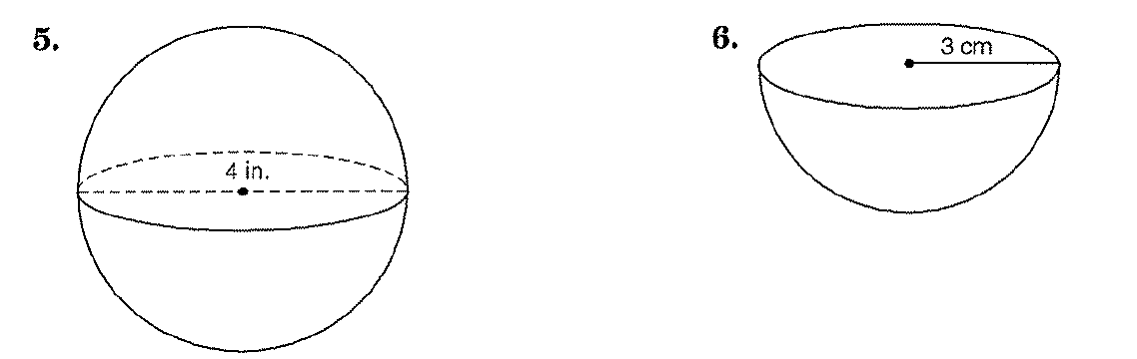

Find the surface area of the following. Use exact values and rounded to the nearest tenth.

