Square Homework
- Opposite sides of a parallelogram are ________________
- Opposite angles of a parallelogram are __________________
- Consecutive angles of a parallelogram are ______________________
- The sum of the angles of a parallelogram are = __________________
- The diagonals of a parallelogram _________________________
- Diagonals are ___________________ to each other
- Diagonals ______________ the angles
- Diagonals are __________________

1.

2.

ABCD is a SQUARE for each of the following.

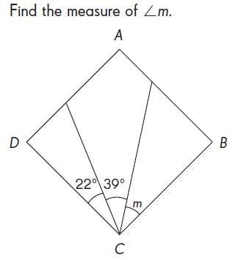
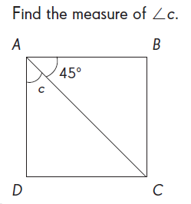
3. Find the missing side. 4. 5.
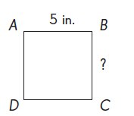

6.

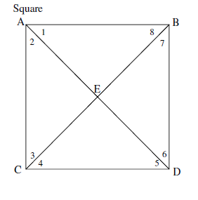
7. Use square ABDC.

a. If AB= 2x + 5 and BD = 5x – 20, find x.

b. Find the measures of the numbered angles.

You must show all of your work on graph paper for the following.

8. Determine whether the figure with vertices A(0,3), B(-3,0), C(0,-3), and D(3,0) is a square.

9. Determine whether the figure with vertices A(-4,0), B(-3,3), C(2,2), and D(1,-1) is a square.

