Surface Area and Working Backwards- ACC Warm Up
Directions: complete the following review questions.

1. The surface area of a cone is 261 km². The cone has a diameter of 18 km. Find the slant height of the cone.

2. The surface area of the trapezoidal prism is 768 mi². Find the missing length below.

h

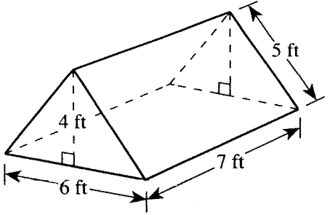
3. The bottomless tent illustrated below is in the shape of a right triangular prism and is made of nylon. How many square feet of nylon is required for the front, rear, and $2$ sides of the tent? (Note: Please ignore the extra nylon for seams.)

4. Find the radius of the base of a right cylinder if SA=528ft² and height is 10ft. (Factor)

5. Find the surface area of this hemisphere as an exact value and to the nearest tenth.

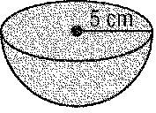

6. Find the surface area of the Right Triangular Prism below.

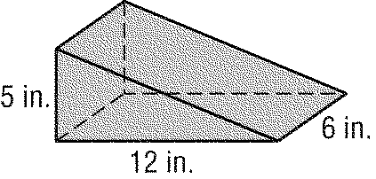
7. The surface area of a sphere is 64π square centimeters. Find the radius.

8. The surface area of a right cylinder is 200π square centimeters and the radius is 4 centimeters. Find the height of the cylinder.

9. The lateral area of a cube is 36 square inches. How long is each edge?

10. The radius of a right circular cone is 6 inches and the height is 8 inches. Find the slant height of the cone.

11. The lateral area of a square pyramid is 300 square units. The perimeter of its base is 100 units. Find the slant height of the pyramid.

12. The area of each face of a cube is 60 square centimeters. Find the surface area of the cube.

13. Find the surface area.
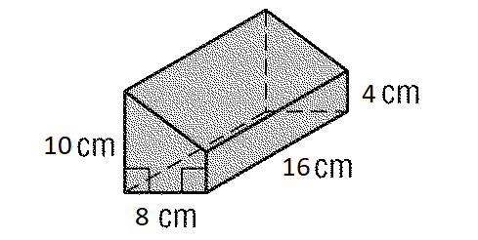

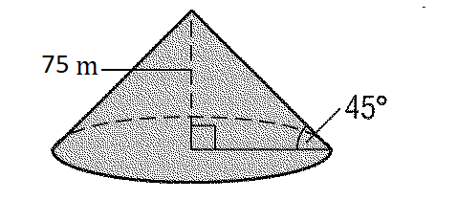
14. Find the exact surface area.

15. Find the exact amount of canvas required for the sides, floor, doors and window of the tent in the shape of a triangular prism as shown in the figure. The base of the prism is an equilateral triangle.

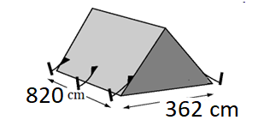

Solutions: 1. 20km 2. 7mi 3. 94ft² 4. 12ft 5. 75$π$cm² or 235.6cm² 6. 240in² 7. 4cm 8. 21cm 9. 3in 10. 10in 11. 6u 12. 360cm² 13. 624cm² 14. $(5625π+5625\sqrt{2}π)$m² 15. $(890520+65522\sqrt{3})$m²

