**Acc Geometry: Surface Area Applications**

1. Find the expression for the surface area.

If the radius of a cylinder is r = 4xy6 and the height is h = 5x2y4 what is the expression which represents the surface area of the cylinder in terms of x and y?

a) b)

7d4w

12d4w3m8

12d4w3m8

**Composites**

**Directions: Find the surface area. If it does not specify, round to the nearest thousandth.**

2. 3.

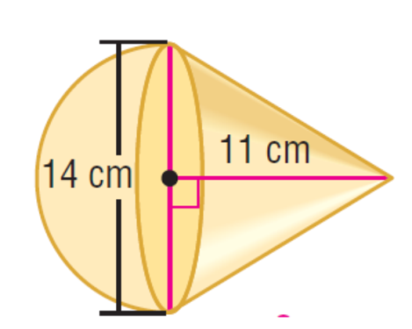

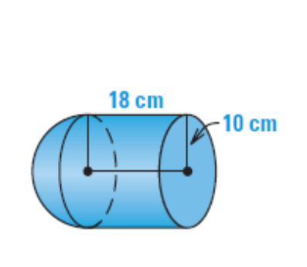4. 5. Find SA in terms of pi.

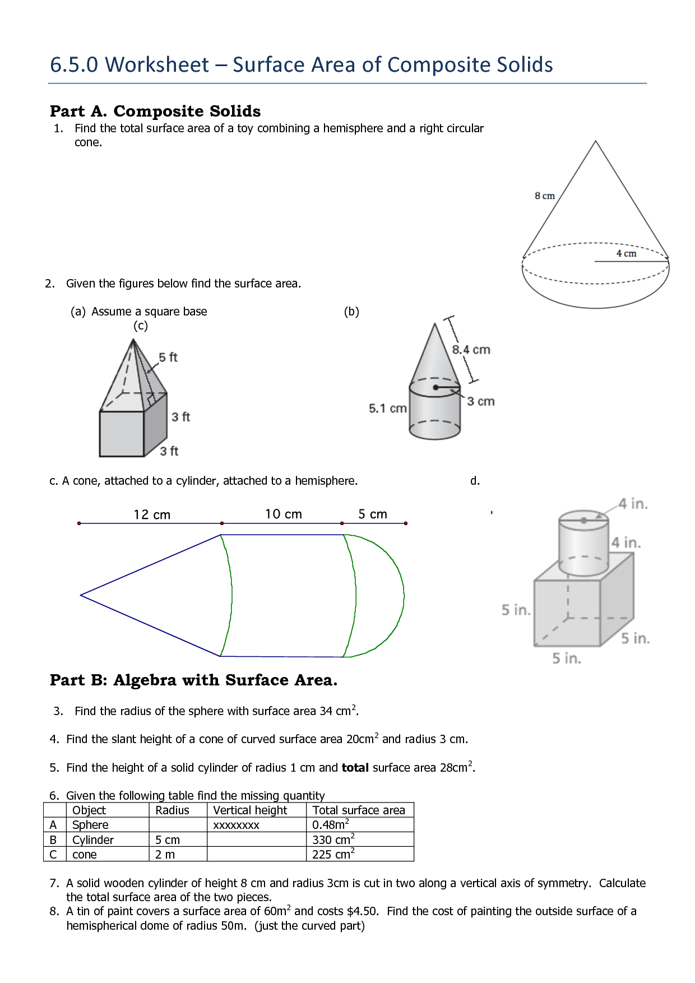



6. 7.

**Applications**

**Directions: If it does not specify, round to the nearest thousandth.**

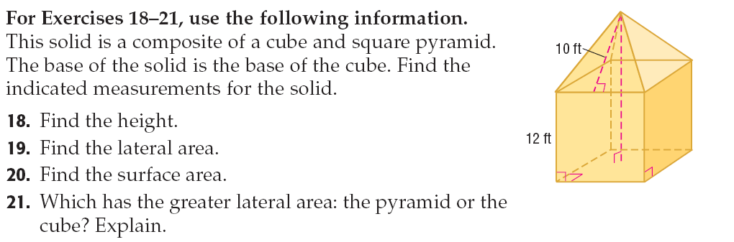8. This solid is a composite of a cube and square pyramid. The base solid is the base of the cube. Find the height, lateral area and surface area of the entire solid.

9. Suppose you are designing a tent in the design shown here. You want to use as little fabric as possible. Given the dimensions of the drawing, find the height of the triangular bases, the surface area of the tent including the floor, sides, windows and doors.

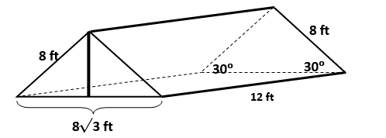

10. The bottomless tent illustrated below is in the shape of a right triangular prism and is made of nylon. How many square feet of nylon is required for the front, rear, and $2$ sides of the tent? (Note: Please ignore the extra nylon for seams.)

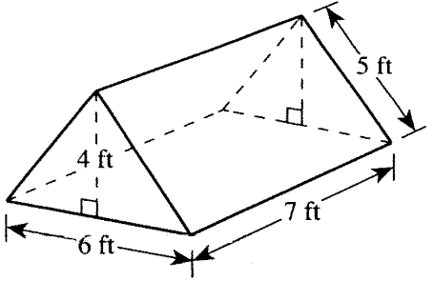

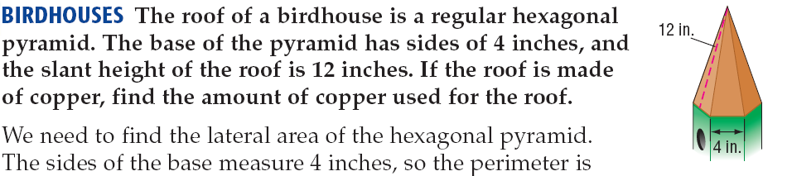

11.

12. The surface area of a cone is 261.9 km2. The cone has a diameter of 18 km. Find the slant height of the cone.

13. The surface area of the trapezoidal prism is 489.6 mi2. Find the missing length below.

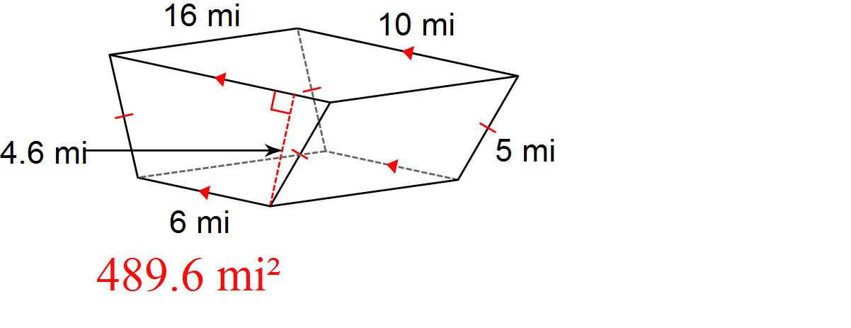

h

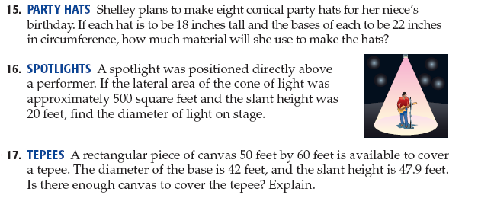14.

15. Find the surface area of the treasure chest.

