**Acc Geometry: Surface Area Practice**

**Interesting Figures**

Directions: Find the surface area of the following figures, you may need to find missing parts before you find the SA. Round to the nearest thousandth if needed.

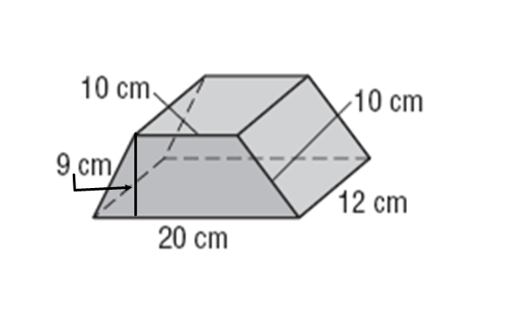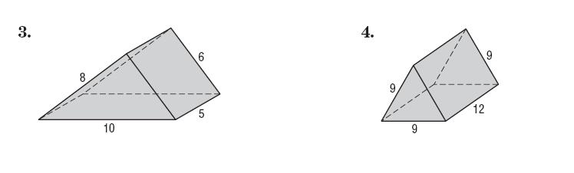1. 2.

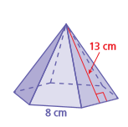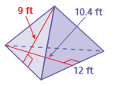

3. 4.

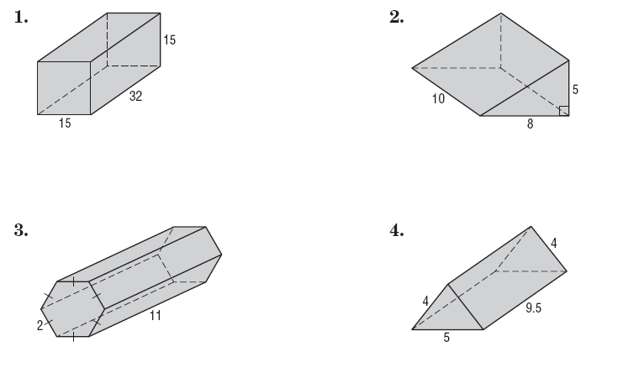

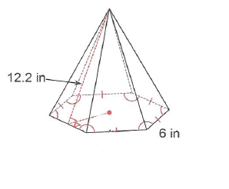

5. 6.



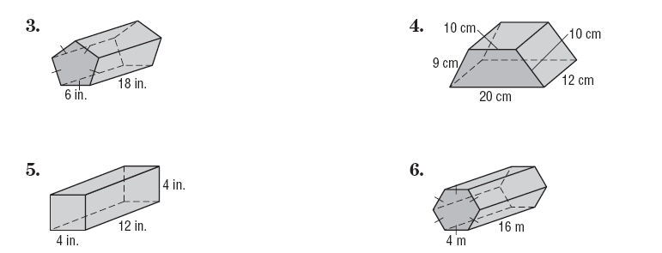

7. 8.

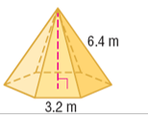9. 10.

[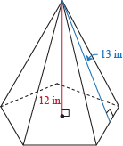](https://www.google.com/url?sa=i&rct=j&q=&esrc=s&source=images&cd=&cad=rja&uact=8&ved=2ahUKEwjoqN69yZHiAhVDiqwKHcarD-UQjRx6BAgBEAU&url=https://www.shmoop.com/surface-area-volume/surface-area-pyramids.html&psig=AOvVaw3pVbvjf5E9FDt53i0RYYVd&ust=1557598694205596)

[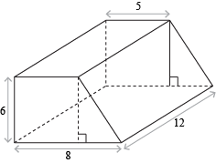](http://www.google.com/url?sa=i&rct=j&q=&esrc=s&source=images&cd=&cad=rja&uact=8&ved=0ahUKEwjoufiu__vTAhXsy1QKHai8Bp0QjRwIBw&url=http://www.shmoop.com/surface-area-volume/surface-area-prisms-cylinders.html&psig=AFQjCNFRgzANLRRcq_Nz_TLQWMyuEE5Wgw&ust=1495284486931901)

[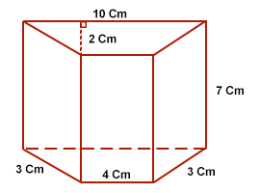](http://www.google.com/url?sa=i&rct=j&q=&esrc=s&source=images&cd=&cad=rja&uact=8&ved=0ahUKEwiuutT4_vvTAhXqgFQKHTOPBnkQjRwIBw&url=http://math.tutorvista.com/geometry/surface-area-of-a-trapezoidal-prism.html&psig=AFQjCNFRgzANLRRcq_Nz_TLQWMyuEE5Wgw&ust=1495284486931901)

11. 12.

Directions: Find the surface area of the following figures. Keep in terms in exact value.

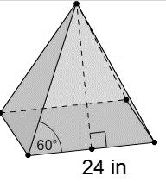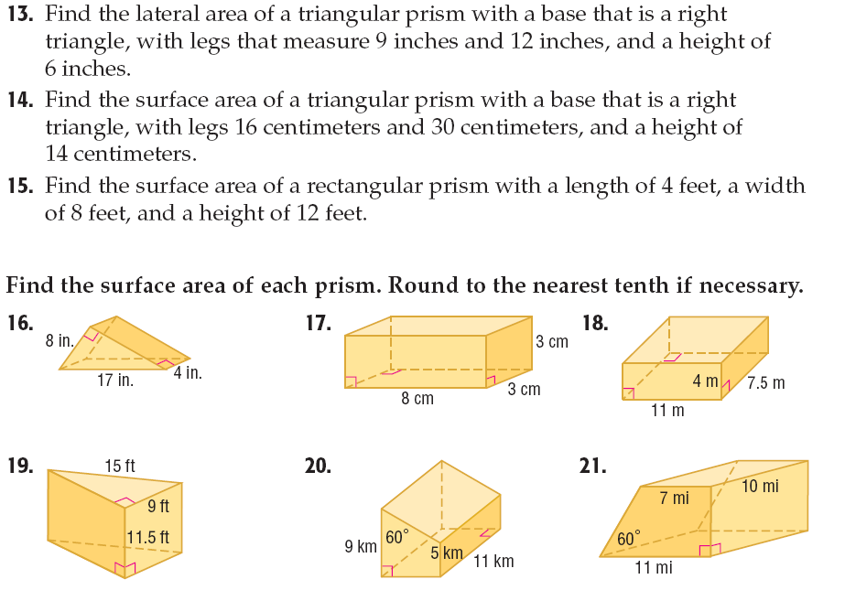13. 14.

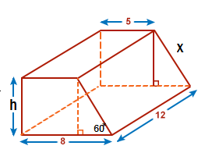

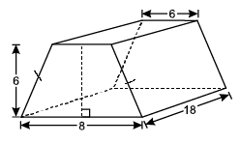

15. 16.