Acc Geometry: Surface Area Practice
The Basics
Directions: Find the surface area of the following figures. Round to the nearest thousandth if needed.
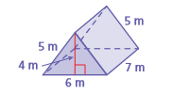
1. 2.

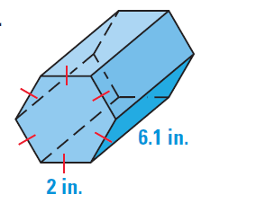
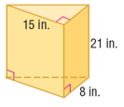
3. x 4.

Directions: Find the surface area of the following figures. Keep in terms of pi.
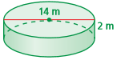
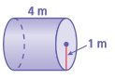
5. 6.

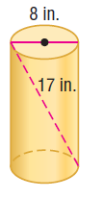
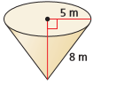
7. 8.

Directions: Keep in terms of pi or exact values.
9. Suppose the surface area of a sphere is 64π square feet. Find the radius.

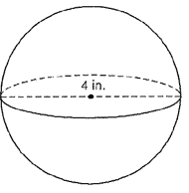
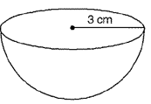
10. 11.

Directions: Find the surface area of the following figures, you may need to find missing parts before you find the SA. Round to the nearest thousandth if needed.
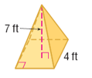
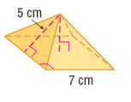
12. 13.

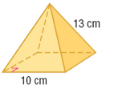
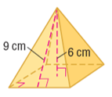
14. 15.

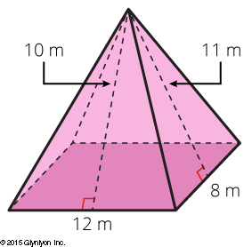
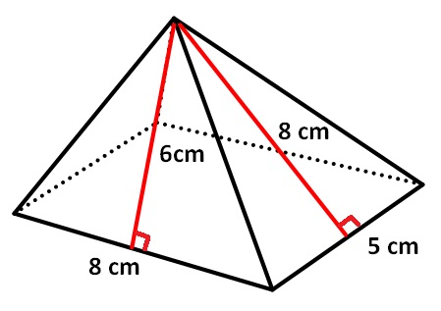
16. 17.

