Name: ___________________________________________________________________

Surface Area and Volume Test Review: Schmidt/Doud

Directions: Find the surface area and volume of each solid. Round to the nearest tenth if needed.
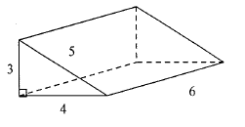
1.

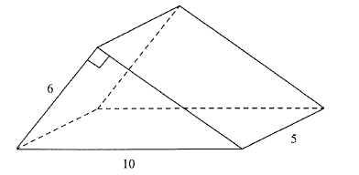

2.

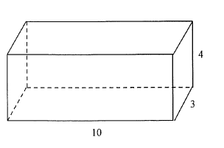
3.

4. Find the surface area, lateral area and volume. Round to the nearest tenth if needed.

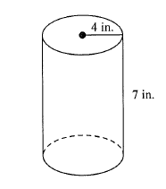

5. Find the surface area, lateral area and volume. Round to the nearest tenth if needed.
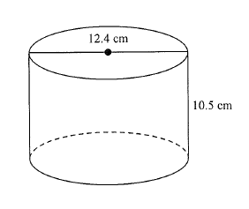

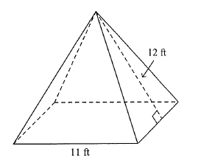
6. Find the surface area, lateral area and volume. Round to the nearest tenth if needed.

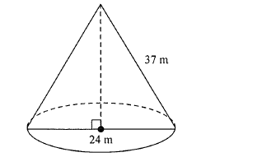

7. Find the surface area, lateral area and volume. Round to the nearest tenth if needed.

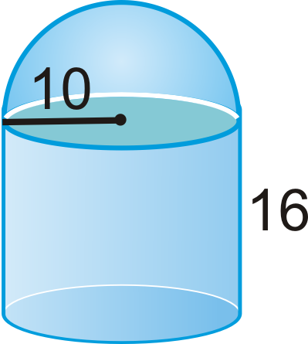
8. Find the surface area and volume. Round to the nearest tenth if needed.

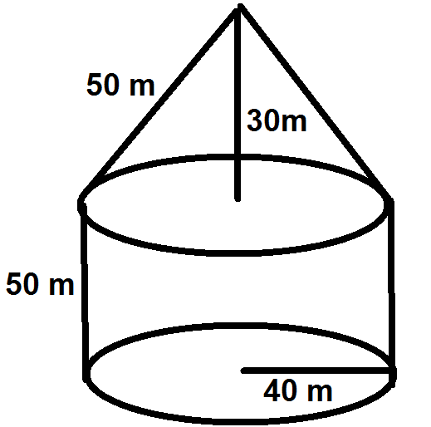

9. Find the surface area and volume. Round to the nearest tenth if needed.

10. Find the surface area. Round to the nearest tenth if needed.

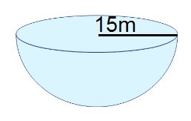

11. Find the volume of the cone if the height of the ice cream cone is 6 inches and the area of the base is about 50.3 square inches. Round to the nearest tenth. 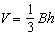
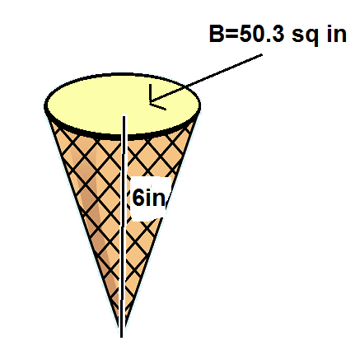

12. Use the net to find the area of the shaded region of the surface of the soild.
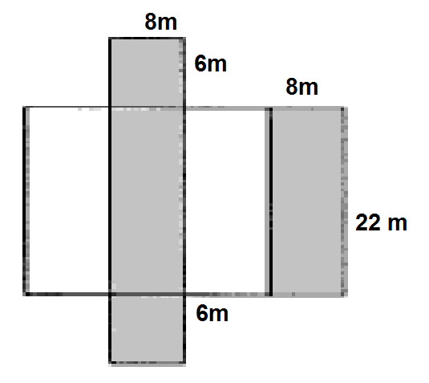

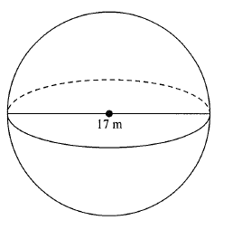
13. Find the surface area and volume. Round to the nearest tenth if needed.

14. Indicate the height, slant height, side length of the base, total surface area and total volume.

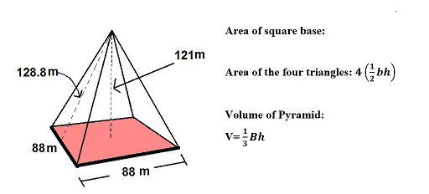

15. . Find the surface area. Round to the nearest tenth if needed. Change the 17

