**Directions: Use the figure to answer questions 1-4.**

1. 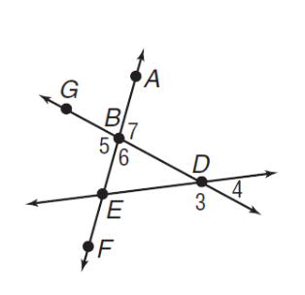Name all angles that have B as a vertex.
2. Name a pair of supplementary angles.
3. Name a pair of vertical angles.
4. Simplify the radical: $\sqrt{192}$
5. Find the value of the variable and *ST* if *S* is between *R* and *T*. Let RS= 16, ST = 2x,   
   RT = 5x + 10. You must show all of your work, justify, and show geometry.

1. Find the value of x and *SR* if *R* is between *S* and *T. SR* = 3x,   
   *RT* = 2x + 1, *ST* = 6x – 1. You must show all of your work, justify, and show geometry.
2. 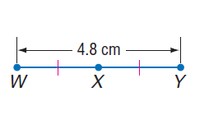Using the picture to the right, find the length of $\overline{XY}.$ You must show all of your work, justify, and show geometry.
3. Find the coordinate of the endpoint S if T is the midpoint of RS and T(3, 4) and R(-2, 3).
4. Find the exact distance between M(3, 5) and N(7, 9). Write your answer as a simplified radical.

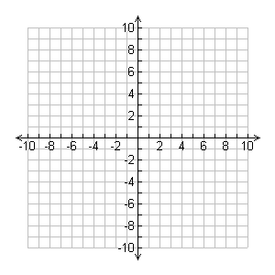**Directions: for 10-12, find the distance, midpoint, and slope of each segment. You must simplify radicals and fractions!**

1. G(-10, 2), H( -7, 6)

Distance: _____________

Midpoint:_____________

Slope: _______________

1. J(4, 2), K(8, -6)

Distance: _____________

Midpoint:_____________

Slope: _______________

1. D(10, 20), E(-10, -20)

Distance: _____________

Midpoint:_____________

Slope: _______________

1. 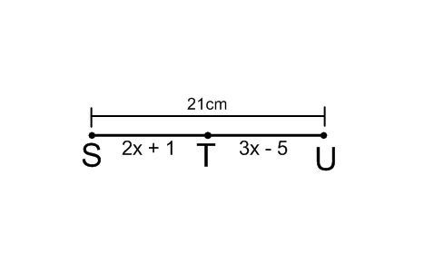Find the value of x and 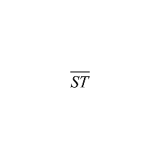using the figure to the right. You must show all of your work, justify, and show geometry.
2. 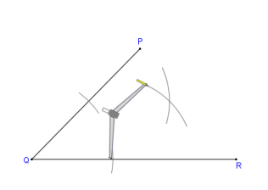A student is completing the following construction. What construction are they making and what is true about the figure?
3. Classify all that apply: adjacent, vertical, linear pairs, complementary, supplementary, right angle and/or congruent.

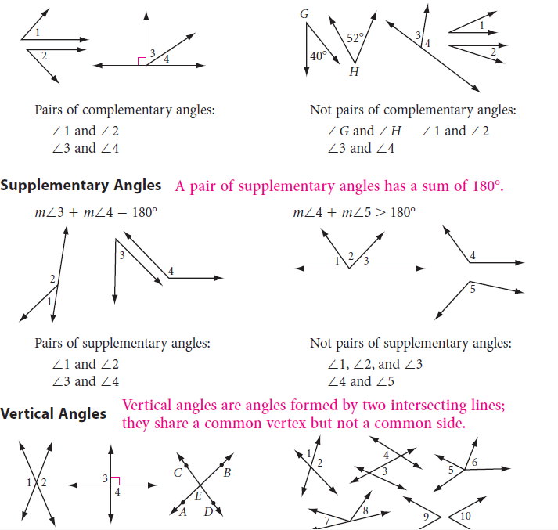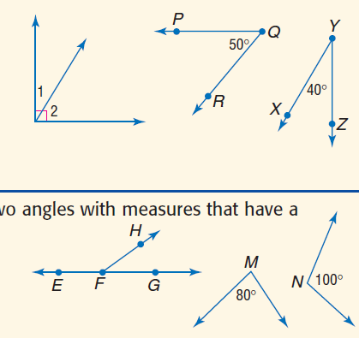

a) b) c)



d) e) f)



1. Draw 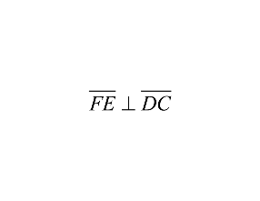 17) Draw 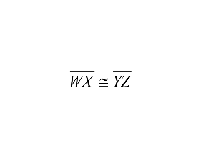
2. Draw $<QRS and<QRT are a linear pair$ 19) Draw $\overset{⃡}{AB} is a ⊥bisector of \overline{ST}$
3. Draw $\vec{ET} is an angle bisector of ∠REO$ 21) Draw $\overline{QR} is a segment bisector of \overline{ST}$

Constructions of Transformations –

***You WILL need to construct transformations!!!!!!!!!!!***

22. Finish the construction, then use the figure to the right

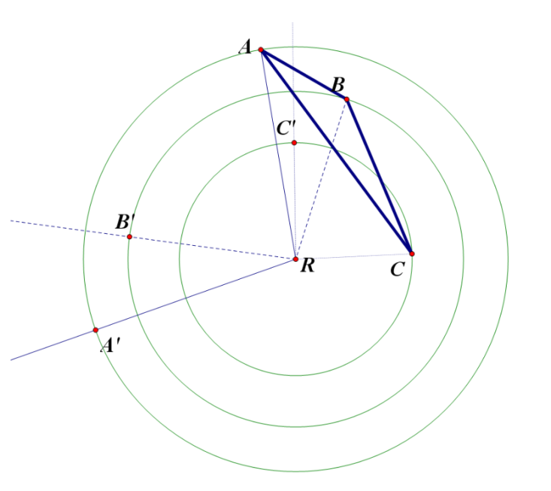a. name the type of transformation

b. name all properties of the construction

23. Finish the construction, then use the figure to the right

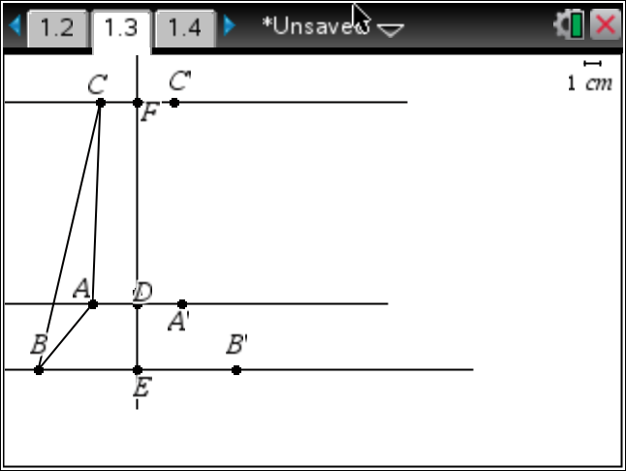

a. name the type of transformation

b. name all properties of the construction

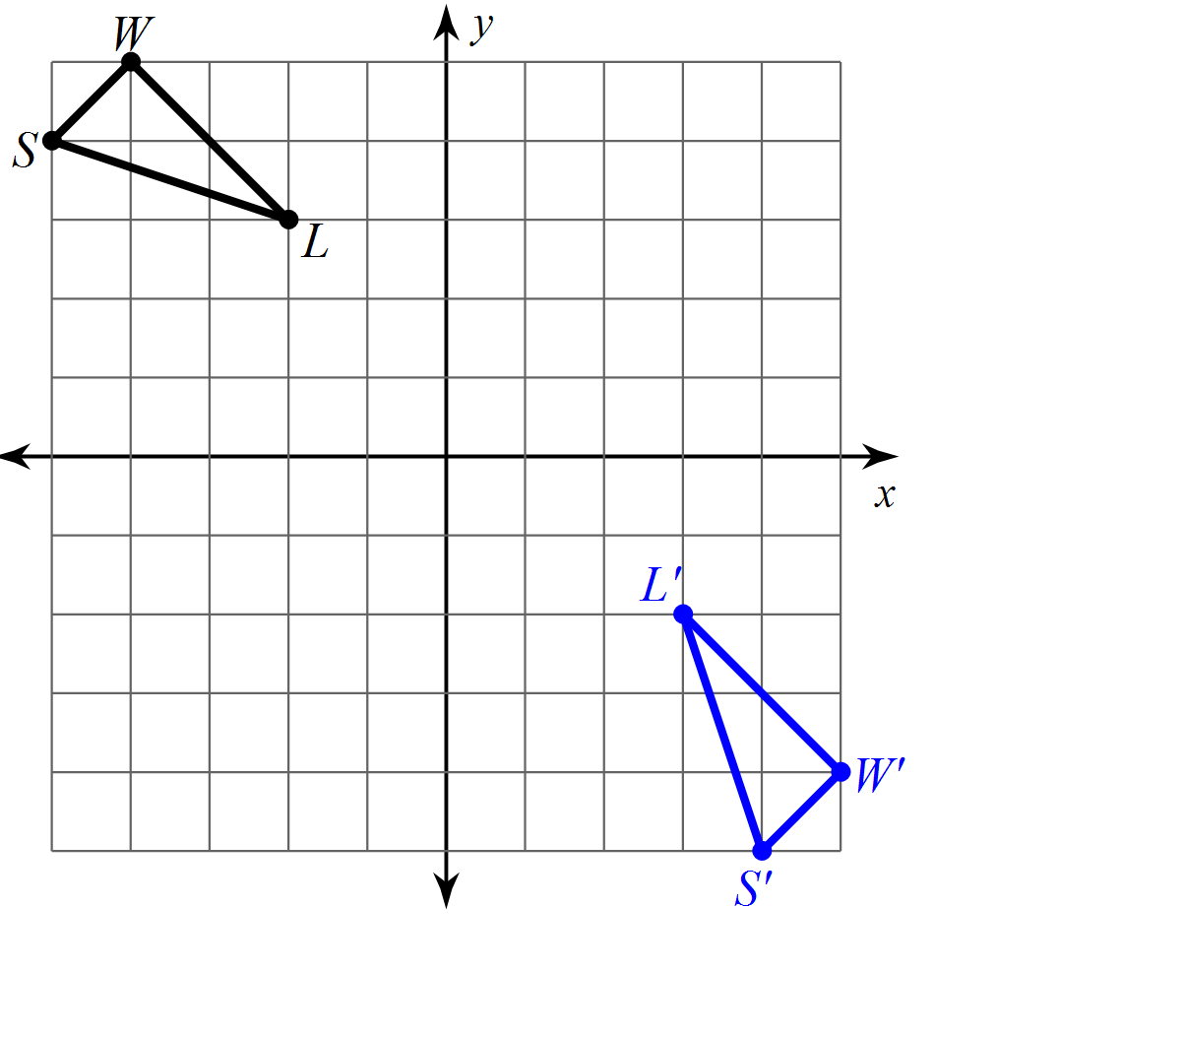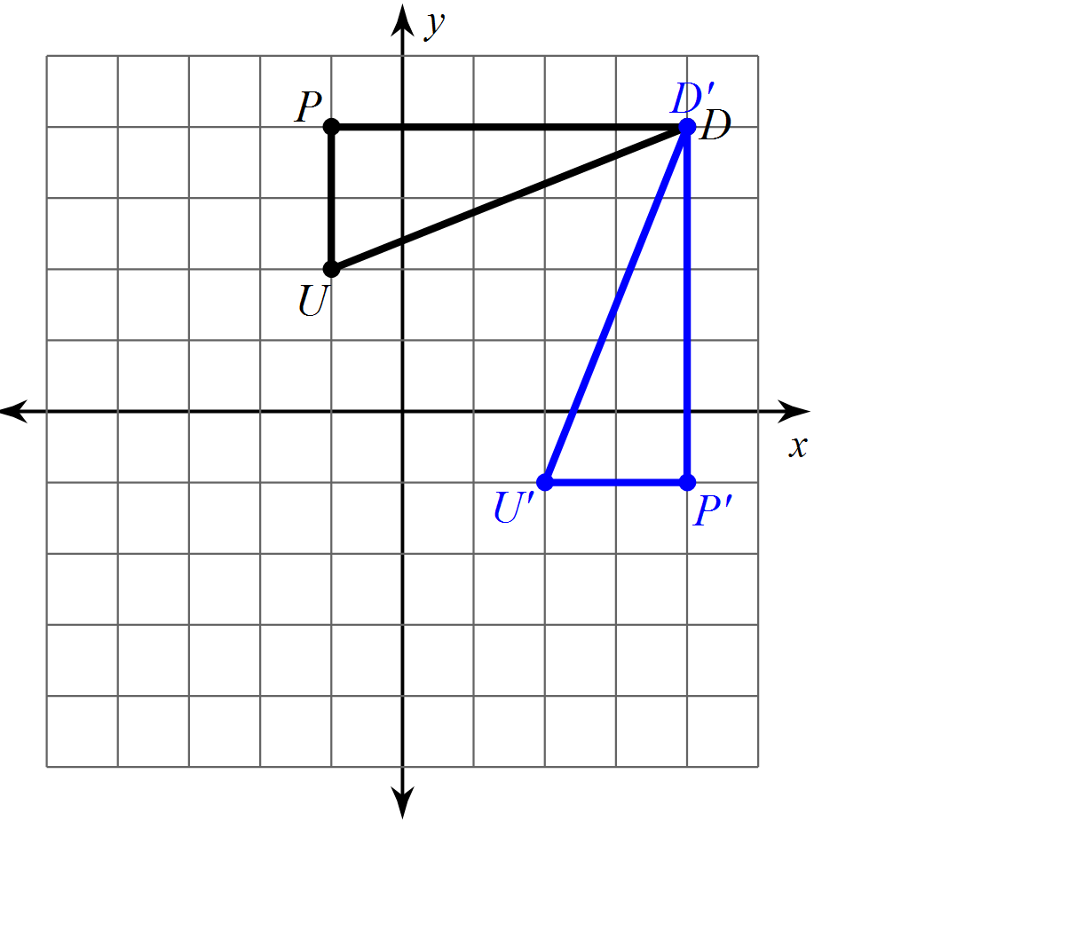Draw in the line of reflection for 24 through 29.

24. 25.

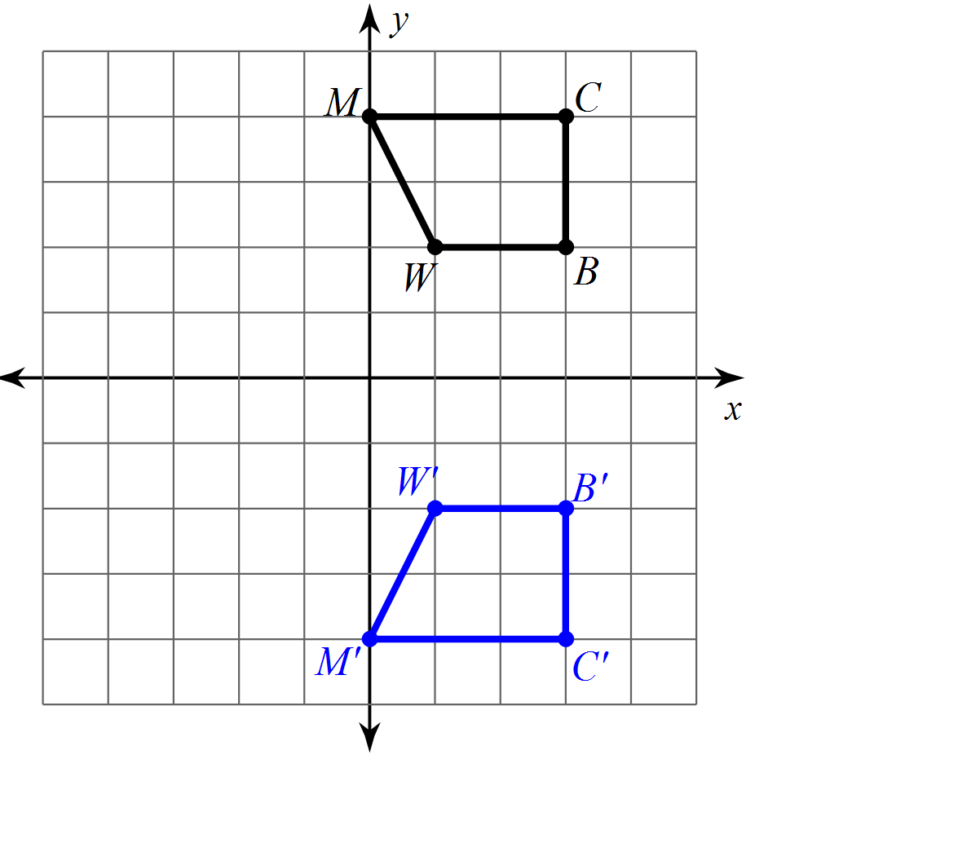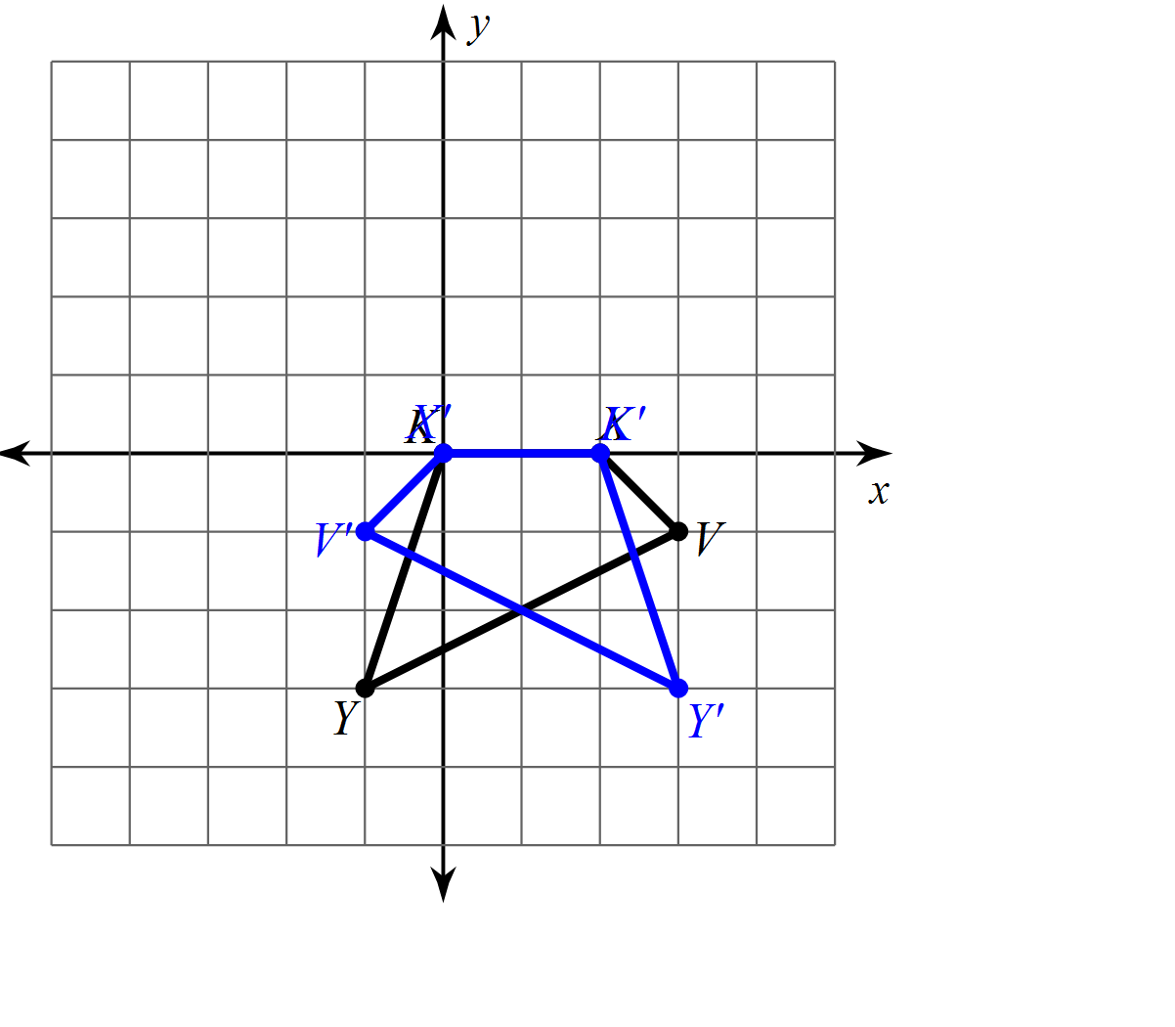26. 27.

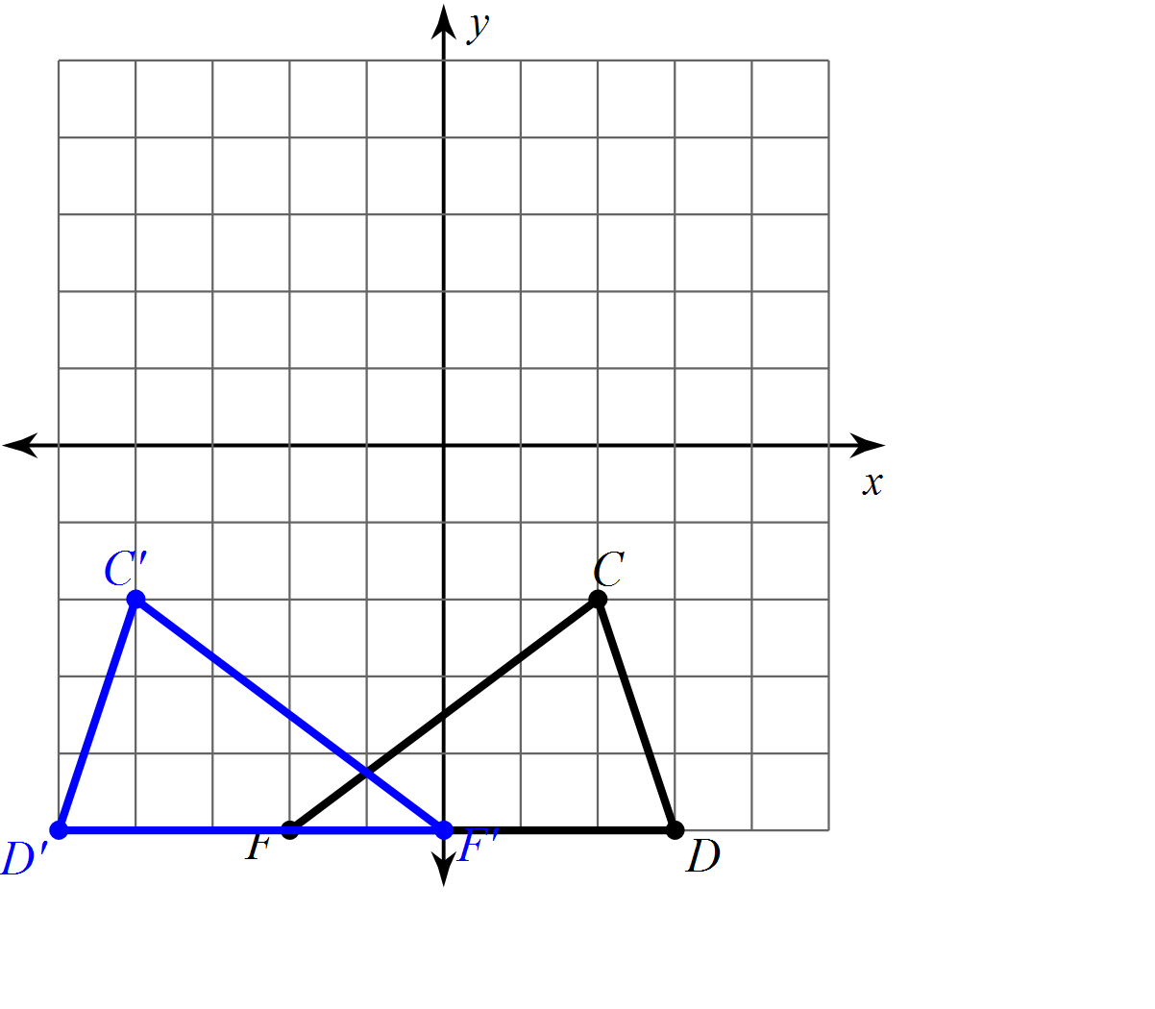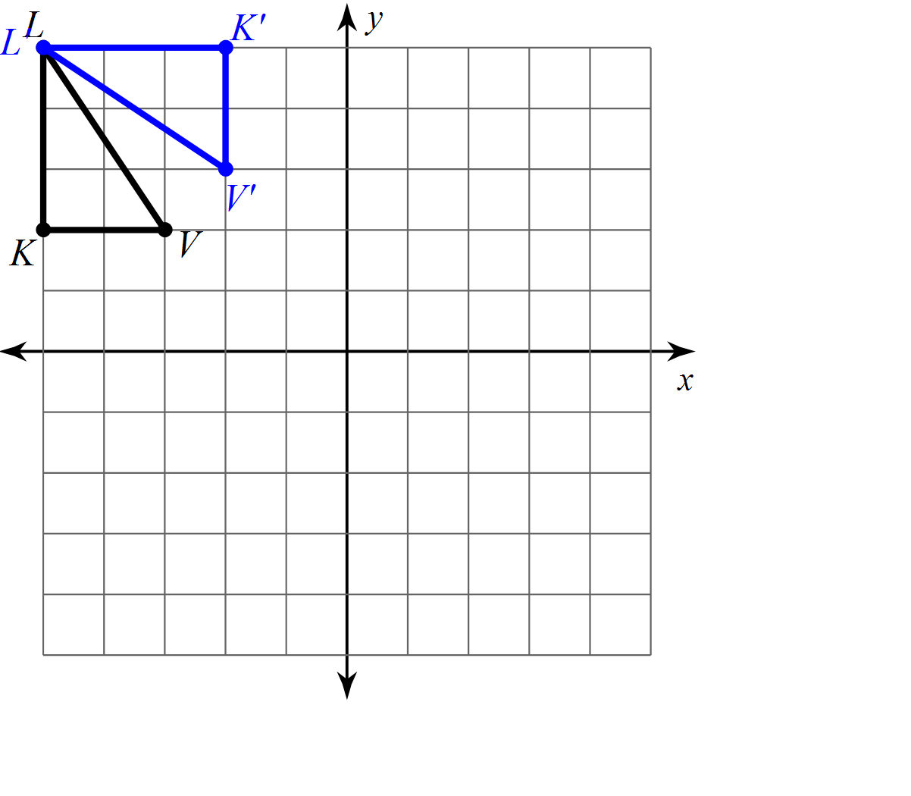

28. 29.

Graph the transformation for 30 through 37. If it is a translation, write the rule for the translation.

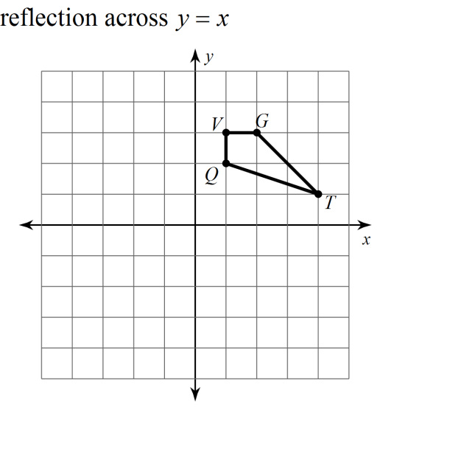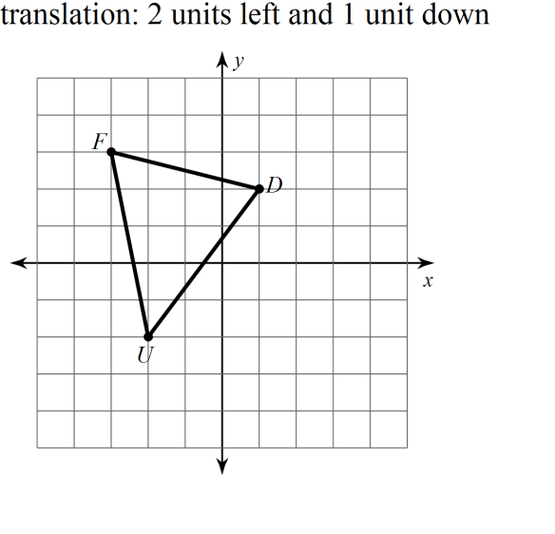30. 31.

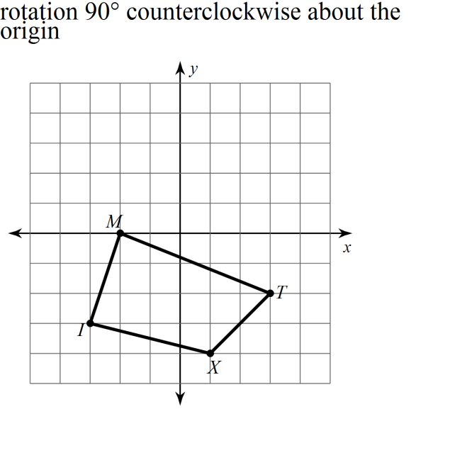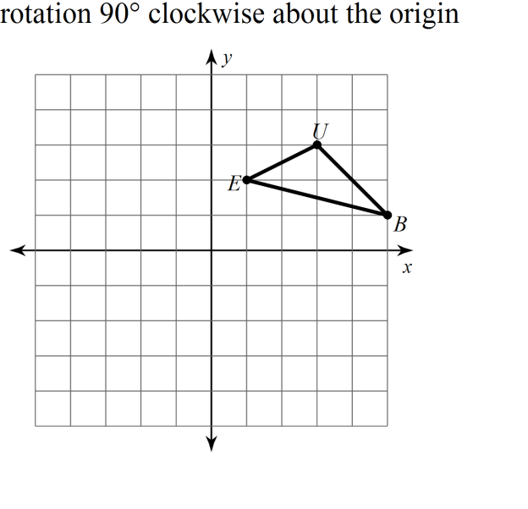32. 33.

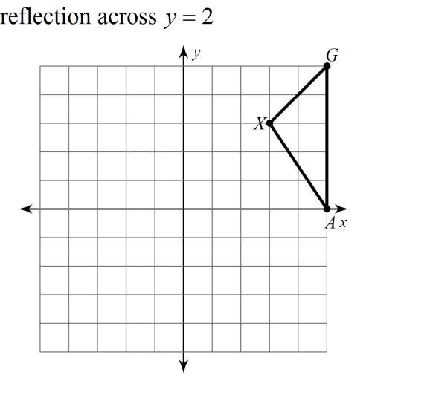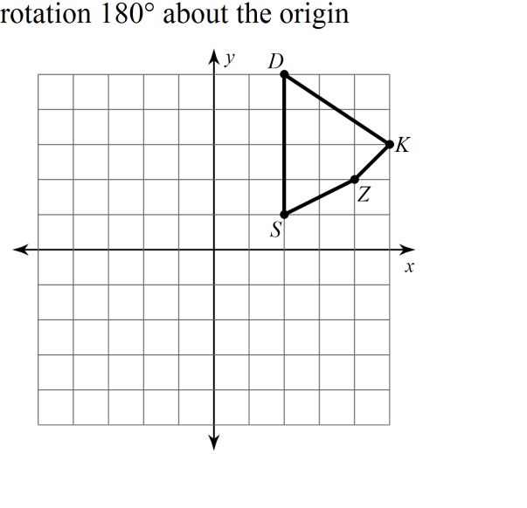34. 35.

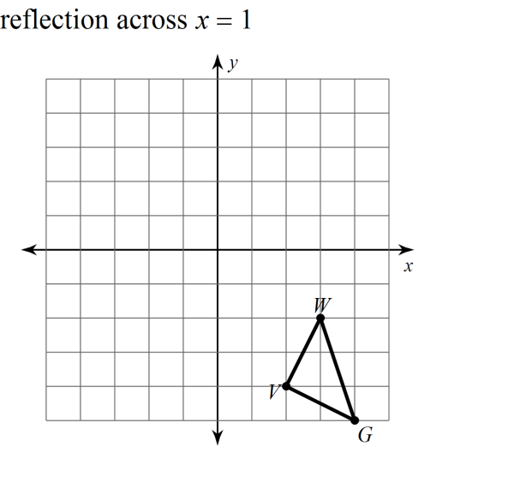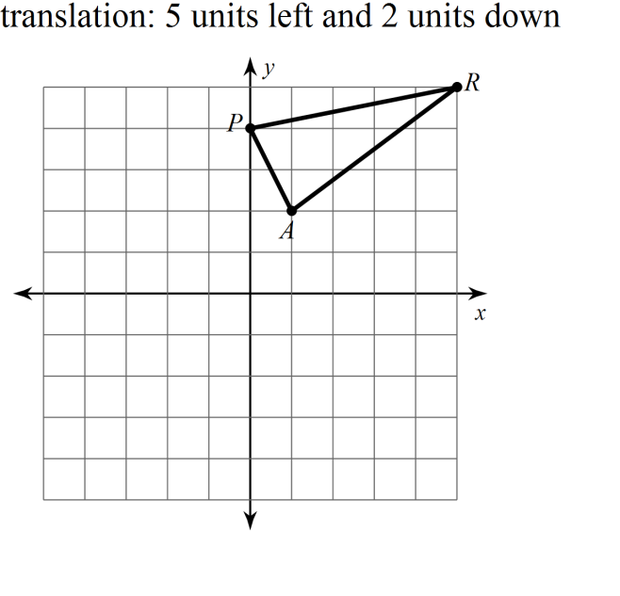36. 37.

38. Create your own real world example of a rotation. (Draw it if it helps.)

39. Create your own real world example of a reflection. (Draw it if it helps.)

40. Create your own real world example of a translation. (Draw it if it helps.)

41. In a basketball game, Roger is standing at position *A* and he bounces the ball to Edwin standing at position *B*. Copy the diagram and sketch the path the ball must travel after being bounced to Edwin by Roger.

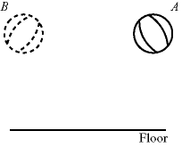

42. Find the slopes of lines. Simplify all fractions, if possible.

S(6, 5), T(-4, 3) X(-4,2), Y(-3,-3)

Slope of ST: ______________

Slope of XY: ______________



43. This is a composite of transformations.

From 1 to 2 the transformation performed is : ____________________

From 2 to 3 the transformation performed is : ____________________

From 1 to 3 the transformation performed is : ____________________

44. The composite of reflections over two parallel lines results in a __________________

This is a composite of transformations.

From 1 to 2 the transformation performed is : ____________________

From 2 to 3 the transformation performed is : ____________________

From 1 to 3 the transformation performed is : ____________________

45. Reflect the figure over the given line.

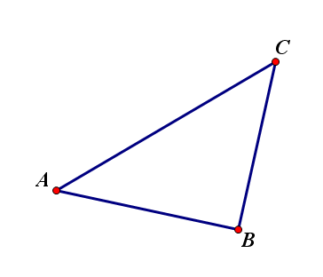

46. Rotate the figure 110 degrees counterclockwise around point R

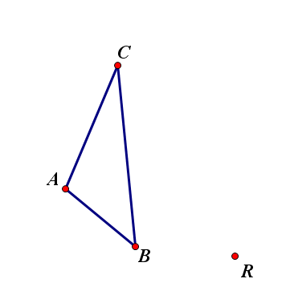

***C***

***A***

***B***

***R***