**Polygon Unit Test Review 2015 RTI**

**Directions: You must show all work for all problems below. For the problems where you have a quadrilateral and use their properties, justify the set up, and provide the geometry. (Some may not have the information to do everything i.e. if no points are there, you cannot show the geometry). Failure to do so will result in a zero.**

1. Find the sum of the measures of the interior angles of a convex 39-gon.

2. Find the sum of the measures of the exterior angles of a convex 21-gon.

|  |
| --- |
|  |

3. Find the measure of an interior angle of a regular polygon with 20 sides. Round to the nearest tenth if necessary.

4. Find the measure of each exterior angle for a regular heptagon. Round to the nearest tenth if necessary.

5. A regular polygon has an exterior angle with a measure of 20o. Find the number of sides.

6. A regular polygon has an interior angle with a measure of 120o. Find the number of sides.

7. Fill in the following table:

|  |  |
| --- | --- |
| Number of Sides | Name of Polygon |
| 3 |  |
| 4 |  |
| 5 |  |
| 6 |  |
| 7 |  |
| 8 |  |
| 9 |  |
| 10 |  |
| 11 |  |
| 12 |  |
| n |  |

8. For parallelogram *RSTU*, find *m*RSU and *m*RUS.

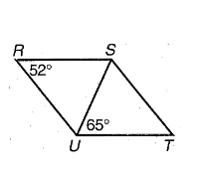

*m*RSU = ____________ *m*RUS = ____________

9. Solve for the missing angle or variable for the following PARALLELOGRAMS.

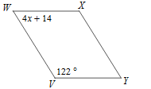a.) Find x. b) Find m<1. C. Find all variables.

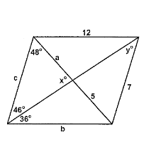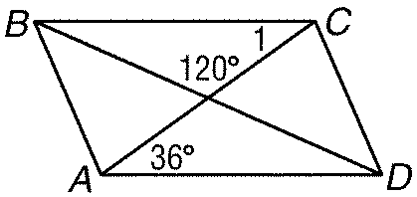

|  |  |  |  |
| --- | --- | --- | --- |
|  |  |  |  |

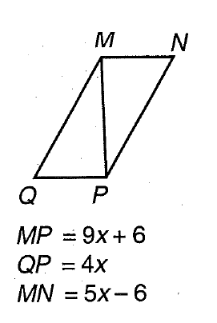10. Find *x* so that the quadrilateral is a parallelogram. Then find the side length of *MP, QP,* and *MN.*

|  |  |  |  |
| --- | --- | --- | --- |
| **x = _________** MP = ____________ QP = ______________ MN = _______________ | M |  |  |

11. ABCD is a square. If AC = 16 and BD = 2x + 4, find x.

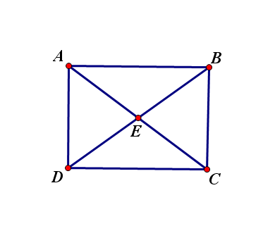

12. Rhombus Practice:

a.) For rhombus *ABCD*, *m*8 = 35, find the *m*1, *m*2, *m*3, *m*4, *m*5, *m*6, and *m*7.

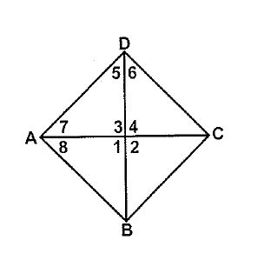

*m*1 = _______ *m*2 = _______

*m*3 = _______ *m*4 = _______

*m*5 = _______ *m*6 = _______

*m*7 = _______

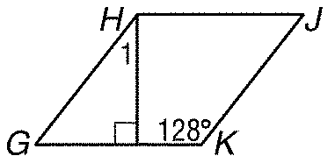

b.) For rhombus *GHJK*, find *m*1

13. ABCD is a rectangle. If *m*1 = 20, find the *m*2, *m*3, *m*4, *m*5, and *m*6.

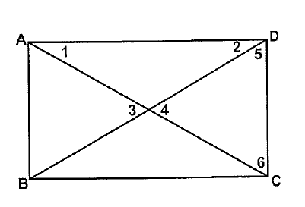

*m*2 = _______ *m*3 = _______

*m*4 = _______ *m*5 = _______

*m*6 = _______

14. For isosceles trapezoid *CDEF*, find *m**F, m**E, m**D,* and *EF*.



*m**F = ________ m**D = ________*

*m**E = ________ EF = _________*

15. Find all of the missing angles.

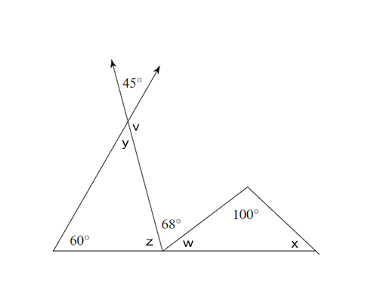

v = __________ w = _________ x = __________ y = _________ z = __________

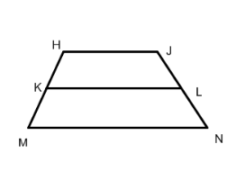16. LK is the midsegment of trapezoid HJNM. Find MN if HJ = 5 and LK = 25.

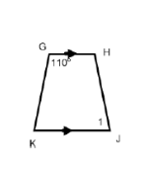

17. For isosceles trapezoid GHJK, find <1.

18. Given isosceles trapezoid ABCD, EF is the midsegment. Find EF, AD, and m<AEF if AB=10, CD = 20, AE = y + 5, FC = 2y – 10, and m<EFC =130

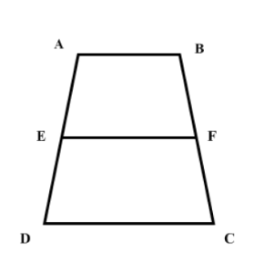

EF = _______

AD = ______

m<AEF = _______

19. For isosceles trapezoid *MNOP*, find m<M, m<O, m<QNO and *m**MNQ* if <P = 65ᵒ.

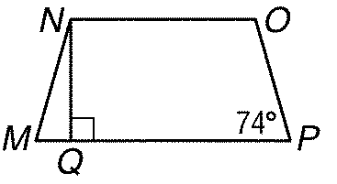

26. Classify *QRST* with vertices Q(-5,7), R(-3, 4), *S*(3, 8), and *T*(1, 11). SHOW ALL WORK!!!!



T

S

Q

R