RTI Angle Relationships TEST REVIEW

1. Find the measure of each angle if the m<HFK=90° and m<HFG=135°.
Ray FJ is an angle bisector of <HFK.
a. m<KFG= ____________ b. m<JFK= ___________

c. m<HFE= ____________ d. m<EFK= ___________

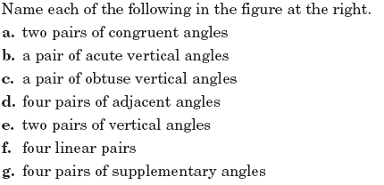
2.

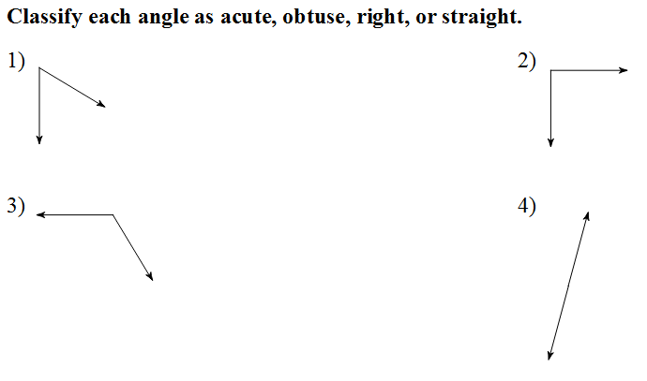
3.

B.
A.

D.
C.

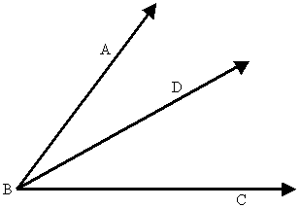
4. Assume that Ray BD bisects <ABC. If <ABD = 34ᵒ, find:

m<DBC = _______________

m<ABC = _______________

5. Use the diagram for the following questions.
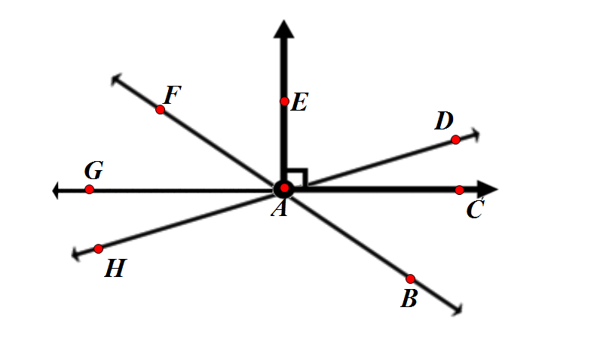

True or false
A.) <CAD <EAD. B.) <CAD <GAH. C.) <FAE <EAD.

Find the measures of the following angles if < CAB = 30ᵒ and m<GAH = 15ᵒ

D.) m<DAC E.) m<EAD. F.) m<BAG

G.) m< GAE. H.) m<HAB I.) m<FAB

6. If <FTR = <ABC and <CBD = 27ᵒ, find m<FTR.

F
C
B
A
T
W
R
D

7. Find x.

5x -20
2x + 10

8. Find x.

14x + 8
7x + 4

9. Find x.
X + 15
2x

10. Find x.

3x - 10
12x + 25

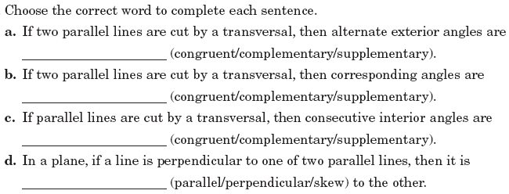
11.

12.

13. If w //v, give the justification for each statement.

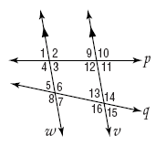
You must use only the following relationships:
Corresponding angles are congruent
Alternate interior angles are congruent
Alternate exterior angles are congruent
Consecutive interior angles are supplementary
Linear pairs are supplementary
Vertical angles are congruent

a. <2<12 b. <8<14 c. <5<13

d. <10<2 e. <7 + <16 =180° f. <16<6

14. If m<3=43°, find the measures of each angle. Fill them in on the picture and list them out in order.
$$∠6=__________$$
$$∠7=__________$$
$$∠8=__________$$
$$∠9=__________$$
$$∠10=__________$$

$$∠11=__________$$
$$∠12=__________$$
$$∠13=__________$$
$$∠14=__________$$
$$∠15=__________$$
$$∠16=__________$$

$$∠1=__________$$
$$∠2=__________$$
$$∠3=__________$$
$$∠4=__________$$
$$∠5=__________$$

Solve for x and justify your set up.
You must use only the following relationships:
Corresponding angles are congruent
Alternate interior angles are congruent
Alternate exterior angles are congruent
Consecutive interior angles are supplementary
Linear pairs are supplementary
Vertical angles are congruent

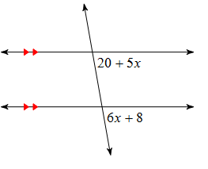
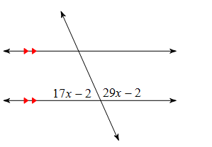
15. 16.

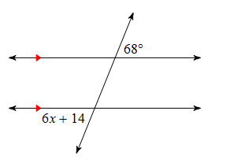
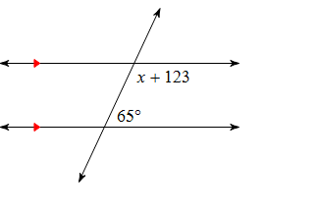
17. 18.

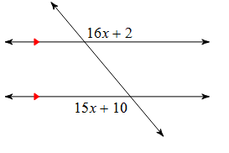
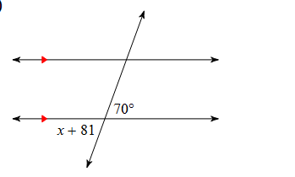
19. 20.

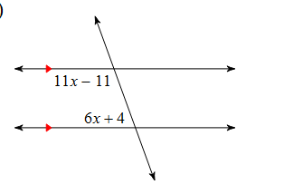
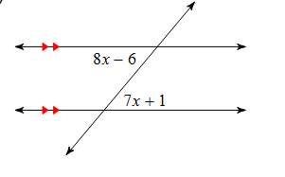
21. 22.

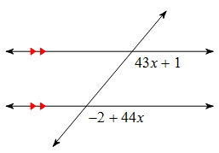
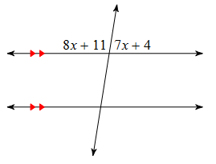
23. 24.

