Name: __________________________________________________________
Trig Functions Unit Test Review
Directions: Sketch the following angles in degrees, then find and indicate the reference angle in degrees.
1. 245° 2. 130° 3. -100°

Reference Angle: _________ Reference Angle: _________ Reference Angle: _________

Directions: Sketch the following angles in radians, then find and indicate the reference angle in radians.
4. $\frac{-π}{6}$ 5. $\frac{2π}{3}$ 6. $\frac{7π}{5}$

Reference Angle: _________ Reference Angle: _________ Reference Angle: _________

Directions: Find the positive and negative coterminal angles in DEGREES and then convert the following from degrees to radians.
7. 245° 8. 130° 9. -100°

Positive: Positive: Positive:

Negative: Negative: Negative:

Radians: Radians: Radians:
Directions: Find the positive and negative coterminal angles in radians and then convert the following from radians to degrees.
10. $\frac{-π}{6}$ 11. $\frac{2π}{3}$ 12. $\frac{7π}{5}$

Positive: Positive: Positive:

Negative: Negative: Negative:

Degrees: Degrees: Degrees:

Directions: Find the circumference of the circle and find the length of $\hat{AB}$in terms of $π$.
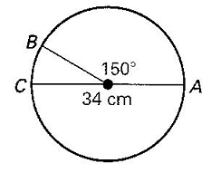
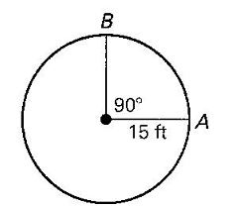
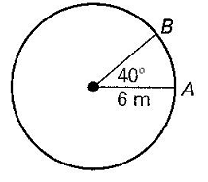
13. 14. 15.

Circumference: Circumference: Circumference:

Arc Length: Arc Length: Arc Length:

16. If point H( $\frac{\sqrt{5}}{7},-\frac{\sqrt{44}}{7}$ ) lies on the unit circle, find sinH, cosH, and tanH.

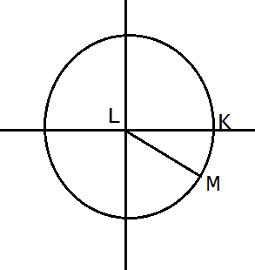
17. Graph the point, label the lengths of the right triangle with right angle C, find the length of the hypotenuse (radius) then find the exact trig ratio value. Simplify all radicals, simplify all fractions and make sure there is no radical in the denominator.
$\left(\sqrt{3}, -1\right)$ r = _____________

’ = ___________

sin ’ = ________

cos ’ = _______

tan ’ = _______

If ’ = ___________ (in degrees) then the actual = ___________(in degrees) rotated from the positive x-axis. Find and ’ in radians.

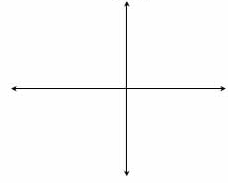
18. Graph the point, label the lengths of the right triangle with right angle C, find the length of the hypotenuse (radius) then find the exact trig ratio value. Simplify all radicals, simplify all fractions and make sure there is no radical in the denominator.
$\left(-2\sqrt{3}, 2\right)$ r = _____________

’ = ___________

sin ’ = ________

cos ’ = _______

tan ’ = _______

If ’ = ___________ (in degrees) then the actual = ___________(in degrees) rotated from the positive x-axis. Find and ’ in radians.
19. If $cosθ=\frac{\sqrt{3}}{2}$ and in quadrant I, complete the following:
a.) Construct the triangle on the coordinate plane.
b.) Find the value of the reference angle in degrees.
c.) Find the length of the missing side.
d.) Find the value of sin .

a.) b.) Reference angle `=

c.) missing side length =

d.) sin =

20. If $sinθ=-\frac{1}{2}$ and in quadrant IV, complete the following:
a.) Construct the triangle on the coordinate plane.
b.) Find the value of the reference angle in radians.
c.) Find the length of the missing side.
d.) Find the value of cos .

a.) b.) Reference angle `=

c.) missing side length =

d.) cos =

21. If $cosθ=-\frac{1}{2}$ and $θ=\frac{kπ}{6}$ on the unit circle, give at least one possible value for k. (For the test- Providing two correct values will earn one extra credit point, however, any incorrect answers will result in a loss of two points.).

Directions:
Explain how you arrived at your answer by use of the Unit Circle or by using the triangle method.

The triangle method must show the following:
When using the unit circle you must show the
following:
Sketch the full quadrant of the unit circle including points, degrees/radians, and both axis.

A.) Sketch the triangle
B.) Show the reference angle
C.) Right angle
D.) Side lengths

22. cos $\frac{π}{4}$

23. sin $\frac{7π}{4}$

24. cos 2$π$

25. $\tan{\frac{11π}{6}}$

26. sin 240ᵒ

27. tan 210ᵒ

28. cos 330ᵒ

29. $\tan{330°}$

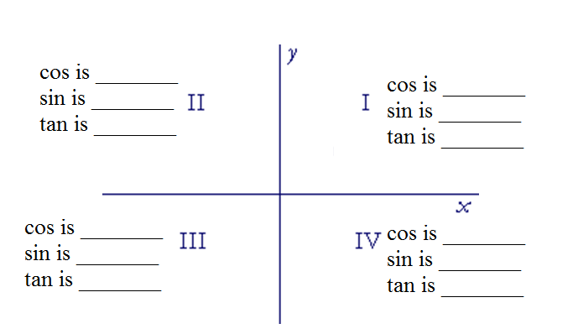
30. Below indicates the quadrants in a coordinate plane. Determine whether sine, cosine, and tangent is positive or negative in each quadrant.

31. Explain how arc length is used to convert degrees to radians on the unit circle with a radius of 1. Use the conversion of 330ᵒ to $\frac{11π}{6}$ to help you explain your work.

You will be given a blank unit circle to help you. It will not be graded- However on your test review you will need to be able to fill in the entire unit circle. You will not need to have the whole thing memorized but you will need to know the 1st quadrant.

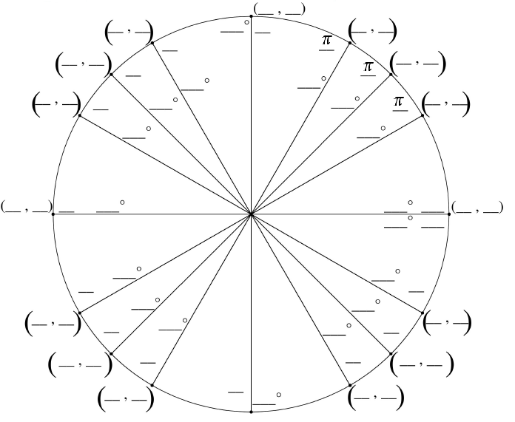

Teachers: This is for the answer key- use if you want so you don’t need to re-draw the unit circle every time when you go over answers.

