Constructions of Transformations –

***You WILL need to construct transformations!!!!!!!!!!!***

1. Finish the construction, then use the figure to the right

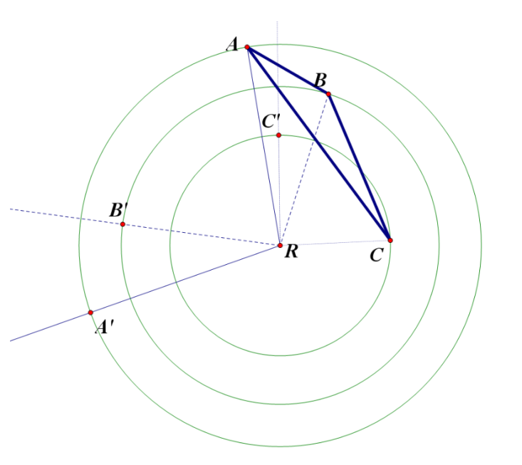a. name the type of transformation

b. name all properties of the construction

2. Finish the construction, then use the figure to the right

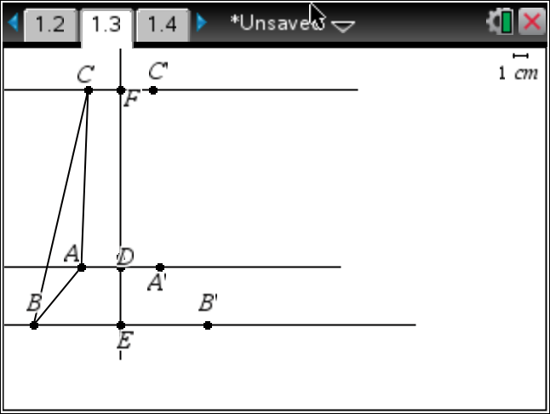

a. name the type of transformation

b. name all properties of the construction

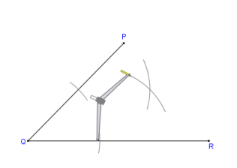3. A student is completing the following construction. What construction are they making and what is true about the figure?

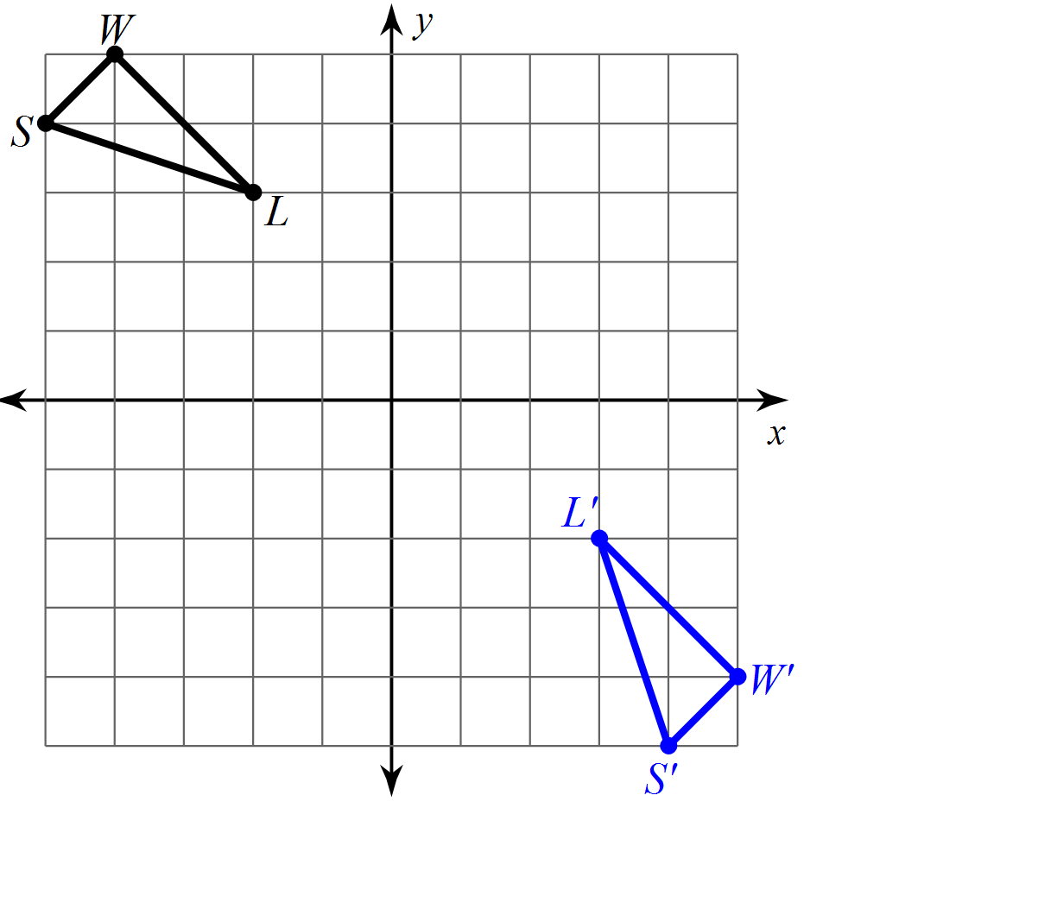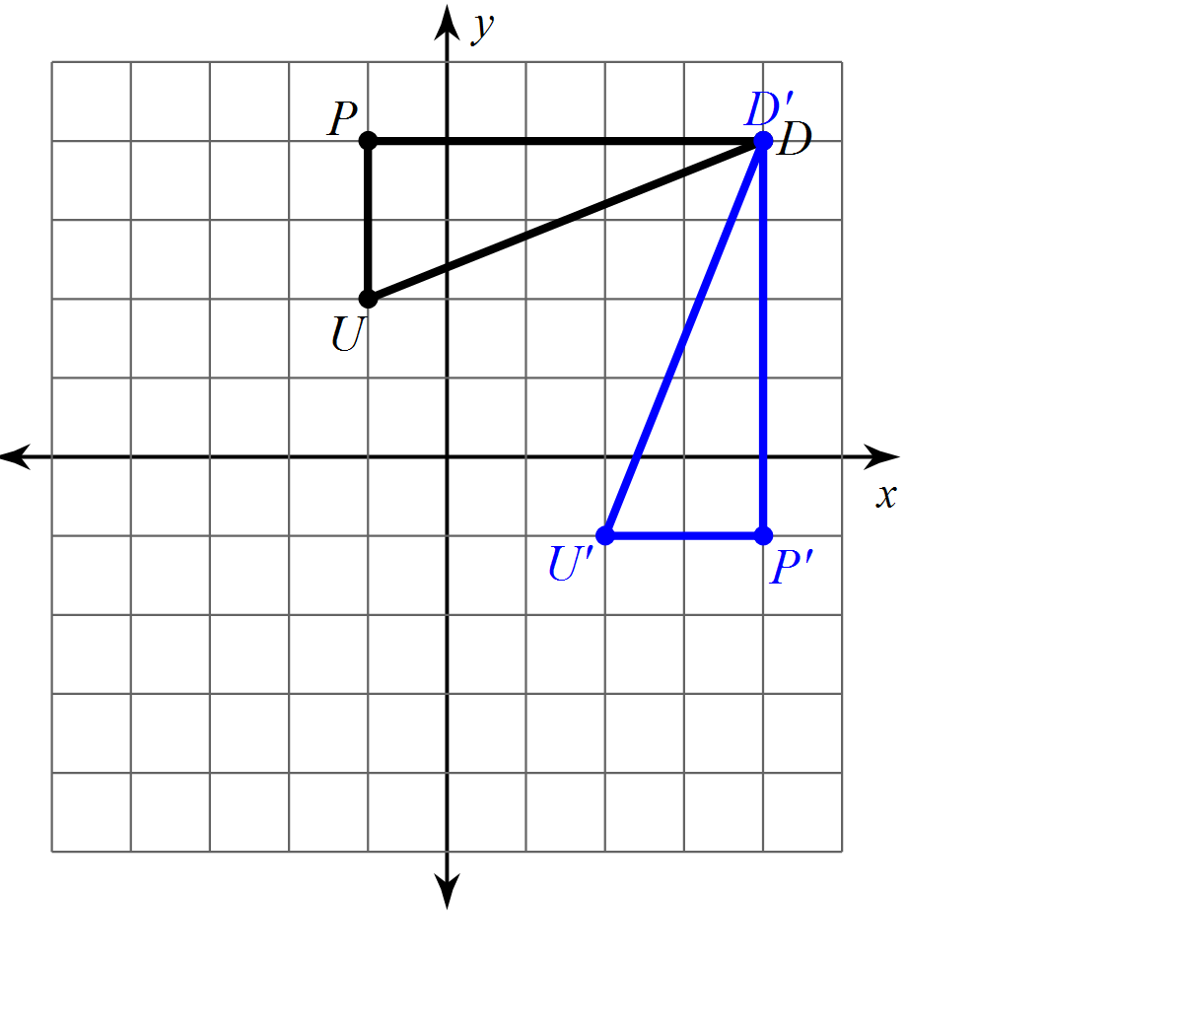Draw in the line of reflection for 4 through 9. Then, write the equation of the line!

4. 5.

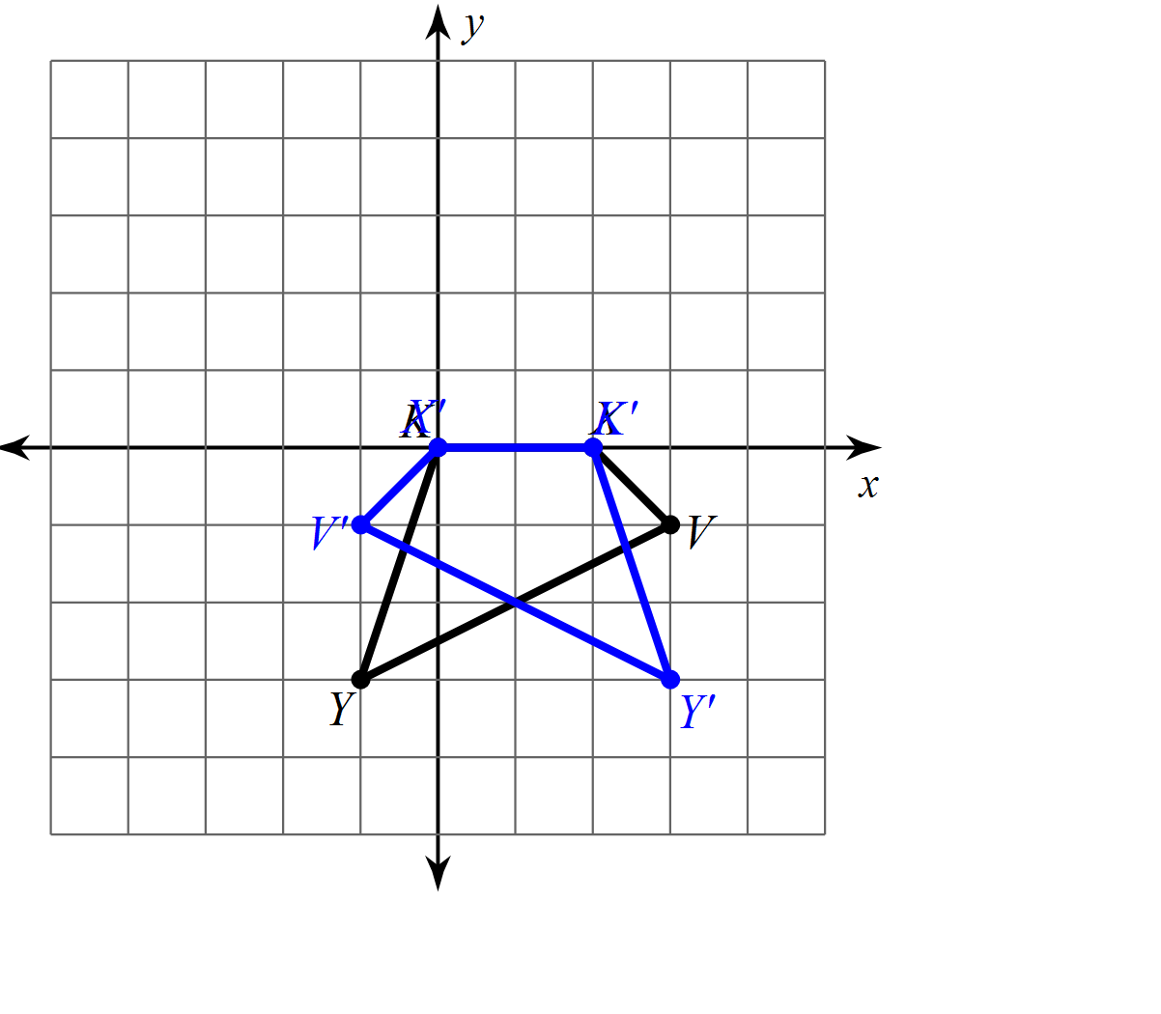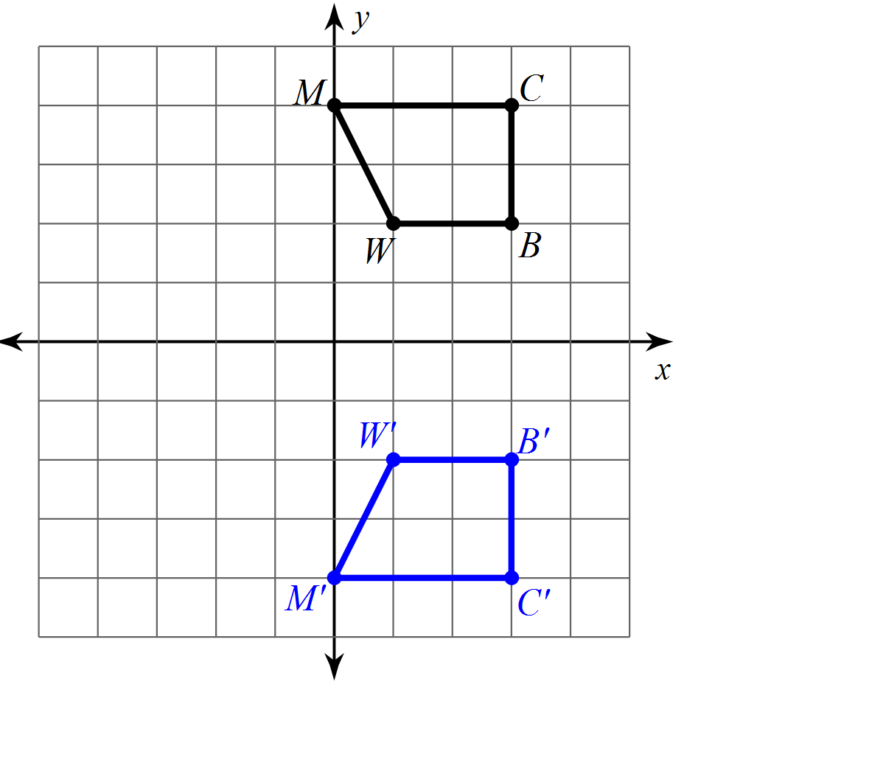

6. 7.

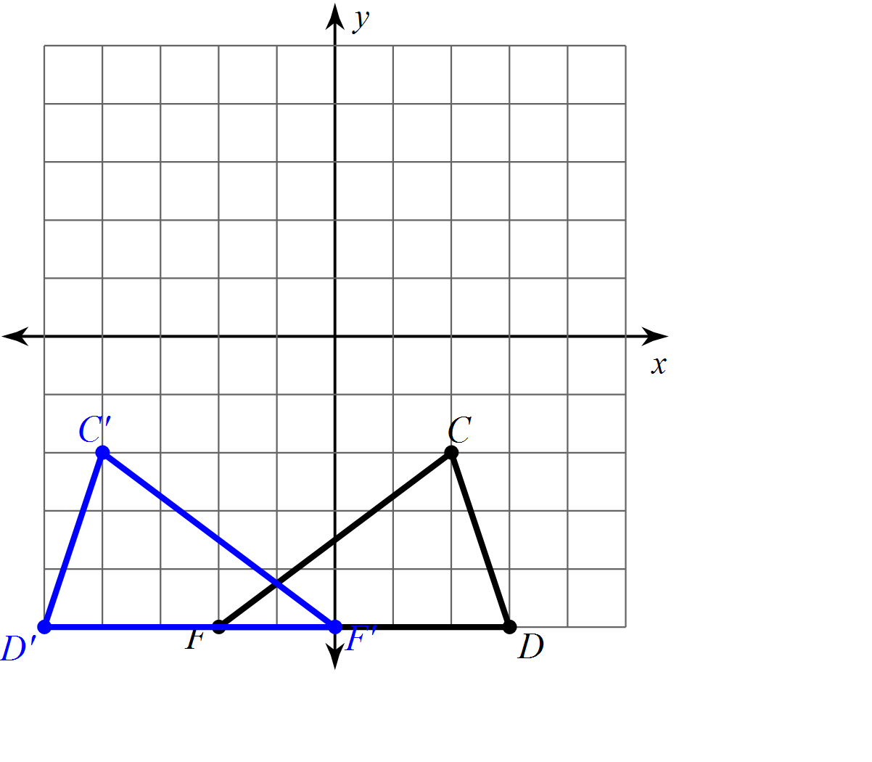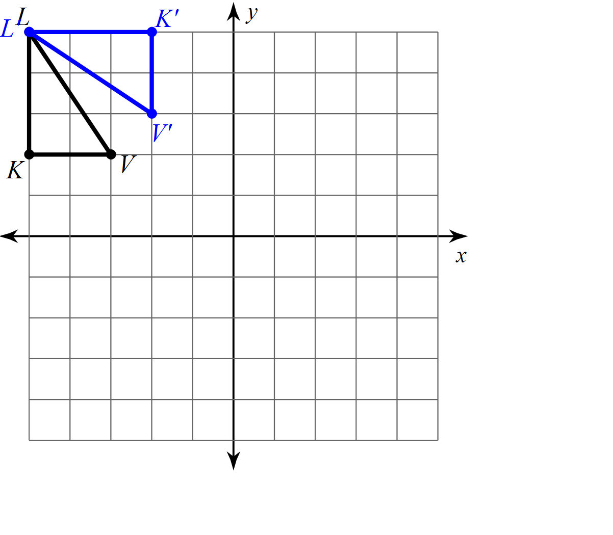

8. 9.

Graph the transformation for 10 through 17. Additionally, if it is a translation, write the rule for the translation.

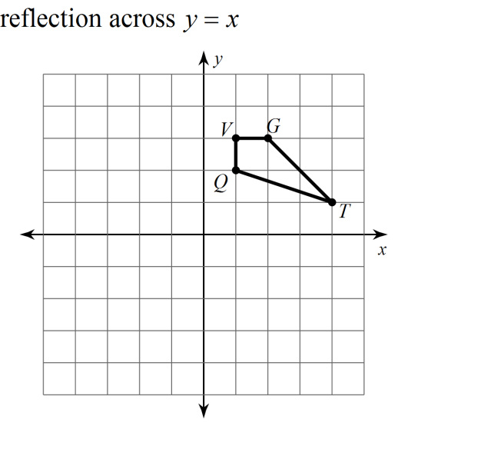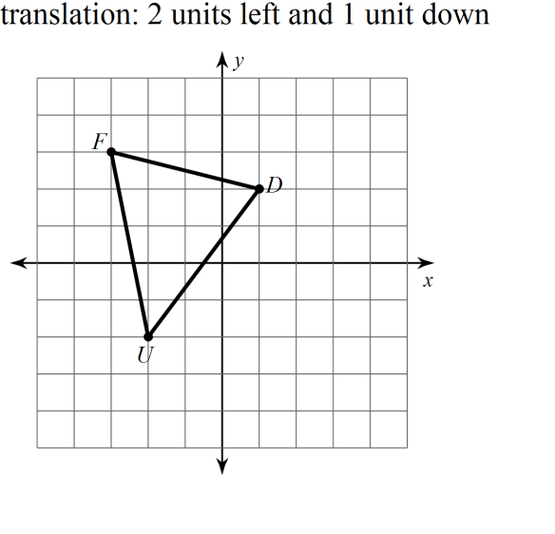10. 11.

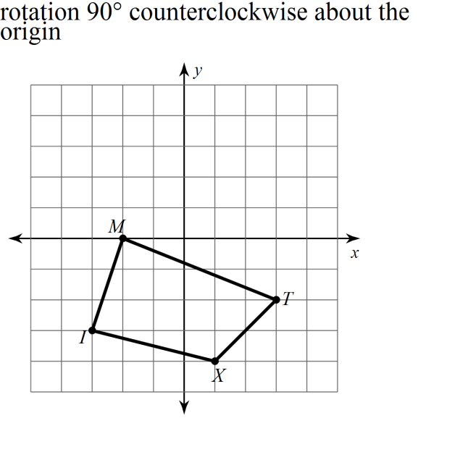

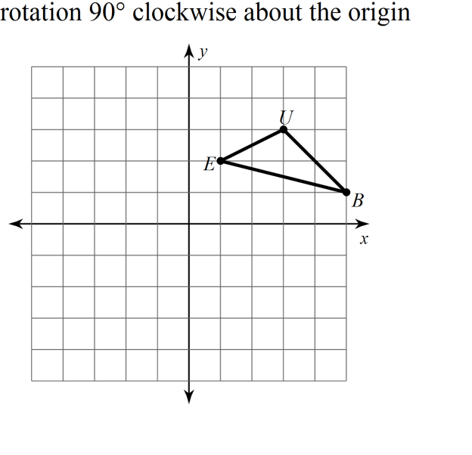12. 13.

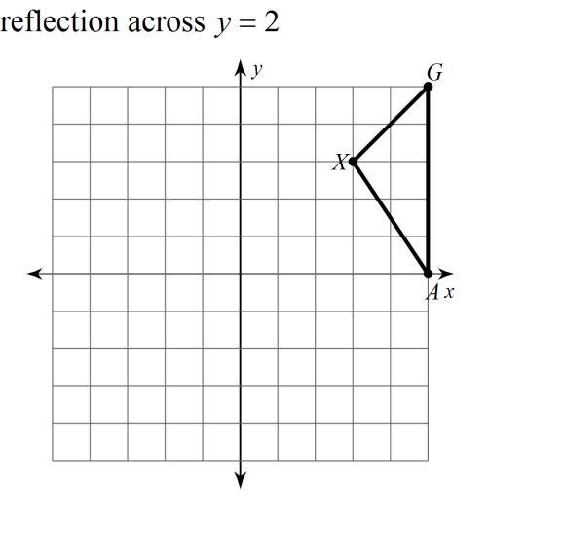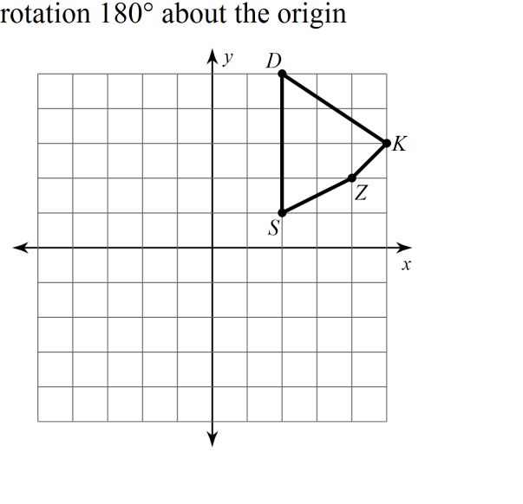

14. 15.

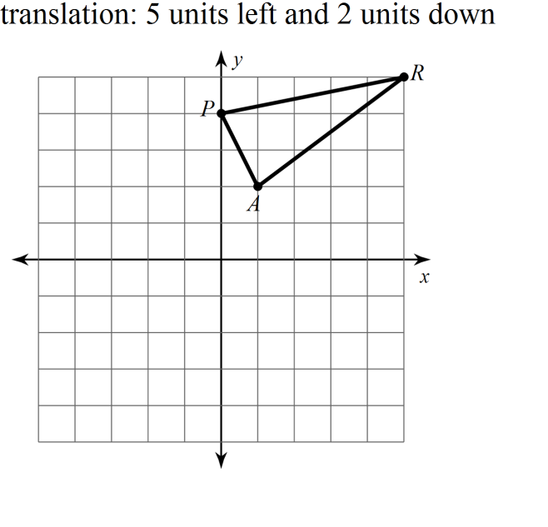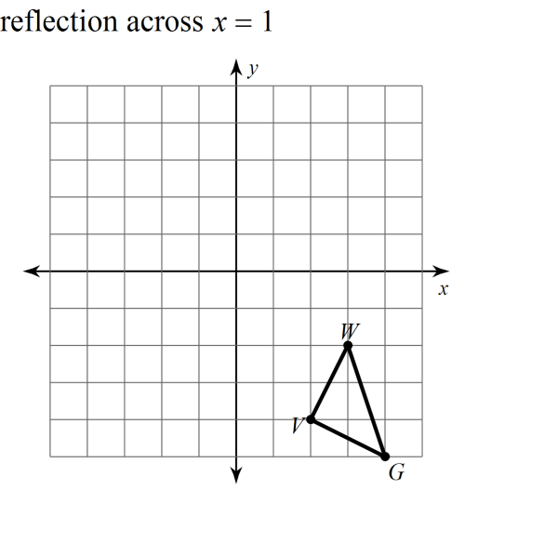16. 17.

18. Create your own real world example of a rotation. (Draw it if it helps.)

19. Create your own real world example of a reflection. (Draw it if it helps.)

20. Create your own real world example of a translation. (Draw it if it helps.)

21. This is a composite of transformations.

From 1 to 2 the transformation performed is: ____________________

From 2 to 3 the transformation performed is: ____________________

From 1 to 3 the transformation performed is: ____________________

22. The composite of reflections over two parallel lines results in a ______________________

23. This is a composite of transformations.

From 1 to 2 the transformation performed is: ____________________

From 2 to 3 the transformation performed is: ____________________

From 1 to 3 the transformation performed is: ____________________

24. The composite of reflections over two intersecting lines results in a ______________________

25. Find the slope of the line containing points A(8, -3) and B(-6, -2).

26. Determine if AB and CD are parallel, perpendicular, or neither.

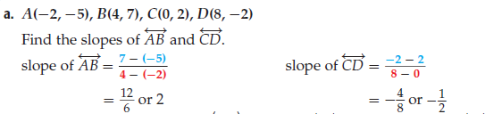

Ans: _______________________________________________________________

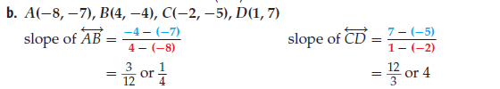

This time find all slopes first.

Ans: _______________________________________________________________

27.

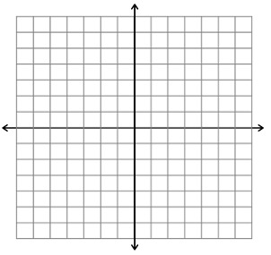

28.

29. Write the slope intercept form of line l.

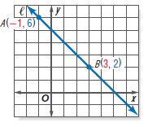



30.



31.

32. Reflect the figure over the given line.

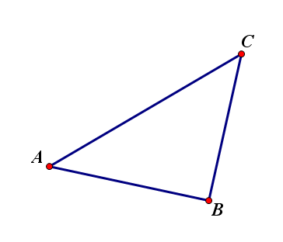

33. Rotate the figure 110 AND 70 degrees counterclockwise. Color them in two different colors.

