Name: ____________________________________ Date :____________________ Hour: ____________

**~Transformations Test REVIEW~**

Constructions of Transformations –

***You WILL need to construct transformations!!!!!!!!!!!***

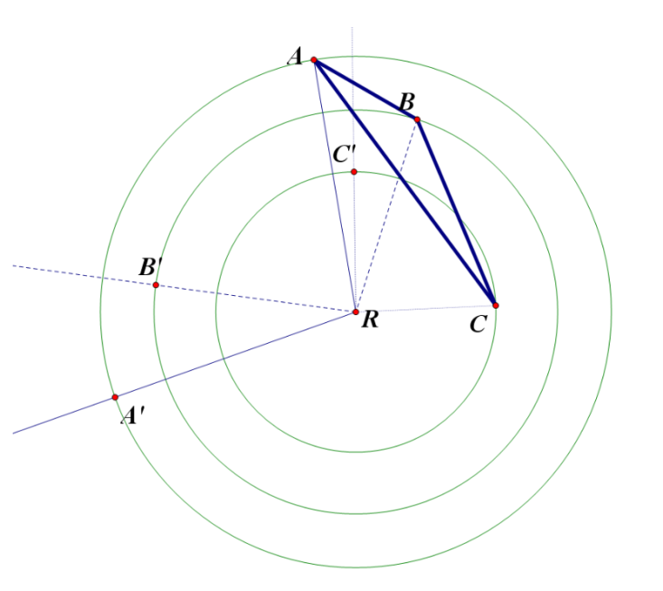

1. use the figure to the right

a. name the type of transformation

b. name all properties of the construction

2. use the figure to the right

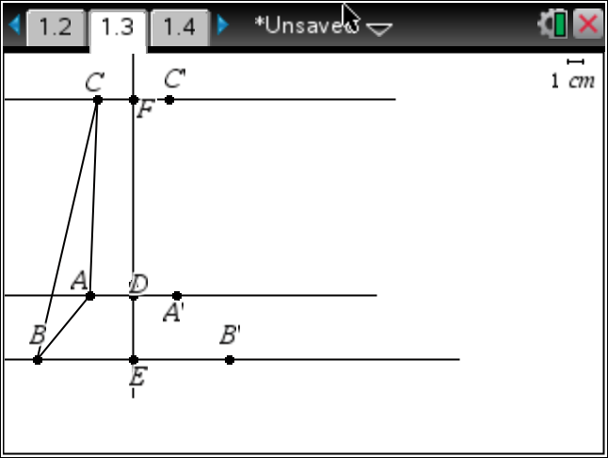

a. name the type of transformation

b. name all properties of the construction

3. What are the properties of a REFLECTION?

4. What are the properties of a TRANSLATION?

5. What are the properties of a ROTATION?

Identify the type of transformation.

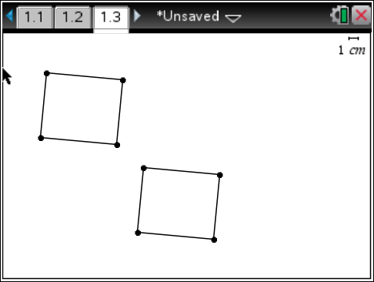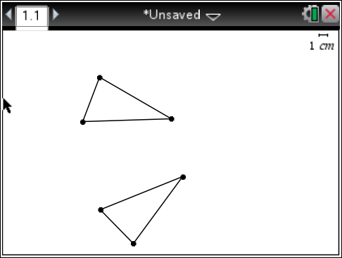

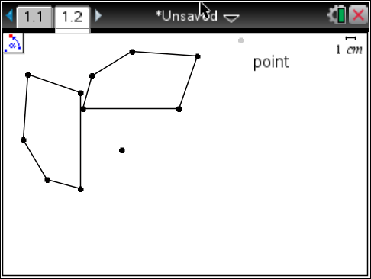6. 7. 8.

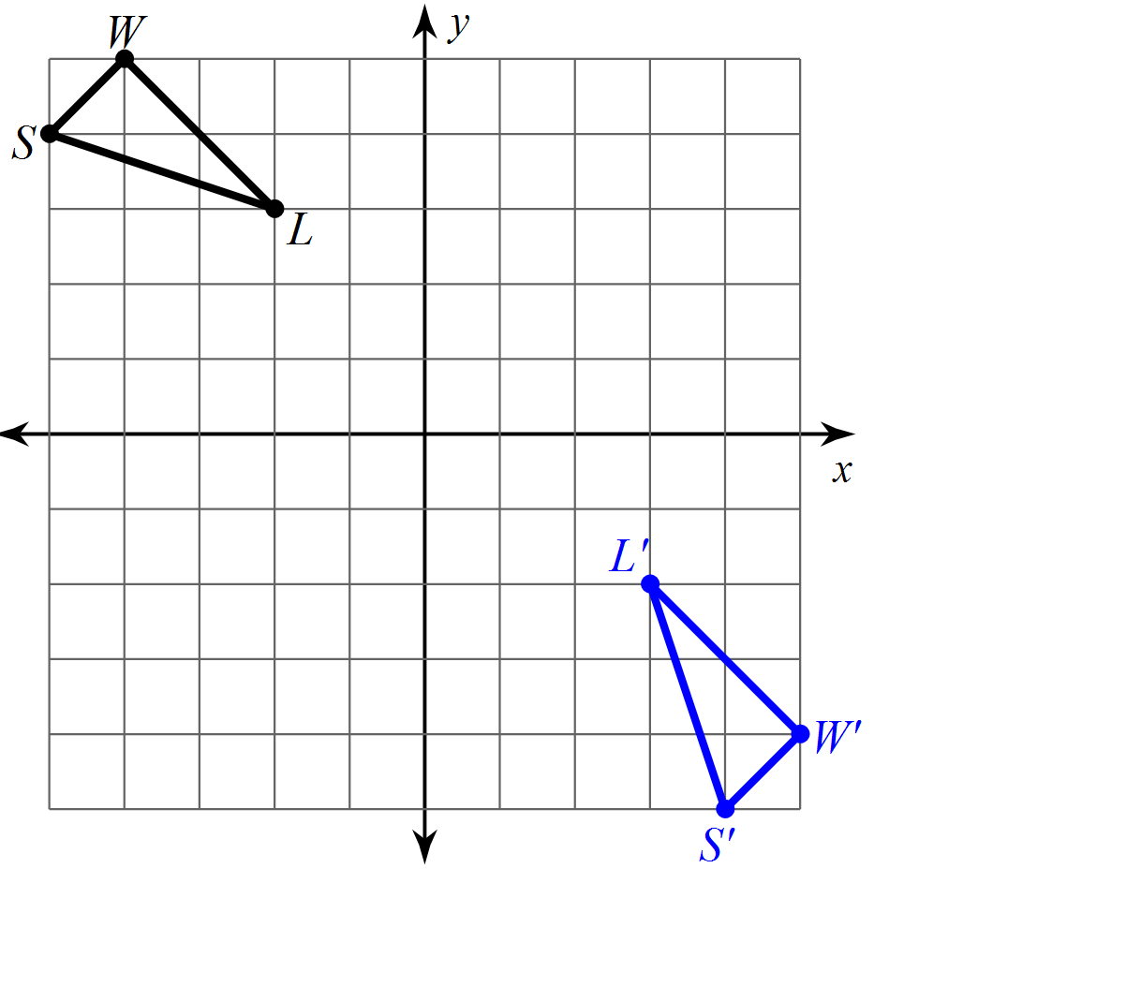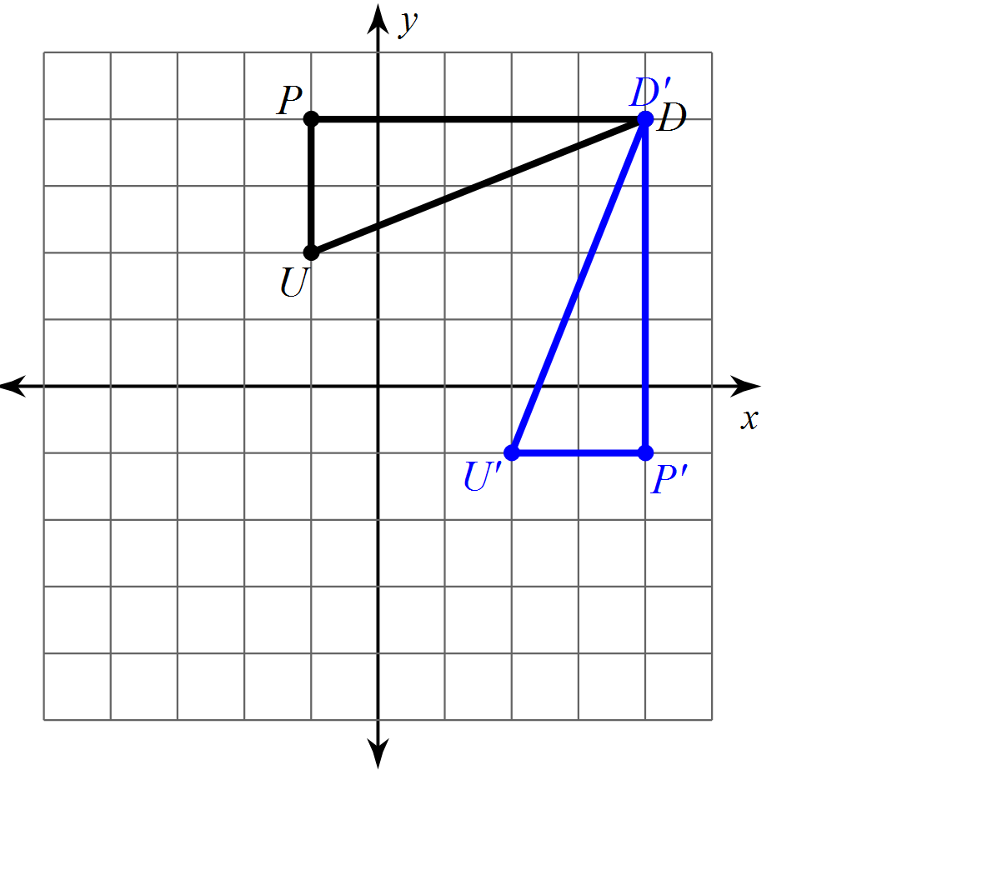Draw in the line of reflection for 9 through 14.

9. 10.

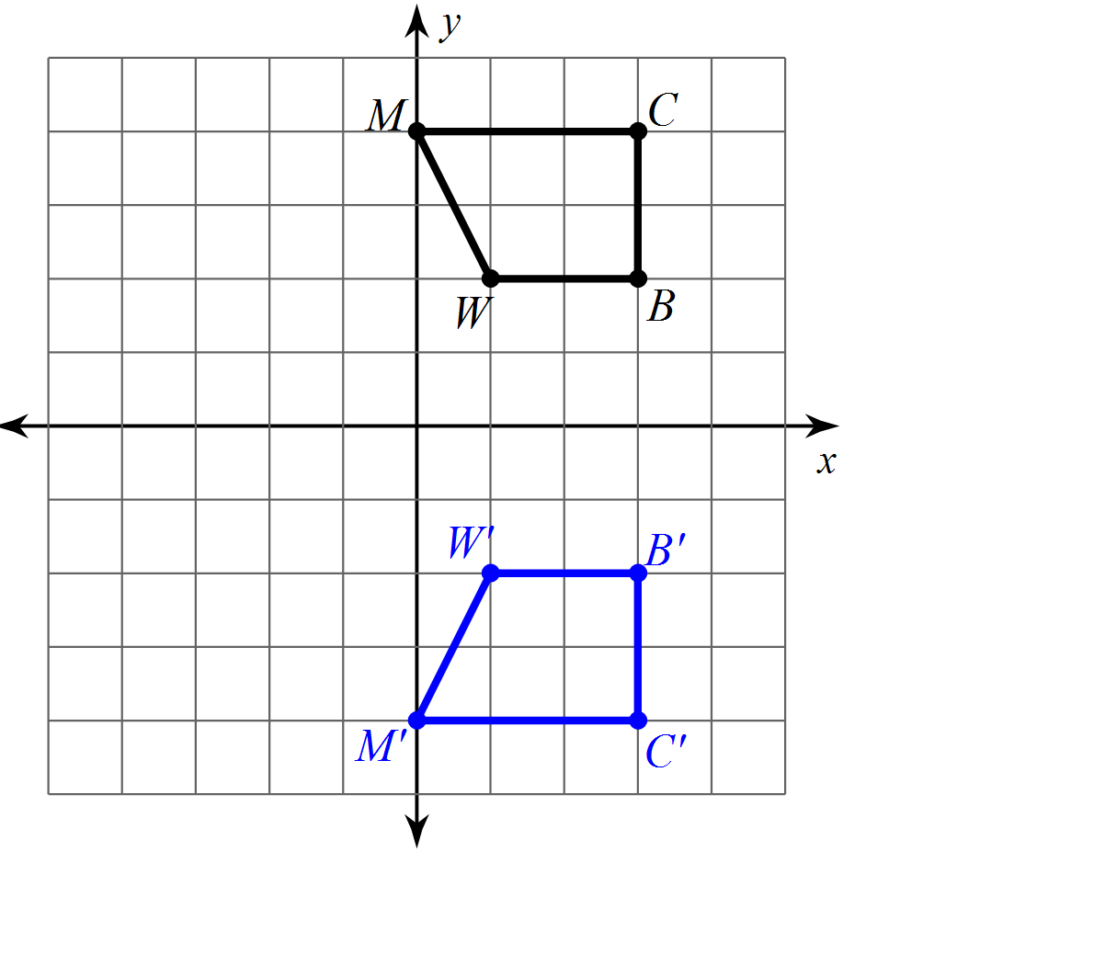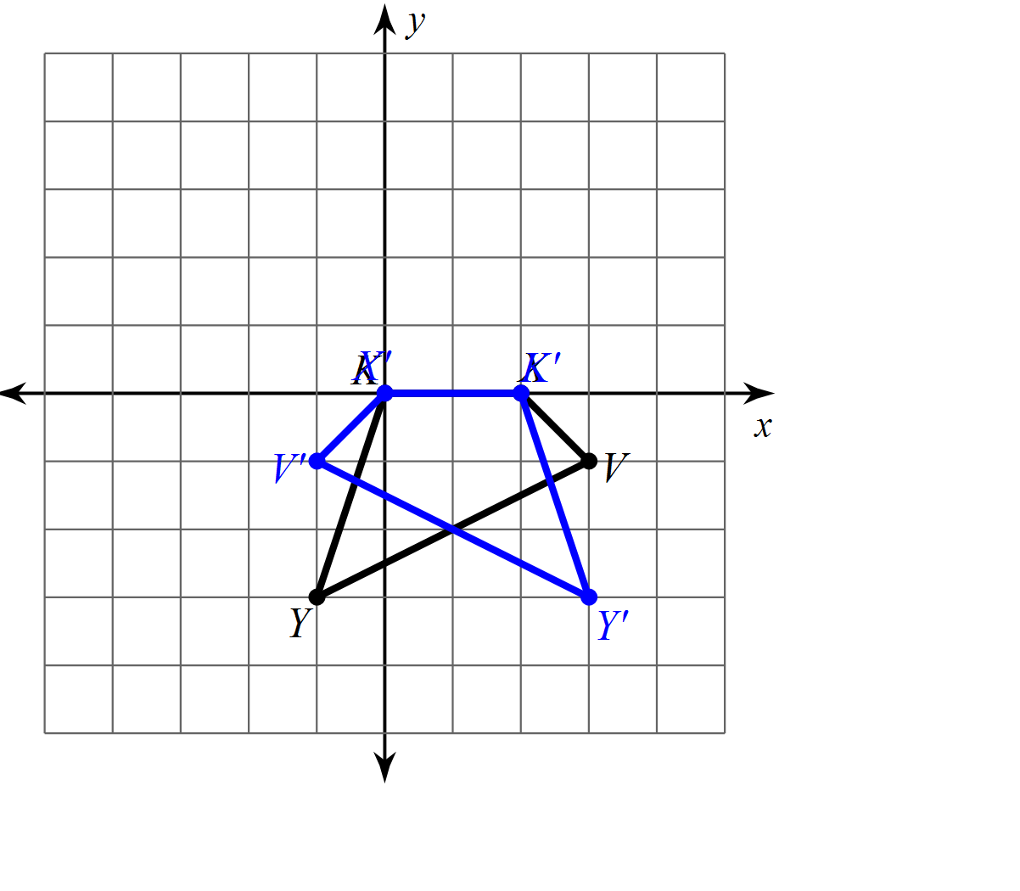

11. 12.

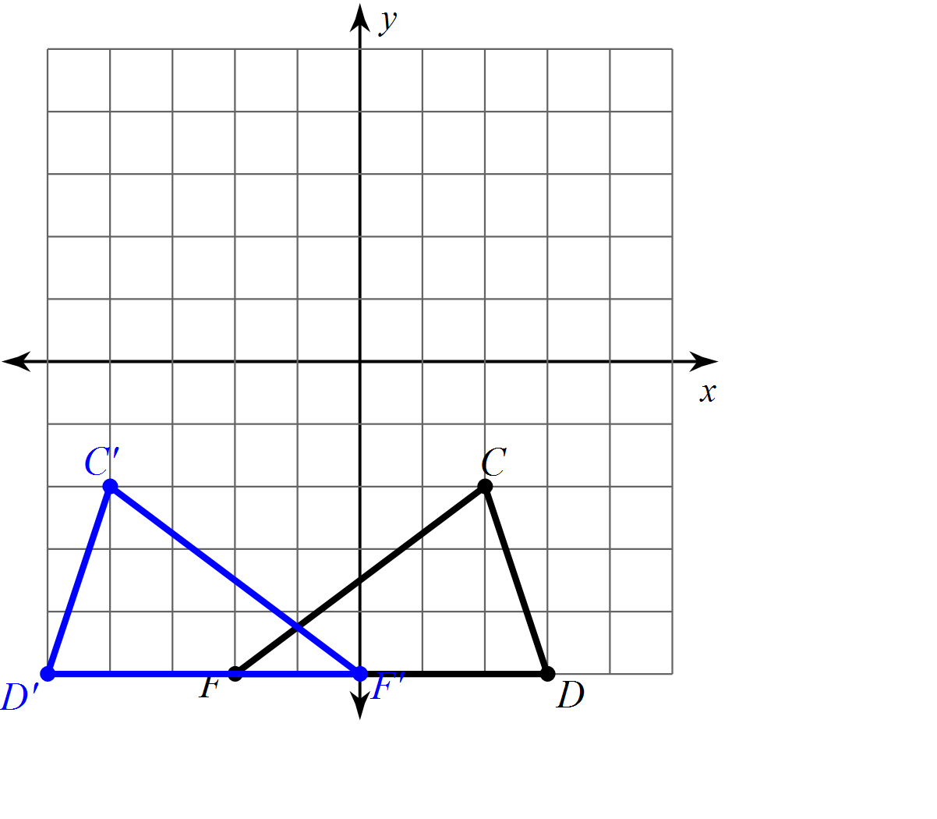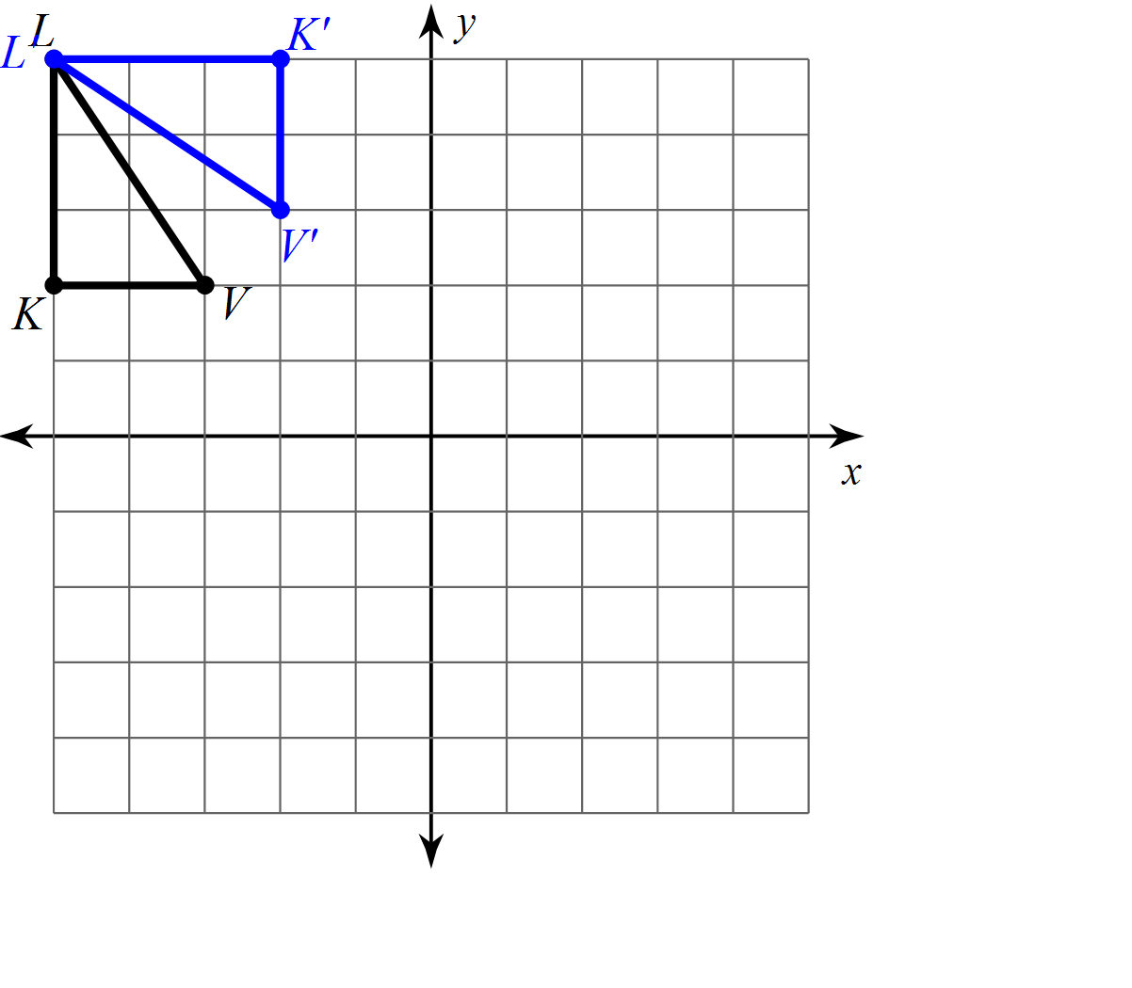

13.   14.

Graph the transformation for 15 through 23. If it is a translation, write the rule for the translation.

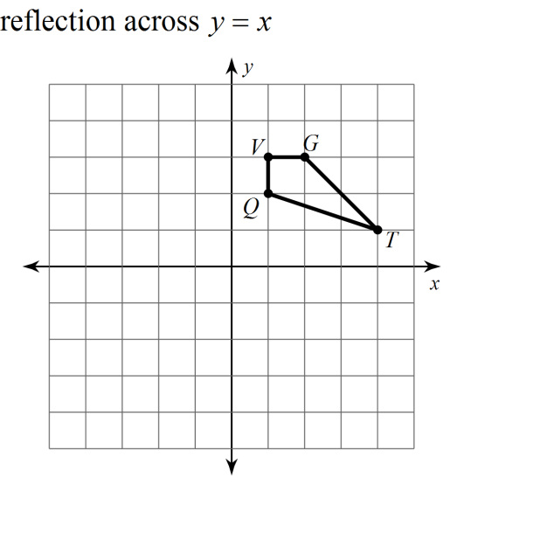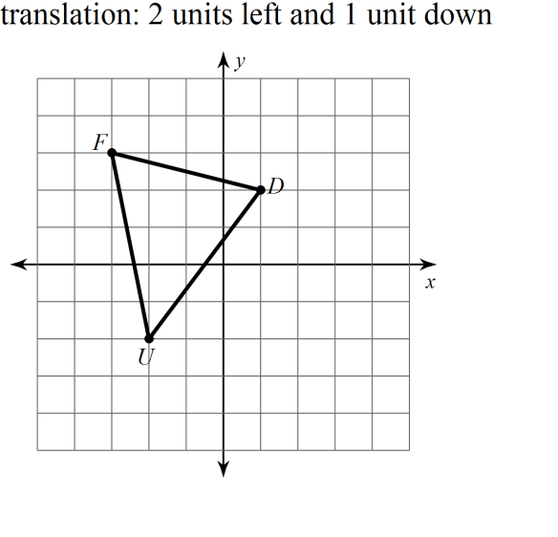15. 16.

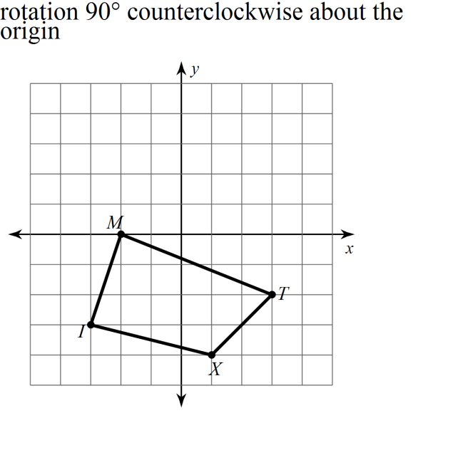

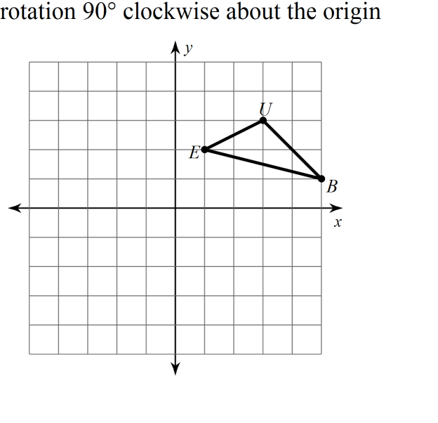17. 18.

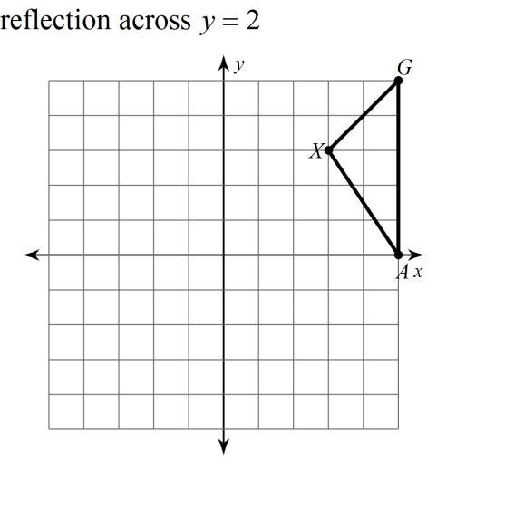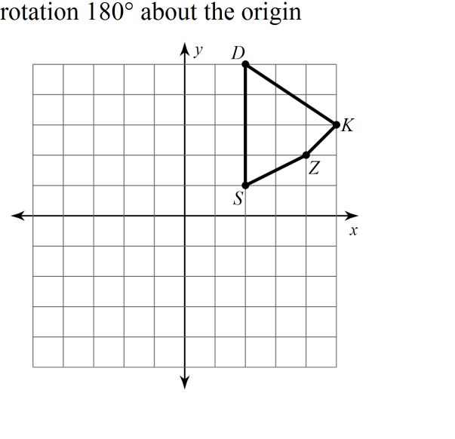

19. 21.

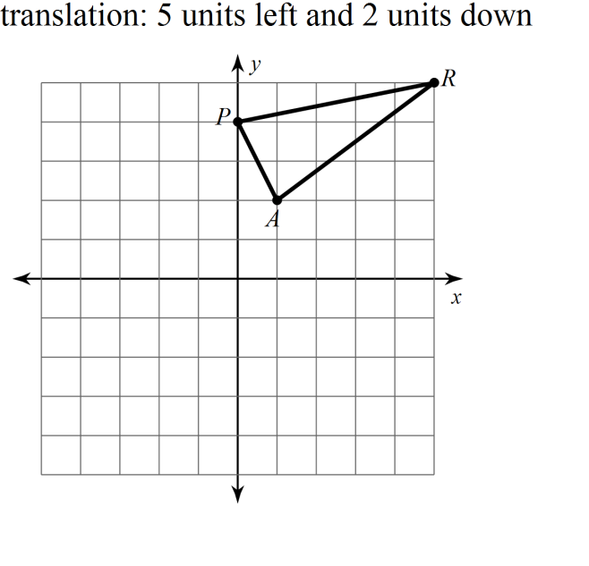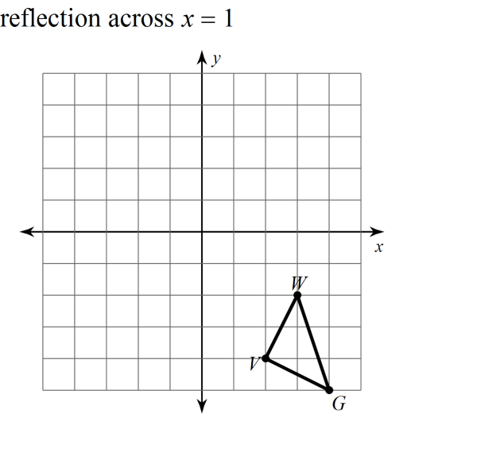22. 23.

24. Create your own real world example of a rotation. (Draw it if it helps.)

25. Create your own real world example of a reflection. (Draw it if it helps.)

26. Create your own real world example of a translation. (Draw it if it helps.)

27. In a basketball game, Roger is standing at position *A* and he bounces the ball to Edwin standing at position *B*. Copy the diagram and sketch the path the ball must travel after being bounced to Edwin by Roger.

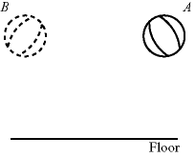

28. John and Richard are playing squash. The diagram shows how John hits the ball from point *A*. Sketch the path the ball must travel towards Richard at point *B* after hitting the wall of the court.

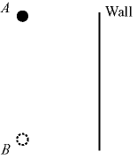

29. Sketch how the ray of light reflects back when it strikes the reflecting surface.



30. Jeremy and Cassidy are playing air hockey. Cassidy hits the puck as shown in the diagram. Sketch the path the puck must travel to reach Jeremy.

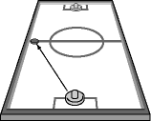

31. Find the slopes of lines. Identify if they are parallel, perpendicular, or neither. Simplify all fractions, if possible.

S(6, 5), T(-4, 3) X(-4,2), Y(-3,-3)

Slope of ST: ______________

Slope of XY: ______________

[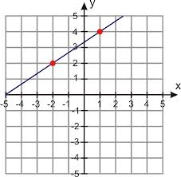](http://www.google.com/imgres?q=linear+graph+through+two+points&um=1&hl=en&sa=N&biw=1680&bih=898&tbm=isch&tbnid=7h6G_Z-0TVW7AM:&imgrefurl=http://www.ck12.org/user:amRvdXRoYXRAd2lja2VuYnVyZy5rMTIuYXoudXM./section/Forms-of-Linear-Equations-::of::-Finding-Equations-of-Linear-Functions-(with-regression)/&docid=egX3c3qKPzzJwM&imgurl=http://www.ck12.org/flx/show/image/user:amRvdXRoYXRAd2lja2VuYnVyZy5rMTIuYXoudXM./AlgII-05-01-04.png-201207161342476132182555.png&w=651&h=636&ei=Jv1zUK6NN4WMyAGS4YHYDw&zoom=1&iact=hc&vpx=1282&vpy=356&dur=360&hovh=222&hovw=227&tx=128&ty=107&sig=115864779295286494546&page=2&tbnh=163&tbnw=167&start=28&ndsp=36&ved=1t:429,r:34,s:28,i:272)32. Find the slope of the line. Then, find the slope of the lines parallel and perpendicular to the line. Simplify all fractions, if possible.

Slope: ________________

Perpendicular Slope: _________________

Parallel Slope: _______________

33. Find the equation of the line. Write the equation of a line parallel and perpendicular to the line. Simplify all fractions, if possible.

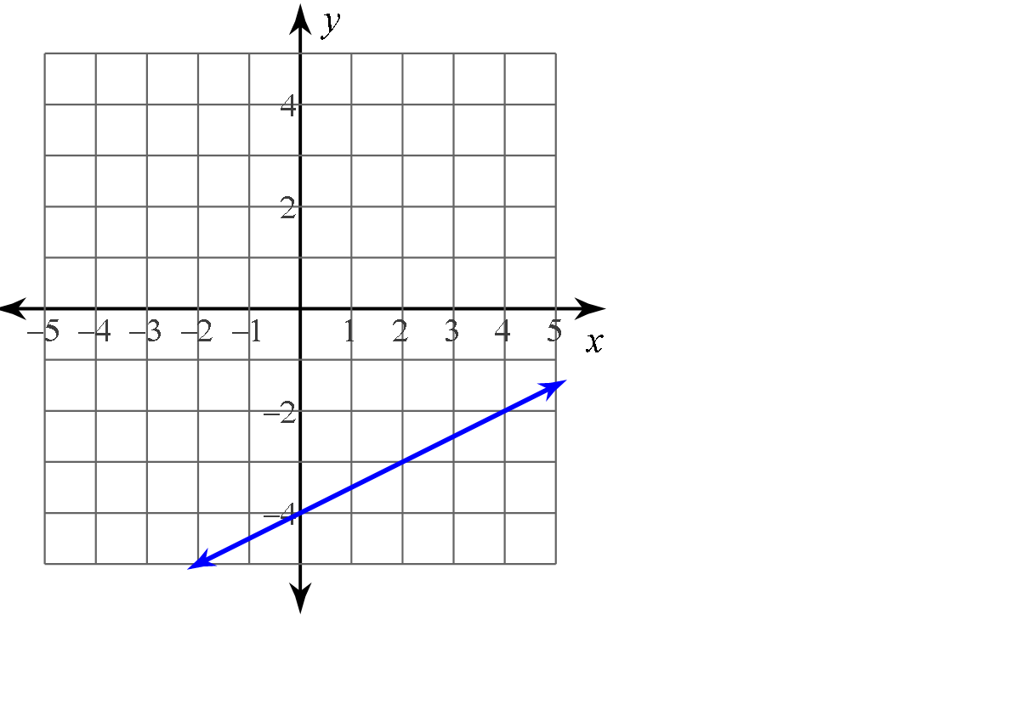Equation of line: _________________________

Parallel Equation: ________________________

Perpendicular Equation: _________________________



34. This is a composite of transformations.

From 1 to 2 the transformation performed is : ____________________

From 2 to 3 the transformation performed is : ____________________

From 1 to 3 the transformation performed is : ____________________

35. The composite of reflections over two parallel lines results in a __________________

36. This is a composite of transformations.

From 1 to 2 the transformation performed is : ____________________

From 2 to 3 the transformation performed is : ____________________

From 1 to 3 the transformation performed is : ____________________

37. The composite of reflections over two parallel lines results in a __________________

38. Reflect the figure over the given line.

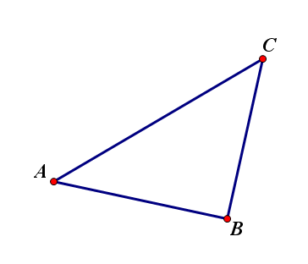

39. Rotate the figure 110 degrees counterclockwise.

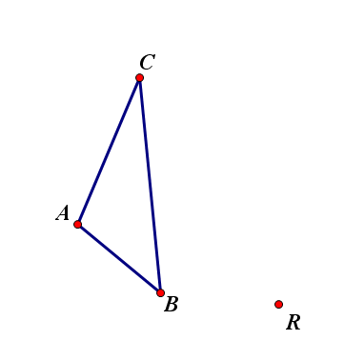

***C***

***A***

***B***

***R***